Legal vocabulary: People and places
12.1

Match these words with their meanings

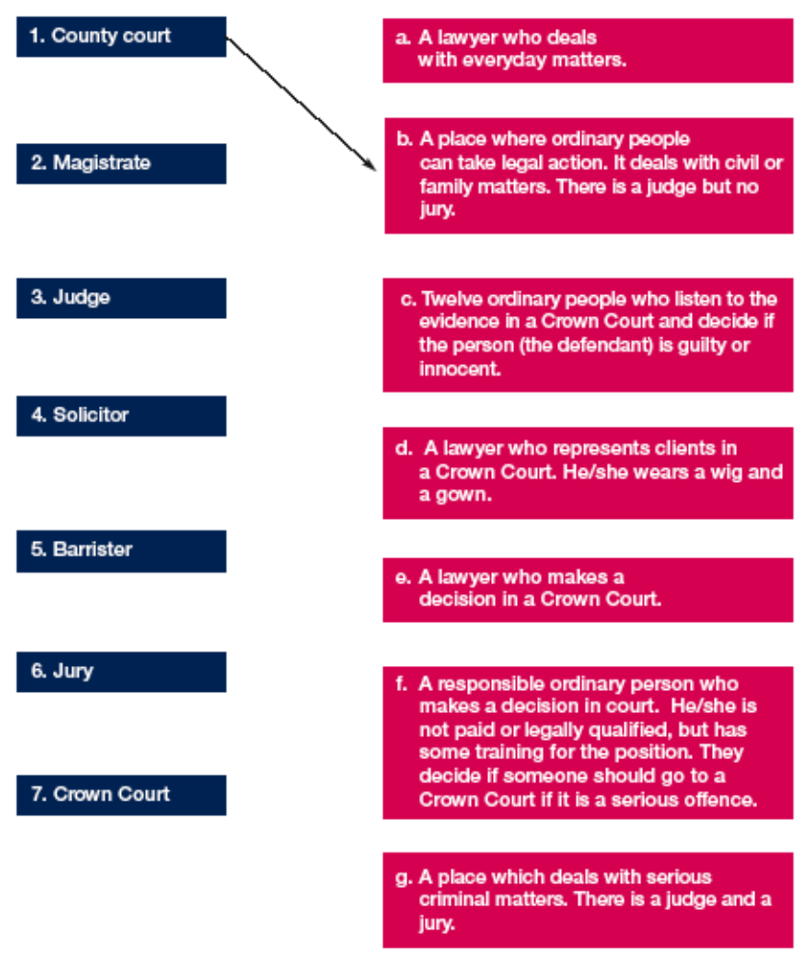

The law courts: Reading text
12.2

Task sheet 1: The legal system in England and Wales

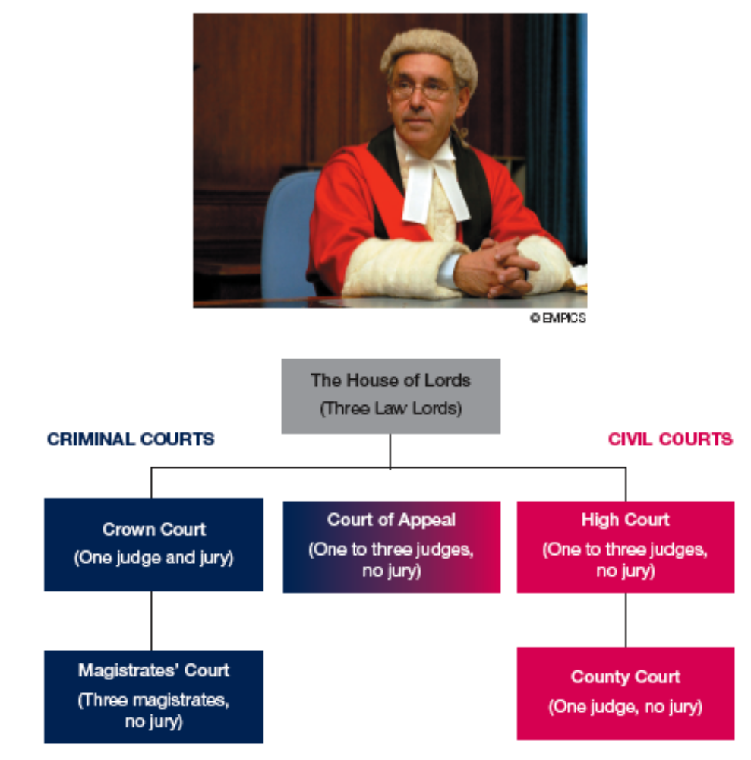

The law courts: Reading text
12.2

Task sheet 2: Text

There are different types of courts in England and Wales which deal with different matters. Criminal courts involve the state (Crown) prosecuting someone for a crime, for example, robbery or murder. Civil courts, such as the (a)_______________ court deal with people’s rights, duties and obligations, for example, in divorce or personal injury cases. The high court deals with more difficult matters, such as domestic violence.

The majority of criminal cases are dealt with at magistrates’ courts. These are the most common type of law court in England and Wales. There are 700 magistrates’ courts and about 30,000 (b)____________________ . There is no (c)_________________ in a magistrates’ court.

More serious criminal cases go to the (d)__________________ court. There are about
90 of these in England and Wales. There is one (e)_________________ and a (f)___________________ of 12 people. Their decision is called a verdict.

The Court of Appeal deals with civil and criminal appeals. The highest Court of Appeal in England and Wales is the House of Lords.

The legal system also includes youth courts (which deal with young people) and coroners’ courts (which investigate violent or sudden deaths).

The law courts: Reading text
12.2

Task sheet 3: Discussion
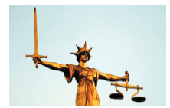

© EMPICS
Discuss the following questions:

1. What is the difference between criminal and civil law?

2. Which type of law court deals with the most criminal cases in England and Wales?

3. Which courts do you think would deal with the following:

- A serious problem between a landlord and tenant?

- A drowning?

- A bank robbery?

- Shoplifting?

- An asylum appeal?

4. If someone is not happy with the verdict, what can they do?

5. In your country, is the legal system similar to this?
Describe how it is similar or different from the English system.

Legal age requirements
12.3

10

12

14

15

16

17

18

21

Legal age requirements
12.3

Statements

Fly an
aeroplane
Play the
National Lottery
Drive a car
on the road
Buy cigarettes
Get a part-time job
Get a tattoo
Give blood
Leave school
Vote in an election
Get a custodial sentence for a crime
Buy a firearm
See a 15 certificate
film
Buy a pet
Buy fireworks
Buy a house
Buy alcohol
Give consent to heterosexual activity
Give consent to homosexual activity
Be entitled to the national minimum wage
Marry with parents’ consent
Sign a tenancy agreement
Serve on a jury
Adopt a child
Stand for Parliament
Join the armed forces

Legal age requirements
12.3

Answers

Fly an
aeroplane
17
Play the
National Lottery
16
Drive a car
on the road
17
Buy cigarettes

18
Get a part-time job

14
Get a tattoo

18
Give blood

18
Leave school

16
Vote in an election

18
Get a custodial sentence for a crime
10
Buy a firearm

16
See a 15 certificate
film
15
Buy a pet

12
Buy fireworks

14
Buy a house

18
Buy alcohol

18
Give consent to heterosexual activity
16
Give consent to homosexual activity
18
Be entitled to the national minimum wage
18
Marry with parents’ consent
16
Sign a tenancy agreement
18
Serve on a jury

18
Adopt a child

21
Stand for Parliament

21
Join the armed forces

18

Drugs and the law
12.4

Task sheet 1

Discuss these statements – are they true (T) or false (F)?

1. Cannabis is a legal drug. T / F

2. Before January 2004, cannabis was a class C drug. T / F

3. If the police find you in possession of cannabis, they
will never arrest you. T / F

4. The police can arrest you for smoking cannabis in public. T / F

5. A magistrates court can send someone to prison for 14 years. T / F

6. Selling or supplying drugs is a more serious offence than
possessing them. T / F

7. In the Crown Court, the judge can fine drug offenders any
amount of money he feels is appropriate. T / F

Now read the text and see if you were right!

Drugs and the law
12.4

Text: Cannabis and the law
line 1 Although UK law concerning cannabis has changed, it is still an
line 2 illegal substance.

line 3 Until January 2004, cannabis was a class B drug and carried a
line 4 maximum penalty of five years in prison for possession. After 2004,
line 5 it became a class C drug. Some people believe that cannabis is
line 6 now a legal substance, but it is not. It is true that the police will not
line 7 usually arrest anybody found to have small amounts of the drug, but
line 8 they are still required to record it as a crime. So if the police catch
line 9 you with a small amount, you will have a criminal record.

line 10 There are some circumstances when the police can arrest people for having
line 11 cannabis. These are:
line 12 when the police think that somebody is going to sell the drug;
line 13 smoking cannabis in public;
line 14 having cannabis when there are children nearby;
line 15 when somebody under 17 is found with the drug.

Penalties
There are two maximum penalties for class C drugs. The maximum penalty for possession is two years in prison and an unlimited fine. The maximum penalty for selling or supplying the drug is 14 years in prison and an unlimited fine.

Most drug offences are tried in front of a jury in the Crown Court. However, if very small amounts are found, the case might be tried in a magistrates court where the maximum sentence is six months in prison and a £2,000 fine.

The sentence that someone gets depends on the amount of the drug that was found, the circumstances when the drug was found and the person’s previous criminal record.

Drugs and the law
12.4

Questions

Study the text on the previous page carefully.

1. What do the following words refer to?

- it (line 1)

- it (line 4)

- it (line 5)

- it (line 6)

- they (line 7)

- you (line 8)

- These (line 11)

2. Look at the first sentence, beginning with ‘Although’. Can you re-write it, using ‘However’? What changes did you need to make?

- Now write two sentences of your own, using ‘although’ and ‘however’.

Drugs Web search task
12.5

Web search: task sheet

Website search instructions

- In the address bar, type in www.bbc.co.uk and click on ‘Go’.
- Click on the ‘A–Z Index’.
- Click on ‘C’ in the alphabet.
- Scroll down and click on ‘Crime homepage’.
- Under ‘drugs’, click on ‘A to Z of Drugs’.
- Look under the banner ‘Search for Drug Factfiles’ and find ‘A to Z Search’.
- Under this, click on ‘drug classifications’.

Now answer the following questions:

1. Which drugs are
Class A?
Class B?
Class C?

2. What is the maximum prison sentence for supplying heroin?

3. What is the maximum prison sentence for possessing heroin?

4. What is the maximum prison sentence for possessing a class B amphetamine?

5. What is the maximum prison sentence for supplying cannabis?

6. When was the Misuse of Drugs Act passed by Parliament?

Immigration and asylum
12.6

True or false?

Listen to the information and decide if these statements are true or false:

1. You must have a work permit to come to the UK. True / False

2. You can come to the UK if you have a tourist visa. True / False

3. You can come to the UK if you are a European citizen. True / False

4. You can apply for asylum a few weeks after you arrive. True / False

5. When you apply for asylum, if you get a negative decision
you can’t appeal against it. True / False

6. ‘Humanitarian protection’ status can be for six years. True / False

7. ILR stands for ‘indefinite leave to remain’. True / False

8. Discretionary leave cannot be for less than three years. True / False

9. It is very easy to get full refugee status. True / False

Now read the text and check your answers.

- With a partner, discuss which ways of entering the UK give you permanent status, and which give you temporary status. For example, a tourist visa is temporary.

Immigration and asylum
12.6

Tape script

Who can move to the UK?

In the UK, we have had many Immigration and Asylum Acts. The rules keep changing. Some ways of entering give you permanent status and some give you temporary status.

At the moment, you can come to the UK if:

- you have a work permit;
- you have a visa – for tourist/visitor/or medical reasons;
- you are the husband or wife or a permanent British resident, or citizen;
- you are an EU citizen;
- as soon as you arrive, you apply for asylum;
- you come under a Gateway Protection programme.

When you apply for asylum, you get a negative or positive decision. You can appeal against a negative decision. These are the possible positive decisions at the moment:

- HP (humanitarian protection), which can be for three years and you can ask after this for ILR (indefinite leave to remain).

- HP has replaced ELR (exceptional leave to remain). This was for three years, with the chance to extend it and change it to ILR.

- DL (discretionary leave), which can be for three years or less. You can ask for this to be extended and after six years you can ask for ILR.

- Full refugee status. Like ILR, it used to be possible to get this immediately after a positive decision. Since April 2003, this is now very rare.

After any positive decision, you are allowed to work and get full welfare benefits.

