Name: _______________________________ Date: ______________

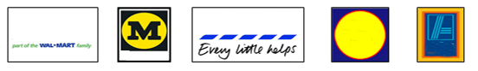

1. 2. 3. 4. 5.

Supermarket names

1 ____________________ 4 __________________
2 ____________________ 5 __________________
3 ____________________

Talk to another student using question words.

1. Where do you go shopping? ___________________

2. When did you go shopping? ___________________

3. What time did you go? ___________________

4. What did you buy? ___________________

Cut out the names from the back page and glue to the picture.

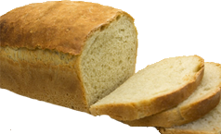 | 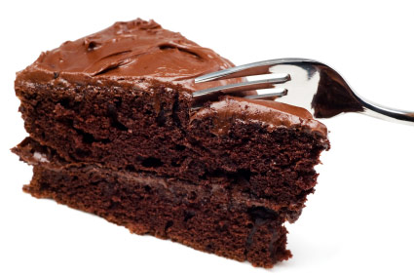
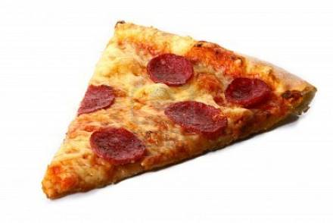 | 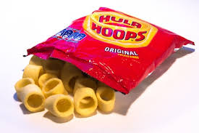
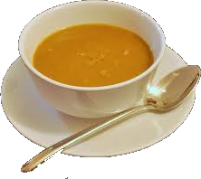 | 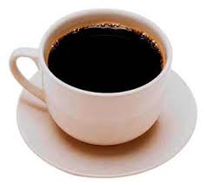
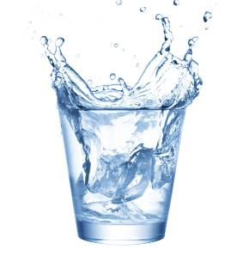 | 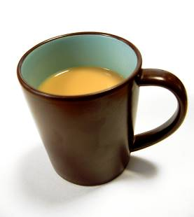
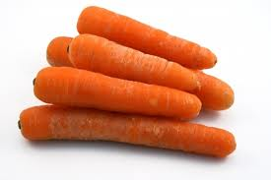 | 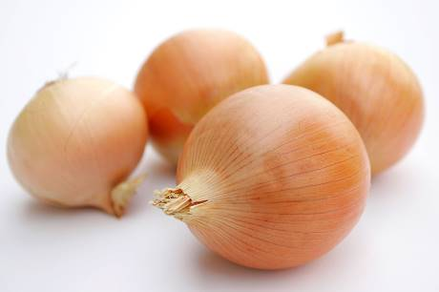

Write the missing words. Listen to your tutor read out the costs.
NOUN COST
- A loaf of ________ ________
- A piece of ________ ________
- A slice of ________ ________
- A packet of ________ ________
- A bowl of ________ ________
- A cup of ________ ________
- A glass of ________ ________
- A mug of ________ ________
- A kilo of ________ ________
- A pound of ________ ________
pound = 1 lb kilo = 1 kg
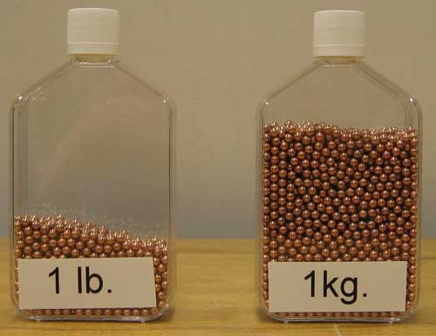

Draw the shapes
loaf | piece
slice | packet
glass | mug
bowl | cup
kilo 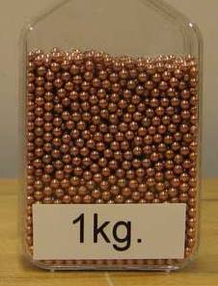 | pound 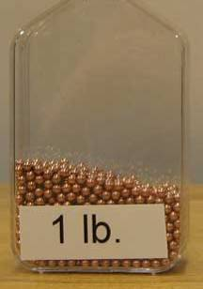
Write the correct phrase
 | 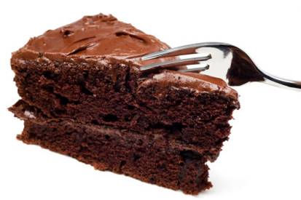
A loaf of bread | A cake
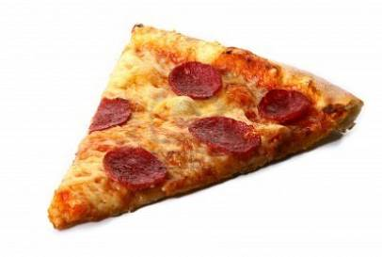
A pizza | A crisps
A soup | A coffee
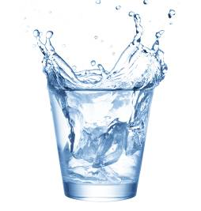 | 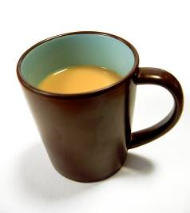
A water | A cake
 | 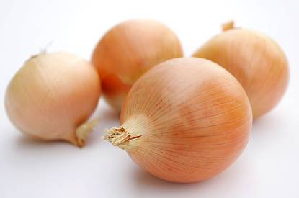
A carrots | A onions

Work in pairs and ask and answer each question.

1. What do you need? | 2. What do you need?
I need a loaf of bread | I need a
3. What do you need? | 4. What do you need?
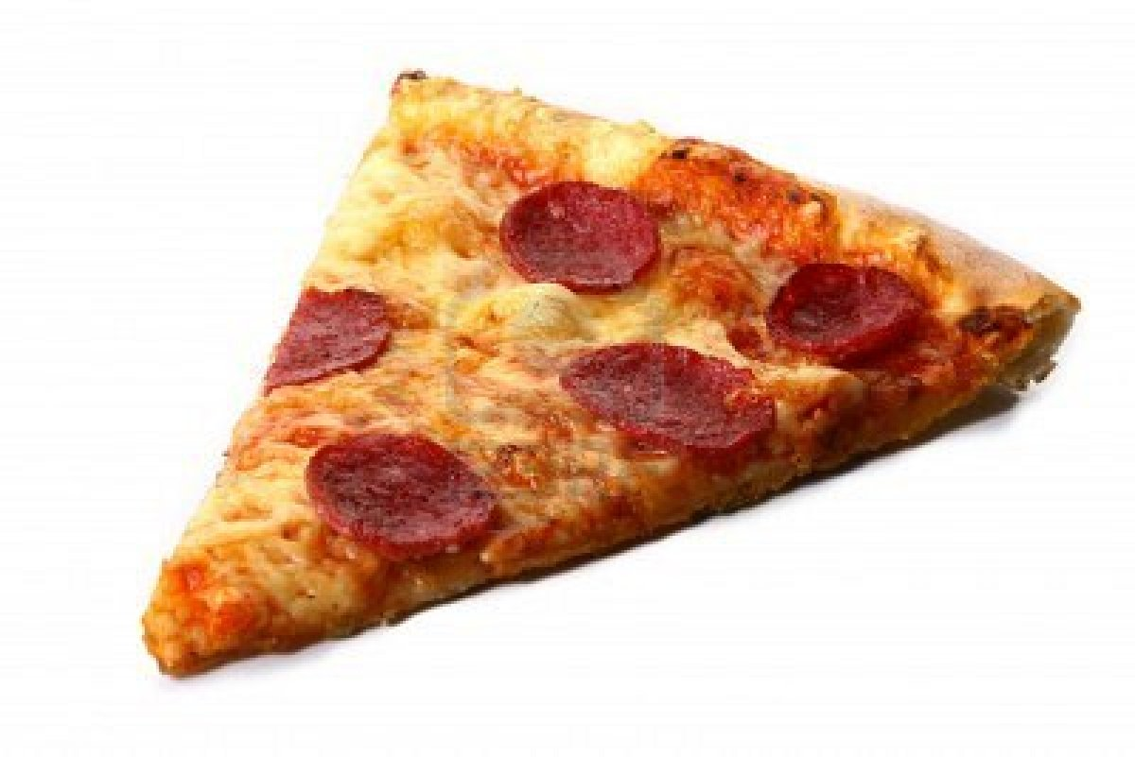  I need a | I need a
5. What do you need? | 6. What do you need?
I need a | I need a
7. What do you need? | 8. What do you need?
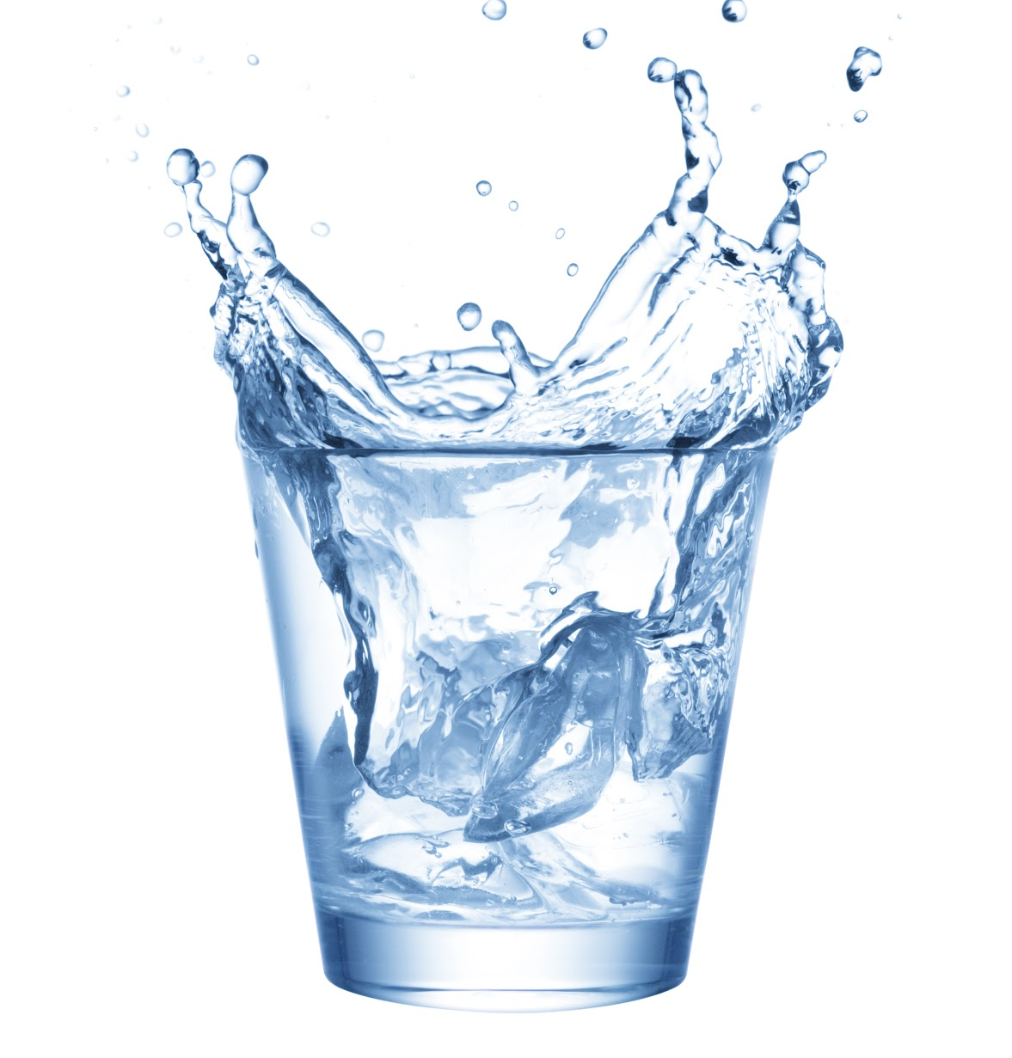  I need a | 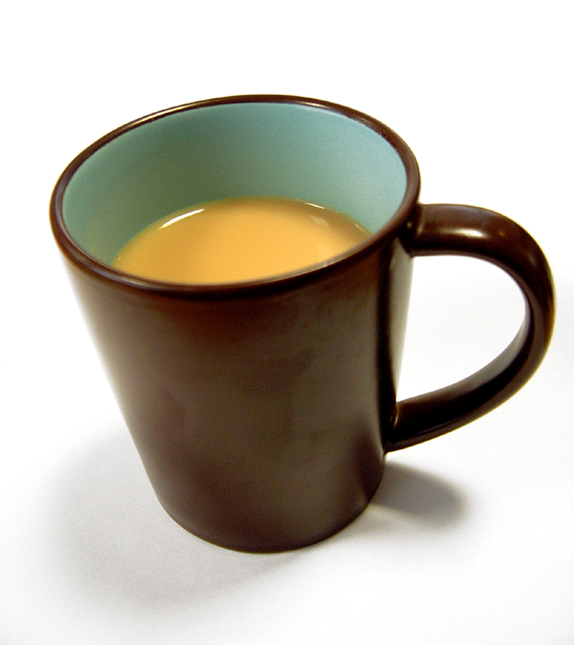  I need a
9. What do you need? | 10. What do you need?
I need a | 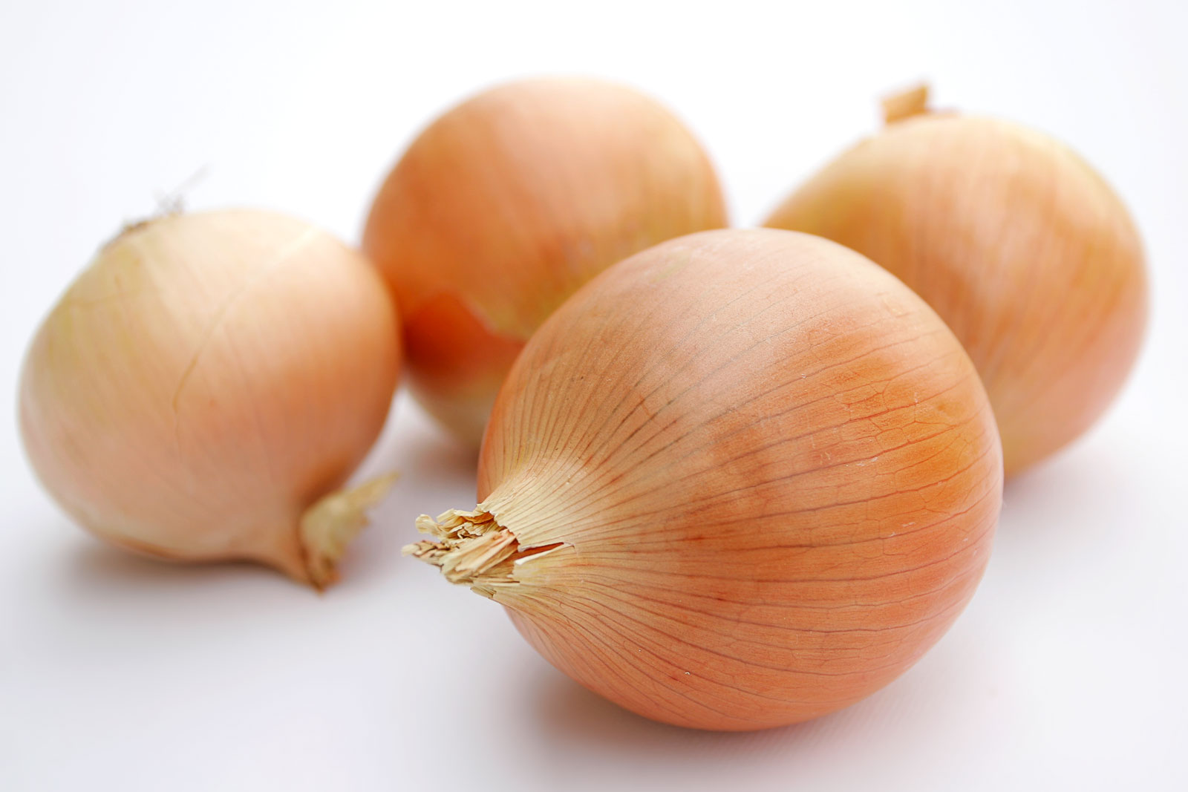  I need a

Words (open PowerPoint – Week 13 Words 2)

 | spellings (listen to the tutor) | correct

Prepositions – write the missing words

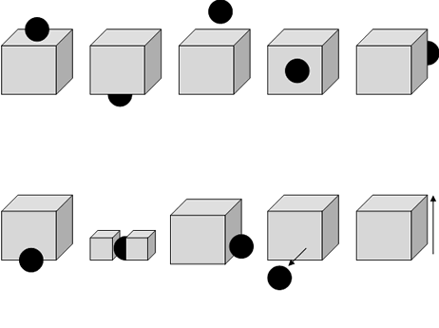

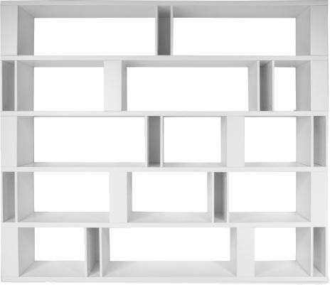
Answer the tutor questions about the location of each item. Then in pairs ask each other questions.
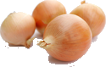
(Open PowerPoint – Week 13 Sentences 2)

Read the sentences with your tutor and copy the sentences neatly. Answer the tutor questions.

 | The bread is above the tea. | 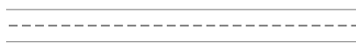
 | The cake is next to the tea.
 | The coffee is under the cake.
 | The pizza is on the shelf.
 | The crisps are between the pizza and the soup.
 | The water is in the glass.
 | The soup is next to the crisps.
 | The pizza is above the water.
 | The onions are in front of the carrots.
 | The carrots are behind the onions.

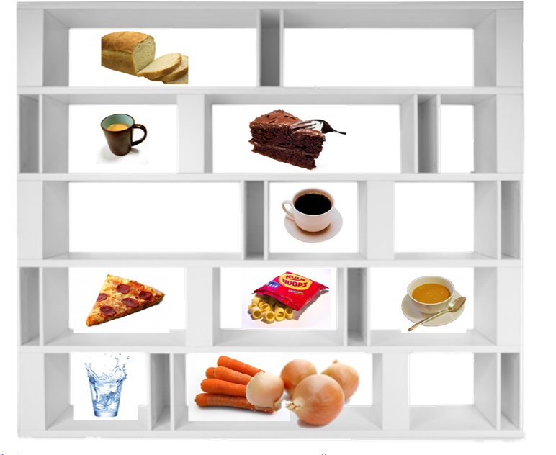
STUDENT 1 - in pairs, read the sentences to the other student and copy.

The bread is above the tea.
___________________________________________
The coffee is under the cake.
___________________________________________
The crisps are between the pizza and the soup.
___________________________________________
The soup is next to the crisps.
___________________________________________
The onions are in front of the carrots.
___________________________________________

STUDENT 2 - in pairs, read the sentences to the other student and copy.

___________________________________________
The cake is next to the tea.
___________________________________________
The pizza is on the shelf.
___________________________________________
The water is in the glass.
___________________________________________
The pizza is above the water.
___________________________________________
The carrots are behind the onions.

1. In pairs, write questions and answers and speak to each other.

Where is the pizza?
___________________________________________
Where______________________________________
___________________________________________
Where______________________________________
___________________________________________
Where______________________________________
___________________________________________
Where______________________________________
___________________________________________

2. In pairs, write questions and answers and speak to each other.

Where is the pizza?
___________________________________________
Where______________________________________
___________________________________________
Where______________________________________
___________________________________________
Where______________________________________
___________________________________________
Where______________________________________
___________________________________________

Think of other words you can put with the phrase.

- A loaf of bread X
- A piece of cake ______________________
- A slice of pizza ______________________
- A packet of crisps ______________________
- A bowl of soup ______________________
- A cup of coffee ______________________
- A glass of water ______________________
- A mug of tea ______________________
- A kilo of onions ______________________
- A pound of carrots ______________________
TUTOR NOTE – add your own costs and read to the class
COST
- A loaf of bread ________
- A piece of cake ________
- A slice of pizza ________
- A packet of crisps ________
- A bowl of soup ________
- A cup of coffee ________
- A glass of water ________
- A mug of tea ________
- A kilo of onions ________
- A pound of carrots ________


bread | cake | pizza | crisps | soup
coffee | water | tea | onions | carrots

