Name ______________________________ Date___________
Dining In – the kitchen
What can you see? What happens here? Talk about the picture.
Tutor – ad lib questions about meals (focus on breakfast, lunch and snack)

Meals: cut out the names from the back page and glue to the picture.

Name: _______________________________ Date: ______________

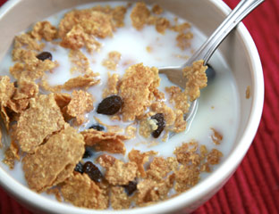 | 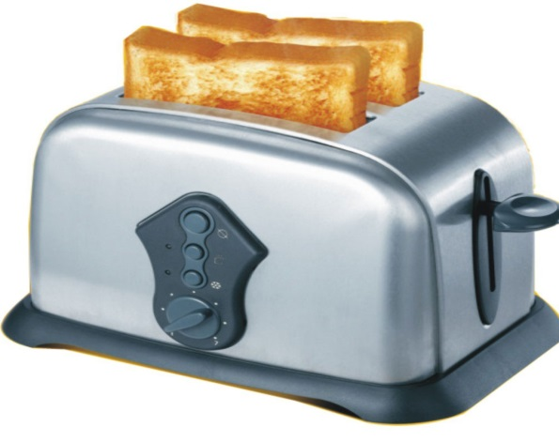
 | 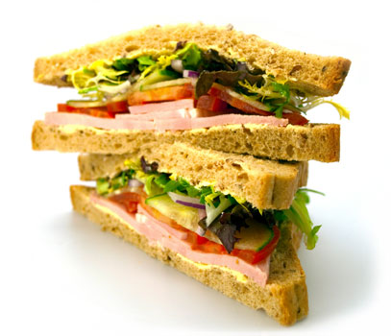
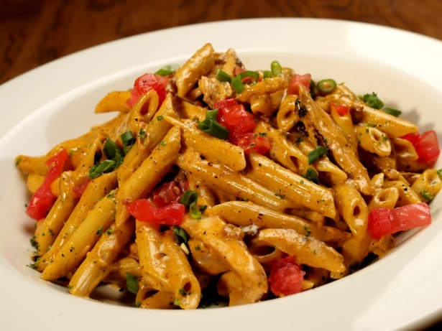 | 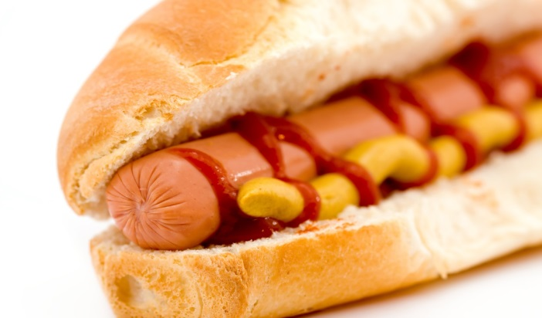
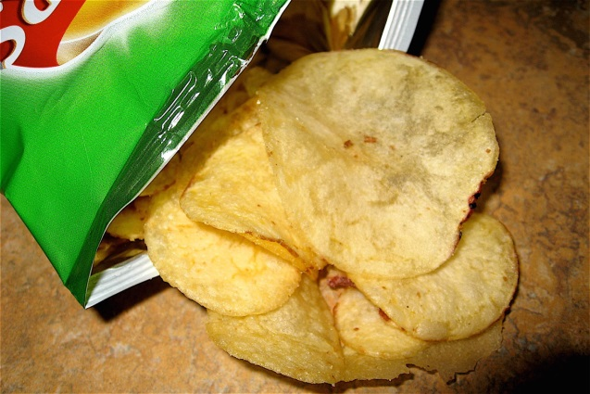 | 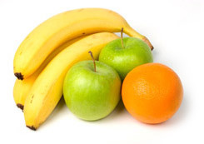
 | 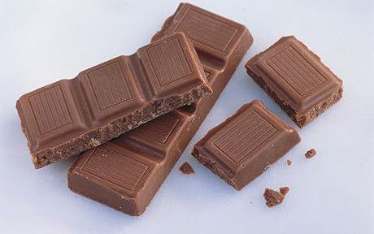
 | 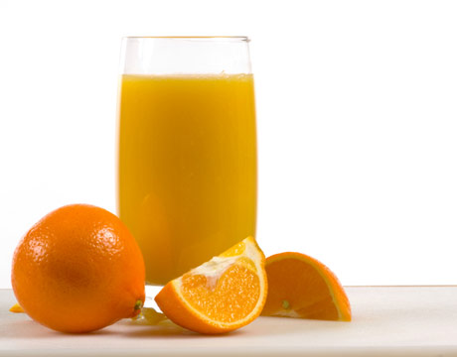
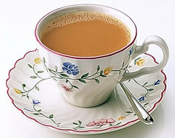
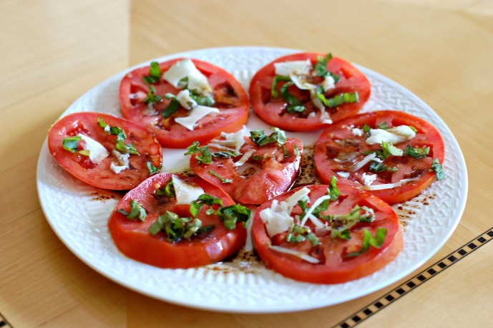 | 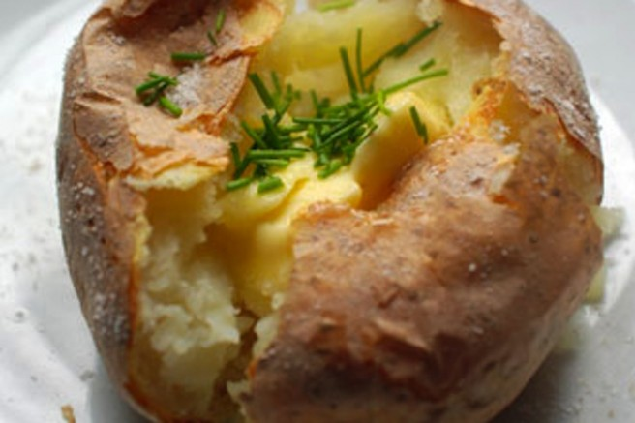

Arrange the words

Do these words best fit into breakfast, lunch, snack or drinks?

A bowl of cereal and milk | A slice of toast
a packet of crisps | a glass of wine
A boiled egg | a glass of orange juice
A slice of toast | Pasta
A hot dog | A pot of strawberry yoghurt
A tomato salad | A piece of fruit
A jacket potato | A cup of tea
A cup of coffee | A bar of chocolate

Breakfast  A bowl of cereal | Lunch  A hot dog | Snack  A bar of chocolate | Drink  A cup of tea

Ask three people about what they eat

What do you have for breakfast? I have a bowl of cereal.
What do you have for lunch? I have a sandwich.

What do you have for breakfast?  What do you have for lunch?  What do you have for a snack? | 1 | 2 | 3

Cereal and milk a slice of toast boiled eggs a sandwich pasta a hot dog a packet of crisps a piece of fruit a bar of chocolate
Something else

Name the family
Write the words under the picture
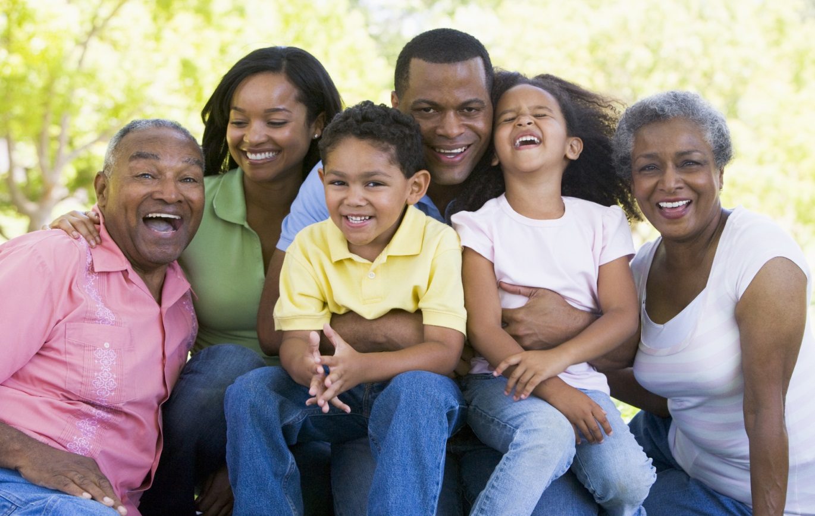

Mum/Mother Dad/father son daughter grandma/grandmother granddad/grandfather

(Open PowerPoint – Week 17 Sentences 1) Dining In
Tomato lunch glass to does toast mum sandwich daughter bar
What _______ Dad have for breakfast?
He has a slice of ____________.

What does _______ have for lunch?
She has a _____________.
What does their __________ have for a snack?
She has a ______ of chocolate.
What does Grandad have ____ drink?
He has a _______ of juice.
What does the son have for _________?
He has a __________ salad.

STUDENT 1 – Here is your dining room. Choose your meals for the day.

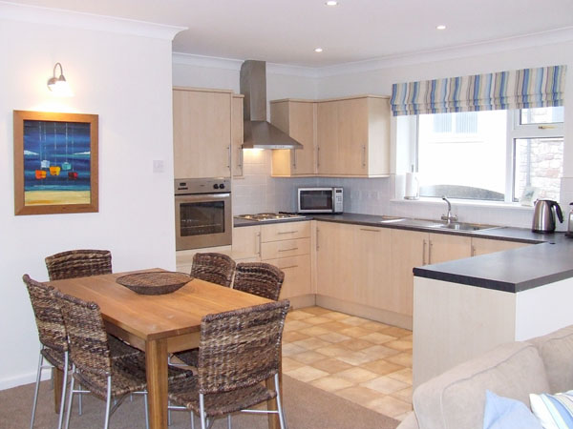

MENU 1

BREAKFAST
- A bowl of cereal and milk
- A slice of toast
- A boiled egg
LUNCH
- Pasta
- A sandwich
- A jacket potato
SNACK

- A bar of chocolate
- A packet of crisps
- A piece of fruit

STUDENT 2 – Here is your dining room. Choose your menu for the day.

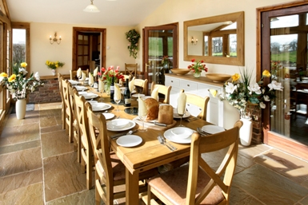

MENU 2

BREAKFAST
- A slice of toast
- A boiled egg
- A bowl of cereal
LUNCH
- Pasta
- A tomato salad
- A sandwich
SNACK
- A packet of crisps
- A pot of strawberry yoghurt
- A bar of chocolate
Dining in –

Use your menus. Student 1 ask student 2 for their meals. Student 2 ask student 1 for their meals.

Student 1

Student 1: What would you like for your breakfast?
Student 2: I’ll have __________________.
Student 1: What would you like for your lunch?
Student 2: I’ll have __________________.
Student 1: What would you like for your snack?
Student 2: I’ll have ___________________.
Student 1: Thank you.

Student 2

Student 2: What would you like for your breakfast?
Student 1: I’ll have __________________.
Student 2: What would you like for your lunch?
Student 1: I’ll have __________________.
Student 2: What would you like for your snack?
Student 1: I’ll have ___________________.
Student 2: Thank you.

Extra work – Talking about what other people like

I like a slice of toast for my breakfast.
She likes a boiled egg for her breakfast.
He likes a bowl of cereal and milk for his breakfast.

Add ‘s’ to the end of the verb for ‘he’ and ‘she’.
Use ‘my’ with ‘I’, ‘her’ with ‘she’ and ‘his’ with he.

likes likes his crisps snack likes her his likes

He _____ a tomato salad for _____ lunch.

He _______ a boiled egg for ____ breakfast.

She _________a bar of chocolate for ____ _____________.

He likes a _______ of juice for _____ drink.
She ______ a packet of ________ for her ______________.

Dining in

A bowl of cereal and milk | A slice of toast
A boiled egg | A sandwich
Pasta | A hot dog
A packet of crisps | A piece of fruit
A pot of strawberry yoghurt | A bar of chocolate
A glass of wine | A glass of orange juice
A cup of tea | A cup of coffee
A jacket potato | A tomato salad

