Section 1 Words (open PowerPoint - Week 2 Words 1)
Name: _______________________________ Date: ______________

Please note: this week’s words are a big jump in vocabulary but are required as part of a college induction process. More stress should be spent on pronunciation and memorisation of the word verbally rather than the literacy aspects of reading and writing. The reading/writing activities this week around the words should focus on sounding out phonically the letters of each word to support the graphophonic approach of later lessons on CVC words. Present one slide at a time, reading for the learners and asking them to echo. Spell out words using phonics and standard letter sounds for Dolch words. Use this activity as a diagnostic, reading one letter at a time, asking them to repeat and write the letters on A4 paper or a board, and to show you, then moving onto the words and pronunciation. Drill the words. After a length of drilling using the PowerPoint, hand out these worksheets and ask them to complete the first column, writing down each word as you say it. Ask learners to compare with a peer and rewrite in the second column. Translate in the third column if possible. You could use Google translate (with prepared translations) or learners’ bilingual dictionaries.

 | First try | Second try | Translate (where possible)
Section 2 Introductions (open PowerPoint - Week 2 Words 1)

(1.) Cut up the pictures and text from the slides. Ask the learners to match and then glue onto the page.

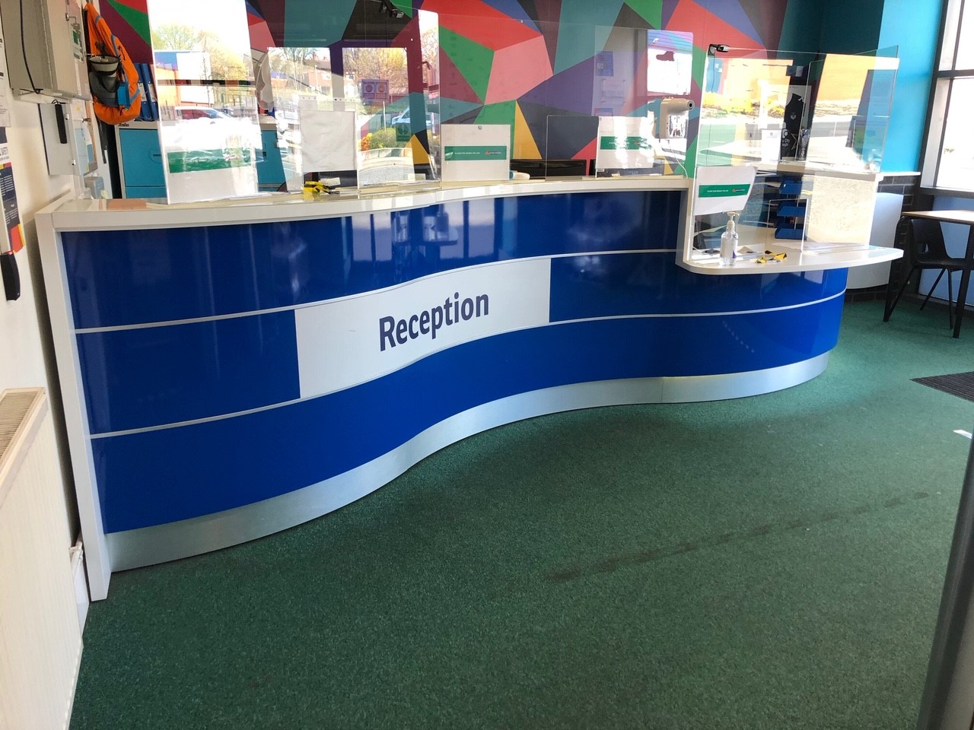 | 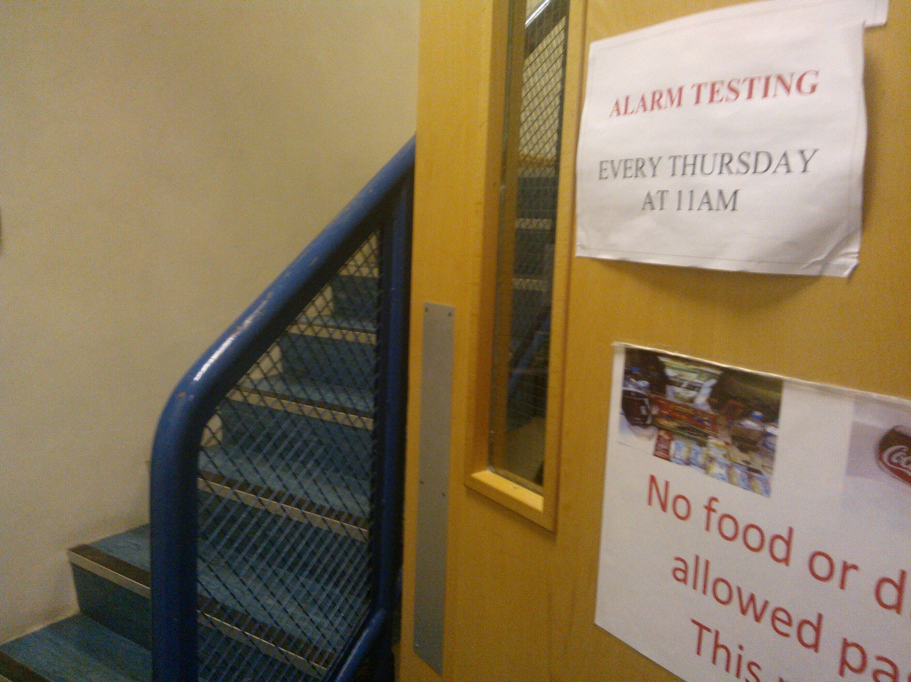
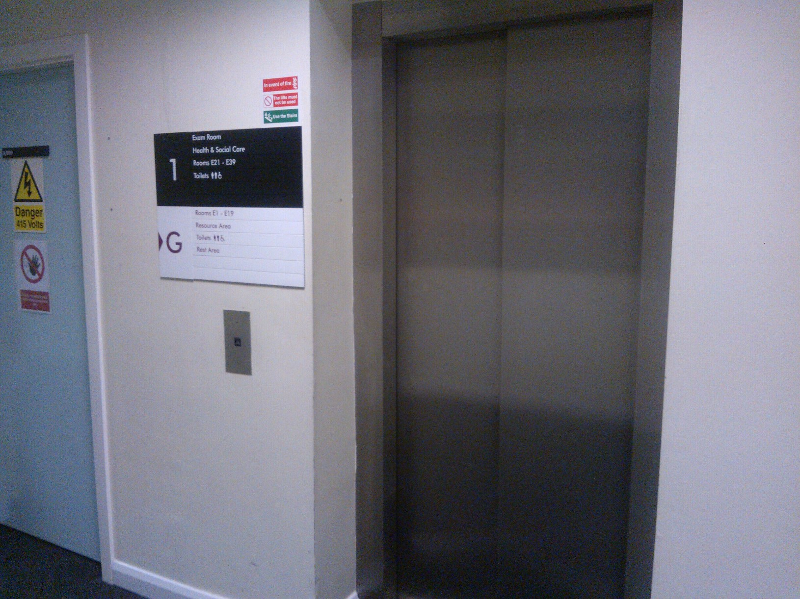 | 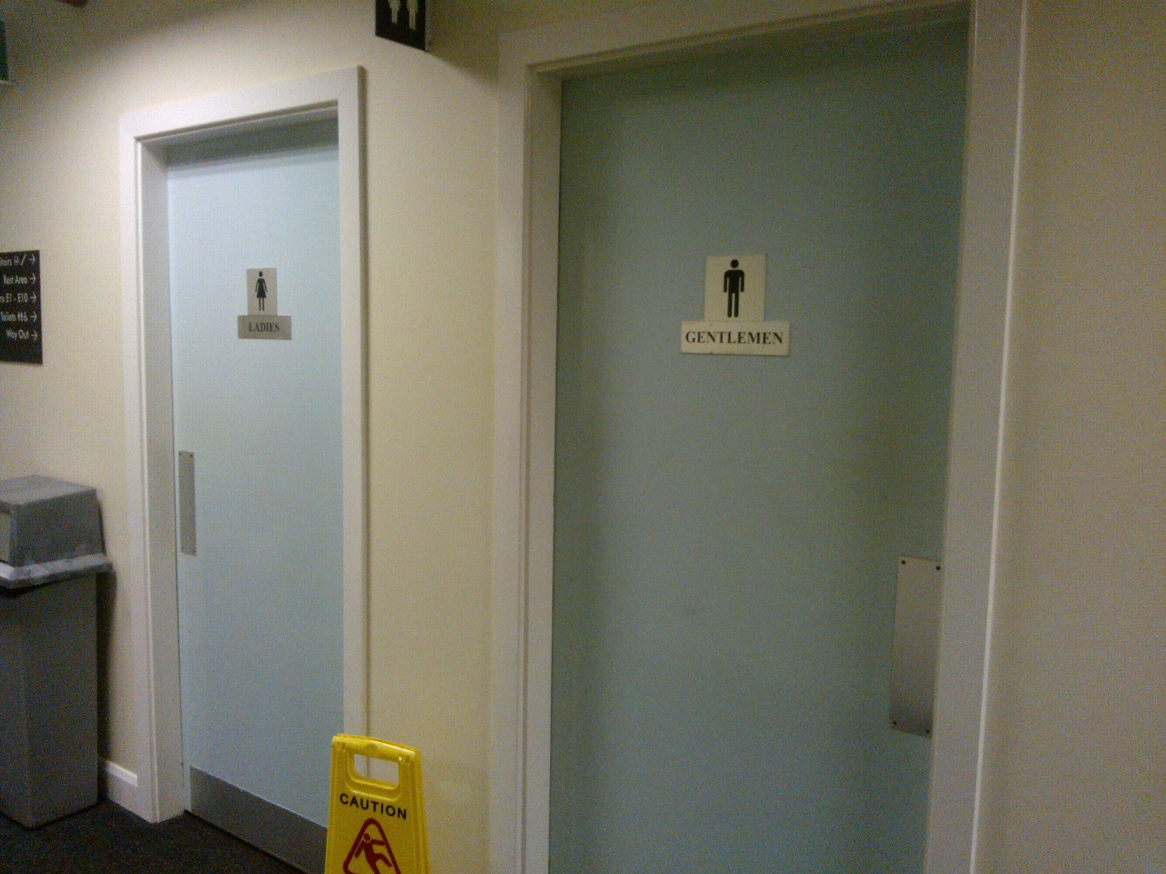
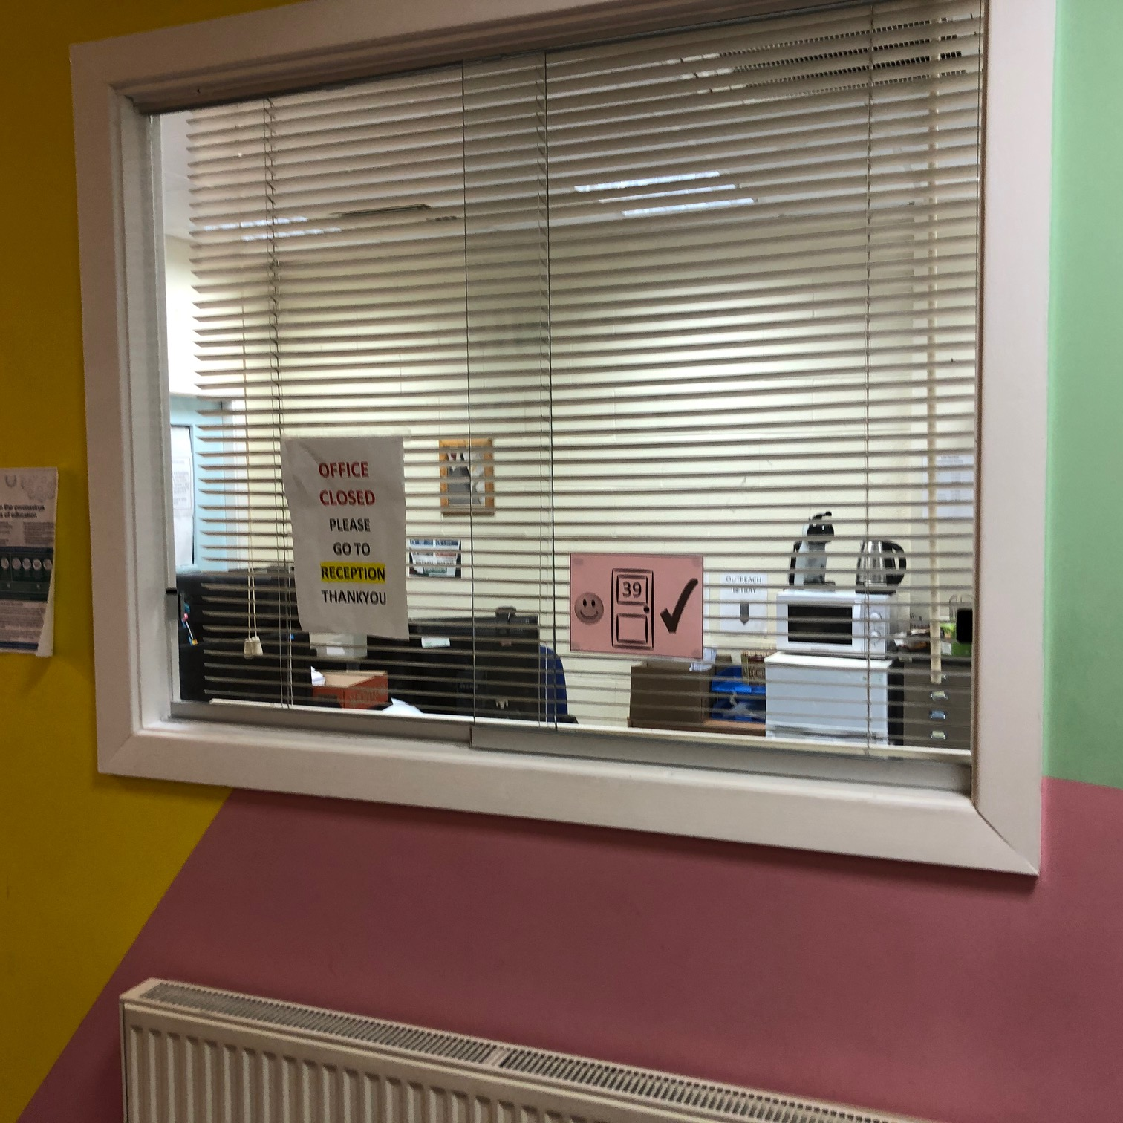 | 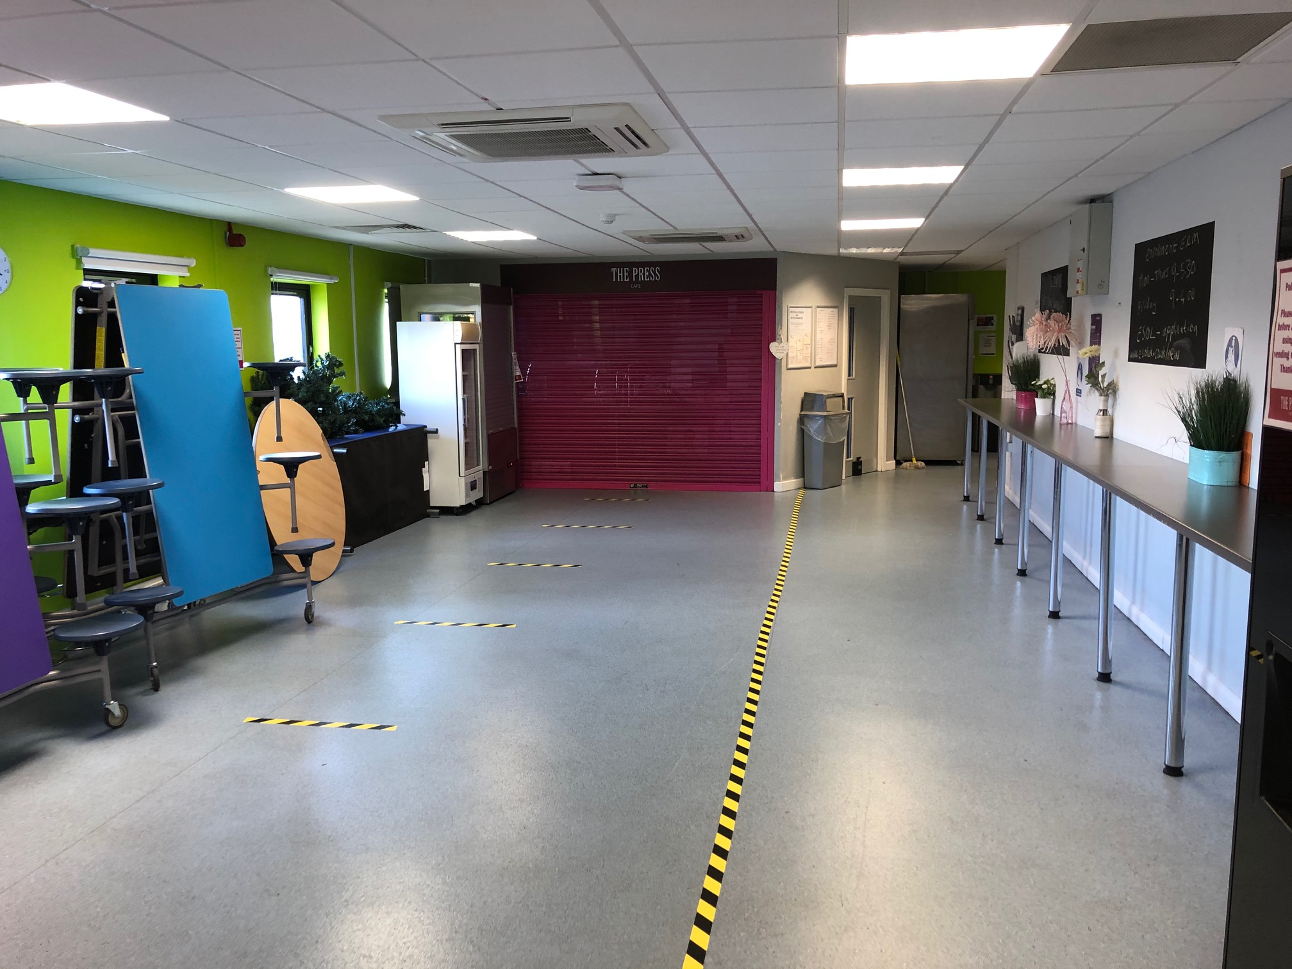
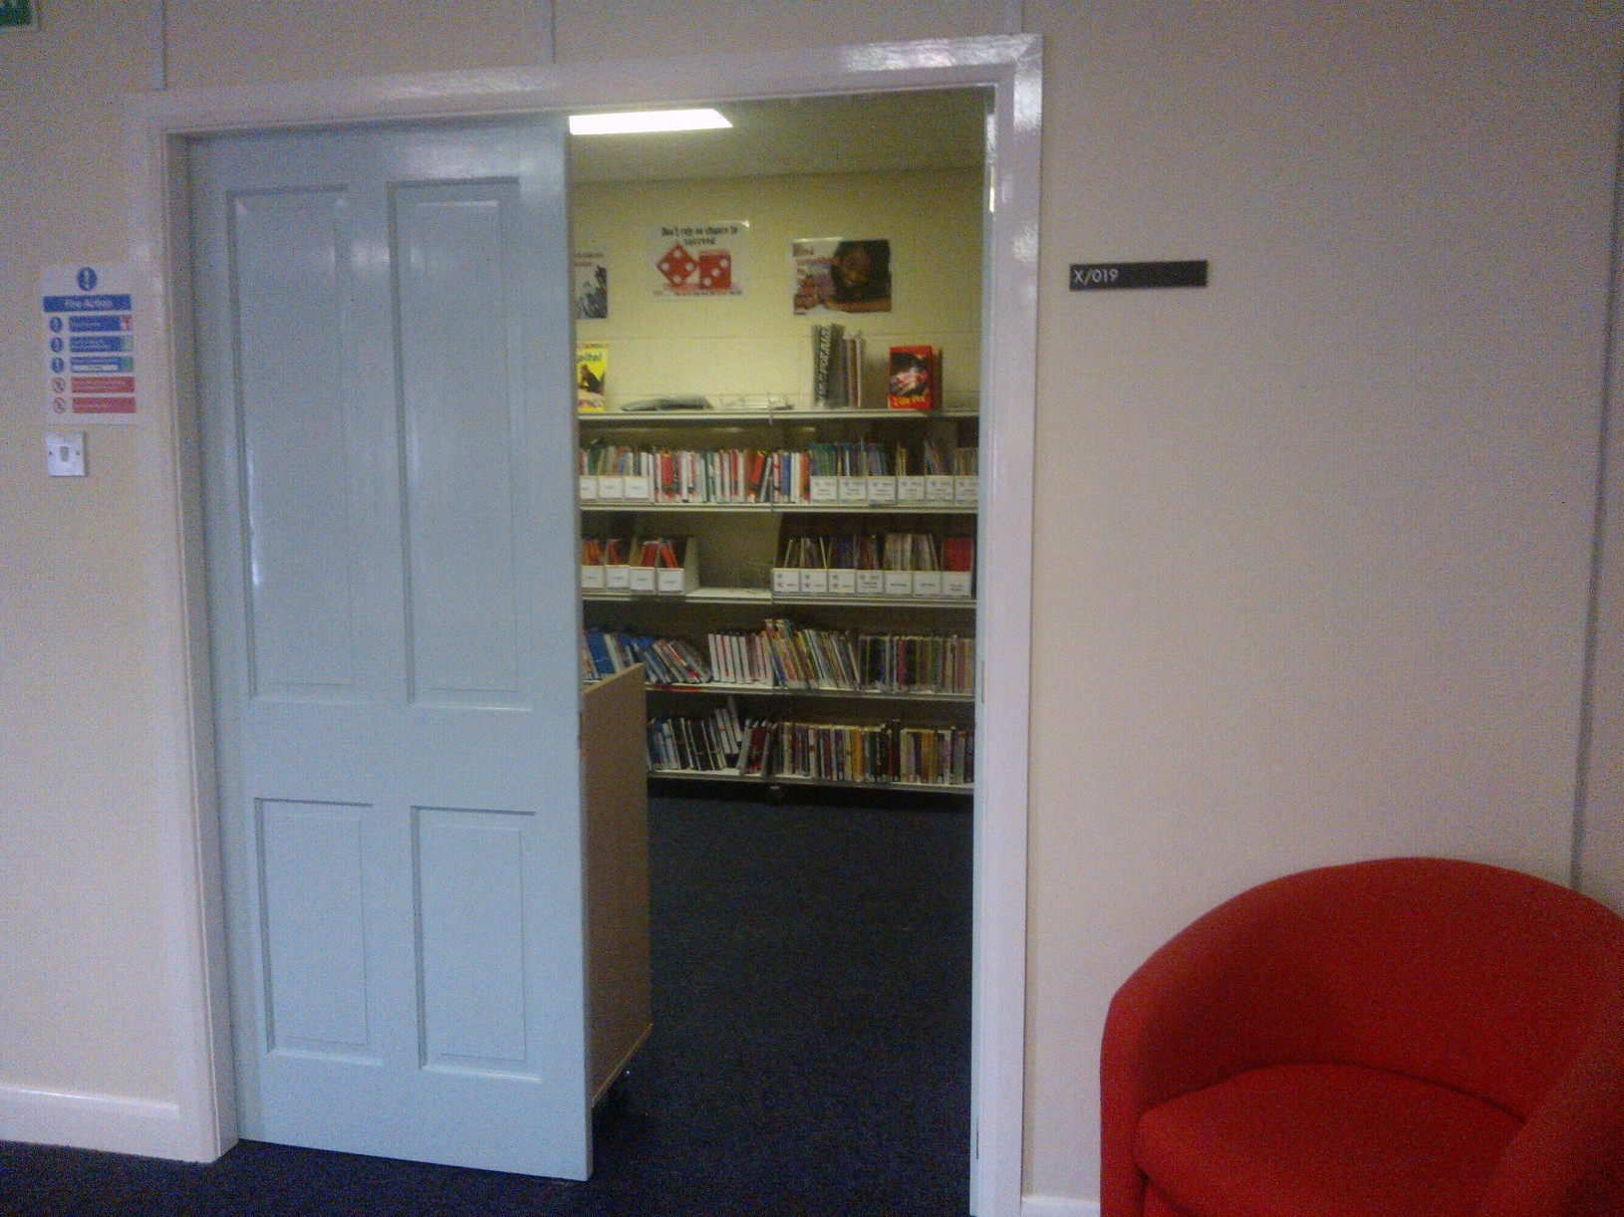

Section 3 Handwriting (Copy words from page 1. Use this web resource to model pen direction.)

1.

2.

3.

4.

5.

6.

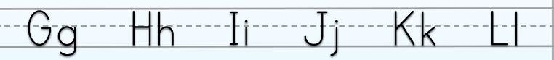

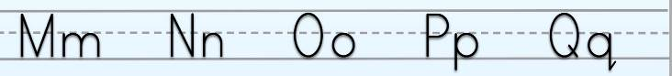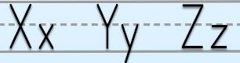
Section 4 find and correct the errors (Open week 2 sentences 1)

Read and write the missing words. Use the map and point with a finger to visualise ‘here’ and ‘there’

is here is there are here

The reception _____ _______________.
The coffee area _____ _______________.
The toilets _____ _______________.
The office _____ _______________.
The library _____ _______________.
The stairs _____ _______________.
The lift _____ _______________.

Section 5 word shapes (lowercase letters)

1 2 3

4 5 6

office library lift

toilets stairs reception

Section 6 word search (capital letters) online click here to create more

P | K | E | S | C | A | P | E | K | O
P | R | E | C | E | P | T | I | O | N
O | G | F | M | F | I | R | E | D | S
Q | W | S | T | A | I | R | S | V | A
V | E | T | O | I | L | E | T | S | G
A | D | M | I | N | T | C | P | K | U
C | O | M | P | U | T | E | R | F | U
Q | C | O | F | F | E | E | B | L | L
C | D | A | O | F | F | I | C | E | N
N | P | D | B | L | I | F | T | V | I

RECEPTION COFFEE OFFICE FIRE
TOILETS STAIRS COMPUTER LIFT

Answer Key:
_ | _ | E | S | C | A | P | E | _ | _
_ | R | E | C | E | P | T | I | O | N
_ | _ | _ | _ | F | I | R | E | _ | _
_ | _ | S | T | A | I | R | S | _ | _
_ | _ | T | O | I | L | E | T | S | _
A | D | M | I | N | _ | _ | _ | _ | _
C | O | M | P | U | T | E | R | _ | _
_ | C | O | F | F | E | E | _ | _ | _
_ | _ | _ | O | F | F | I | C | E | _
_ | _ | _ | _ | L | I | F | T | _ | _

Section 7Spelling activity (read out words from page 1.)

Use LOOK SAY COVER WRITE CHECK

SPELLINGS

 | word | syllables | 1st try | 2nd try | 3rd try
1
2
3
4
5
6
7
8
9.



