2010
Kish Carey, Stephen Woulds, Barbara Greenwood, Rachael Gooch
Leeds City College
So you want to work in childcare?
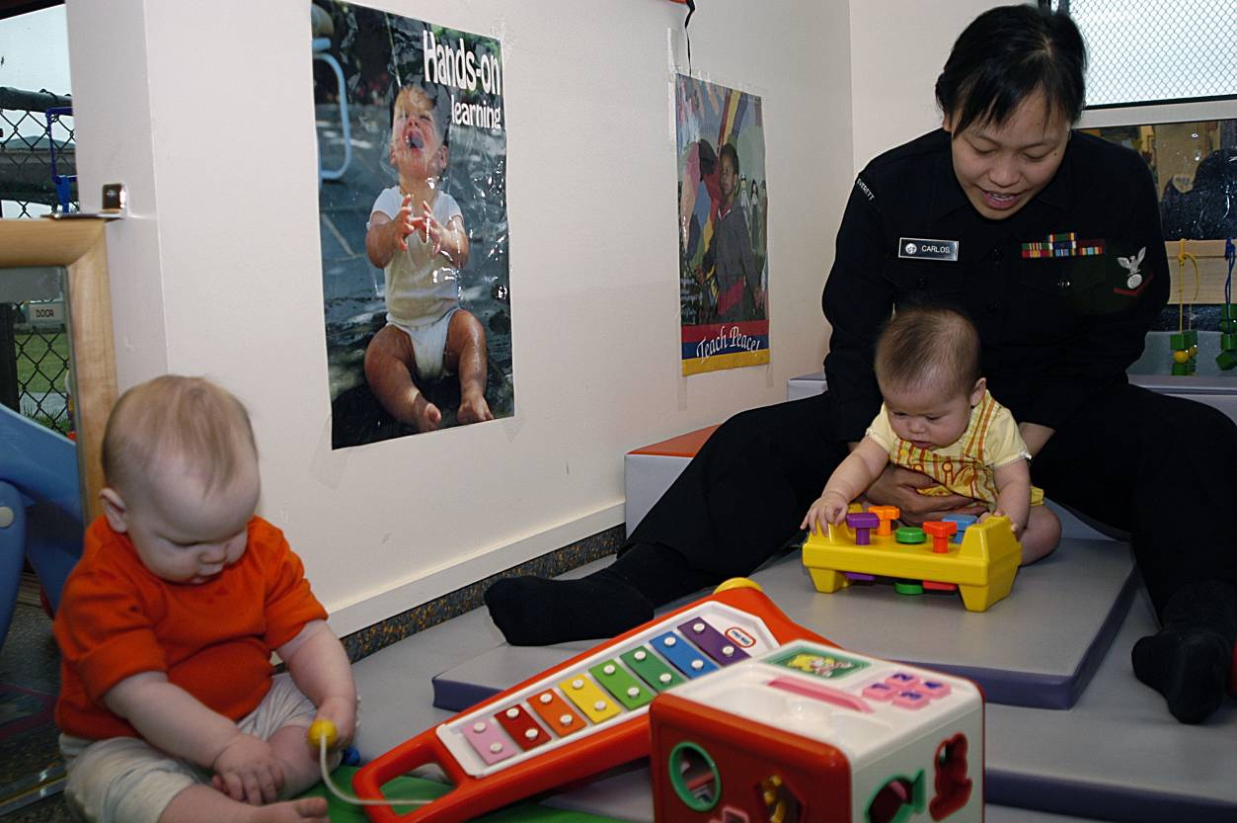


Table of Contents
ESOL childcare website 3
Session 1 4
Session 2 18
Session 3 19
Session 4 40
Session 5 54
Post-Course Questionnaire Evaluation 69

ESOL childcare website

All the activities in this workbook can also be accessed online at www.esolchildcare.com

Look at the image of the webpage below and read the explanations, 1 to 8:

- google translate the webpage into a different language
- text + / - make the writing on the webpage larger or smaller
- colour change the background colour of the webpage
- dictionary type any words you don’t know to use an online dictionary with audio
- > click the writing to open an activity window
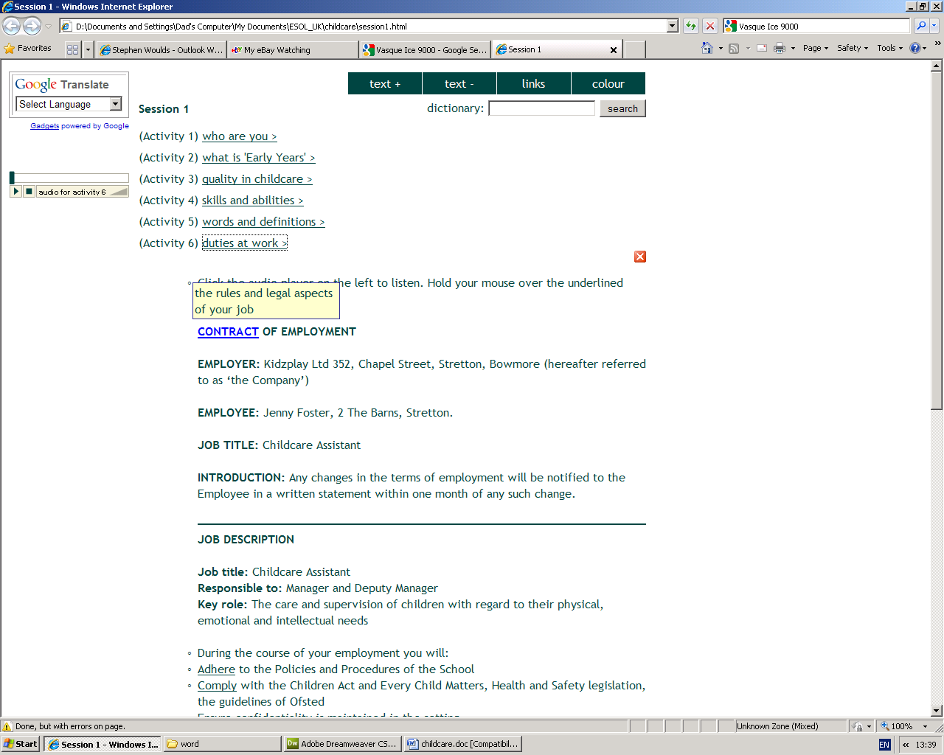
- audio player listen to someone reading when there is a large amount of text
- click the X to close an activity window
- CONTRACT hold your mouse over any underlined words to get a definition

1
2
3
4
5
6
7
8

Session 1

Outcomes for Session 1:
✓
- List the main duties of a Childcare Assistant. □
- Identify the skills and qualities required to work in childcare. □
- Identify what is meant by a ‘fit person’ in childcare. □

End of Class - please tick the outcomes you think have been met for today’s session.

Evaluation: strongly agree undecided disagree strongly agree disagree
I am happy with my contribution: □ □ □ □ □
The activities were appropriate: □ □ □ □ □
The materials were too difficult: □ □ □ □ □
I have learned something new: □ □ □ □ □
The tutor was supportive: □ □ □ □ □

Reflection: If you disagreed with any of the statements above, feel free to record here why you disagreed, how you might change them and consider discussing these with the tutor.

----------------------------------------------------------------------------------------------------------------------------------------------------------------------------------------------------------------------------------------------------------------------------------------------------------------------------------------------------------------------------------------------------------------------------------------------------------------------------------------------------------------------------------------------------------------------------------------------------------------------------------------------------------------------------------------------------------------------------------------------------------------------------------------------------------------------------------------------------------------------------------------------------------------------------------------------------------------------------------------------------------------

For the online activities for this session please go to www.esolchildcare.com/session1.html
Activity 1: who are you
Go to www.esolchildcare.com and click Session1, Activity 1. Send an email to your tutor answering the questions.

Write down your name and add interesting facts about yourself.

Can you describe yourself? What are your interests? What do you like? What don't you like? Do you have any hobbies? What are your skills and qualities?

Let’s think about skills and qualities first:

- Qualities are good things about that you.
  - Examples: Punctual Reliable Confident Tidy
Happy Calm Patient

- Skills are what you can do well.
  - Examples: Able to use a computer / good at cooking / sewing / art / writing /communicating with different people.

Activity 2:
Go to www.esolchildcare.com and click Session1, Activity 2.
There are lots of different types of childcare settings available. Can you fill in the gaps and work out what they are?

 |  | description | childcare type
 | These are professional day carers who look after children in their own homes. |  |  |  | ch
 | These offer care to children in their local community, either as a morning or afternoon session or as extended sessions including lunch. They are often run by voluntary management committees. They care for children aged from three to five years [some groups may accept younger children] and are usually open during term time. |  |  |  | pre-
 | These provide full or part time education and care for the length of the adult working day i.e. 8am to 6pm. Many accept children from their second birthday but some are also registered to care for babies. |  |  |  | nu
 | These provide support to families with children under the age of 8 years (who may be undergoing a period of crisis) through helping to develop parenting abilities and coping skills. Children and adults attend family centres together. |  |  |  | c__ __ __ __ __ __n’s centres and
 | These provide occasional care for children under the age of 8. They care for children for short while whilst parents may be engaged in other activities like shopping or sport. |  |  |  | c
 | These are employed by parents to care for their children at home. |  |  |  | na
 | These are usually between 17 and 27 years of age who come to the UK to study English. They live with the family and provide childcare and light housework. |  |  |  | a
 | These cater for children before and after school and are usually on the school premises. |  |  |  | b
 | These offer care for children during the school holidays usually from 9am to 5:30pm or 6pm each weekday. Most settings accept children from 4-11 years and offer care for the Half Term weeks, Easter and the Summer Holidays. |  |  |  | h

pre-schools and playgroups au pairs holiday play schemes nurseries
breakfast and after school clubs crèches childminders nannies
children’s centre and family centres
Activity 3: quality in childcare
Go to www.esolchildcare.com and click Session1, Activity 3 to watch the video.
Watch the video about childcare. Make notes to answer these questions.
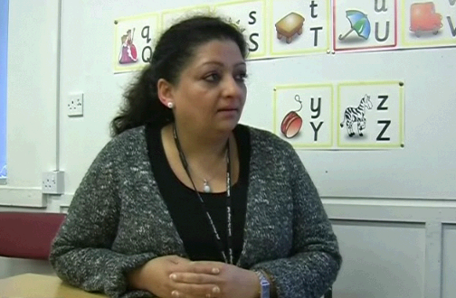

- What skills should a Childcare Assistant have?
- What qualities should a Childcare Assistant have?

Skills:
Qualities:
Activity 4: skills and qualities
Go to www.esolchildcare.com and click Session1, Activity 4.
“What does a manager look for?”

We asked 100 managers what they were looking for when employing a Childcare Assistant.

What do you think they said? Sort the statements into the right order, from 1 to 15. Number 1 is the most important and number 15 the least important. The first one and last one have been done for you. The rest are mixed up. Have we missed any? Add more.

1 | Reliable, punctual and a hard worker in the setting
 | An awareness of the EYFS curriculum
 | Able to plan targets for self and others
 | Well organised
 | GCSE standard of Mathematics/Numeracy
 | Good communicator with adults and children
 | Ability to manage behaviour positively
 | A relevant early years qualification
 | Experience of working with children
 | Ability to use initiative
 | Working as part of a team in a professional and not ‘mumsy’ manner
 | Suitable dress/appearance for the job
 | GCSE standard of English/Literacy
 | Awareness of child development
15 | Ability to display work
Activity 5: Vocabulary
Go to www.esolchildcare.com and click Session1, Activity 5.

Look at these definitions and examples. Write the missing words in the boxes.

 | definition |  |  | example
 | About your body rather than your mind. |  |  | The child's ____________________________needs are to drink water and eat food.
 | About your mind rather than your body. |  |  | The child gets very ________________________ when her mother leaves.
 | The ability to understand, learn and think. |  |  | The boy's ____________________________ development was advanced for his age.
 | To stick formally to something. |  |  | They all had to ______________________________ to the rules of the organisation.
 | To obey and order or request. |  |  | He had to ____________________________ with his mother's wishes.
 | Secret, not to be shown or talked about to other people. |  |  | The information on the child's health was _________________________________.
 | To work closely with a person or group etc and give he/her/them regular information about what you are doing. |  |  | The teacher had to __________________________ with the parents about the child's progress.
 | A particular way of doing something. |  |  | New ___________________________ in childcare are developing all the time.
 | The quality of being able to stay calm and not get angry. |  |  | The children could be very naughty but the mother had a lot of ____________________________.
 | Discussions at which people try to decide or agree on something. |  |  | The group didn’t all agree but with __________________________________ they all felt happy about the outcome.

intellectual adhere comply confidential liaise

techniques patience negotiation physical emotional
Activity 6: Duties at work
Go to www.esolchildcare.com and click Session1, Activity 6.

As a childcare assistant you work as part of a team. It is important for you to know:

- what your duties are
- what the duties of other members of the team are
- who you should report to

Jenny Foster has just started a job as a Childcare Assistant. She is not familiar with her duties yet.

Read the Job description to find out what Jenny should do. Make notes here.
What are my duties at work?
Go to www.esolchildcare.com and click Session1, Activity 6 to read and listen.

The contract of employment sets out your rights and responsibilities at work. You should:
Read the contract in detail before you sign it.
Find out about anything you do not understand.

The job description lists your responsibilities in your job.
All employees are given a written job description which they must read and understand before the contract is signed.

If you accept the contract you agree to do all the things on the job description.

Certain words tell you exactly what you must do.
CONTRACT OF EMPLOYMENT

EMPLOYER: Kidzplay Ltd, 352 Chapel Street, Stretton, Bowmore (hereafter referred to as ‘the Company’)

EMPLOYEE: Jenny Foster, 2 The Barns, Stretton.

JOB TITLE: Childcare Assistant

INTRODUCTION:
Any changes in the terms of employment will be notified to the Employee in a written statement within one month of any such change.
JOB DESCRIPTION

Job title: Childcare Assistant
Responsible to: Manager and Deputy Manager
Key role: The care and supervision of children with regard to their physical, emotional and intellectual needs

During the course of your employment you will:

- Adhere to the Policies and Procedures of the School.
- Comply with the Children Act and Every Child Matters, Health and Safety legislation, the guidelines of Ofsted.
- Ensure confidentiality is maintained in the setting.
- Work as part of a team.
- Work in close association with the Leader on the planning and preparation of activities.
- Liaise with parents.
- Ensure effective communication within the setting.
- Offer all children equal opportunities in accordance with their religious persuasion, racial origins, gender, disabilities, cultural or linguistic background.
- Manage children’s behaviour in a positive way.
- Cater for the social needs of the children.
- Prepare, care for, clean and maintain the learning environment and equipment.
- Provide a good role-model for children.
- Keep accident, incident and risk assessment records.
- Attend staff meetings.
- Any other relevant duties appropriate to the post as directed by the leader/manager.
Activity 7: job role
Go to www.esolchildcare.com and click Session1, Activity 7.

Jenny’s job role; what should Jenny do in each case?
The teacher has asked me to mop up some spilled paint. Should I do it?
- Yes / No

There’s a parents’ meeting on Thursday. Do I have to be there?
- Yes / No

Harry grazed his knee in the playground today. Do I have to fill in the accident record?
- Yes / No

Is it my job to decide what equipment I put out and tidy away?
- Yes / No

Two children need help to go to the toilet. Do I have to help them?
- Yes / No

Molly has been really naughty and I'm very tempted to give her a smack. Should I do?
6 Yes / No

Tom has been using swearing and using bad language all day, I'm going to have a word with his mum and tell her it's not acceptable. Should I?
7 Yes / No

I've got a little boy who doesn't speak much English and can't join in with the songs, so I've put him in the quiet corner to look at some books. Is that ok?
8 Yes / No

9 Yes / No
I don't like working with Mrs Brown, she keeps going outside for a cigarette. Should I speak to the manager?

10 Yes / No
Billy came in today with a nasty bruise on his arm. Do I have to record it somewhere?

Activity 8: Who is a ‘Fit person’?
Go to www.esolchildcare.com and click Session1, Activity 8.
The law says you must be a “Fit Person” to work with children and young people. All adults working in Early Years settings are required by law to have a CRB (Criminal Records Bureau) check to ensure they are fit to work with children.

In addition to the legal requirement, think about the qualities and skills that a fit person might need to become a teaching assistant.

Personal qualities | Communication skills
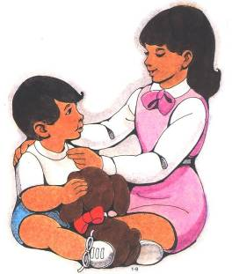 | 
A Child Care Worker must be patient, tolerant, helpful and friendly at all times with all children. | A Child Care Worker must be able to communicate with many people including parents and people working in other organisations.
Knowledge of children | Personal skills
 | 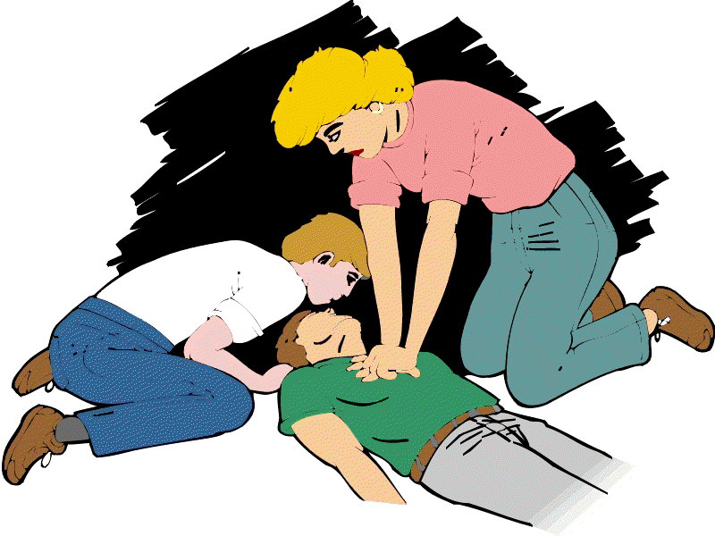
A Child Care Worker must have an understanding of how children play, grow and develop. | A Child Care Worker must have good skills in other areas such as preparing food and first aid techniques.

Identify the skills and qualities in the boxes below. The first three have been done for you.

Tick which belongs in each category |  | Personal qualities | Communication skills | Knowledge of children | Personal skills
 | confident about communicating with children |  | ✓
 | energy and stamina | ✓
 | how children develop |  |  | ✓
 | creativity and imagination
 | sense of humour
 | how to organise children’s learning
 | patience
 | negotiation skills
 | respect for the different beliefs and values of other people
 | basic first aid
 | confident about communicating with other professionals
 | able to work as part of a team
 | good listening skills
 | how to assess children’s learning
 | awareness of non-verbal communication
 | good writing skills to write reports
 | how children learn
 | what children learn at different stages
 | empathy
 | good observational skills
 | lifting and handling techniques
 | confident about communicating with parents
 | calm and caring attitude
 | basic knowledge of technology

Activity 9: Choose ten words from today, or use those below, and practise spelling them. Look at the glossary on the next page as well.
Go to www.esolchildcare.com and click Session1, Activity 9 for the spelling test.

Use LOOK SAY COVER WRITE CHECK

 | word | syllables | 1st try | 2nd try | 3rd try | 4th try
1 | negotiate | ne go ti ate  1 2 3 4
2 | confidential
3 | liaise
4 | emotional
5 | physical
6 | intellectual
7 | patience
8 | incident
9 | punctual
10 | positive

Glossary for Session 1
 | word | definition | example
 | Physical | About your body rather than your mind. | The child’s physical needs are to eat and drink water.
 | Emotional | About your mind rather than your body. | She always gets very emotional when her mother leaves.
 | Intellectual | The ability to understand, learn and think. | The boy’s intellectual development was advanced for his age.
 | Adhere | To stick formally to something. | They all had to adhere to the rules of the organisation.
 | Comply | To obey and order or request. | He had to comply with his mother’s wishes.
 | Confidentiality | Secret, not to be shown or talked about to other people. | The information the child’s health was confidential.
 | Liaise | To work closely with a person or group etc and give he/her/them regular information about what you are doing. | The teacher liaised with the parents regularly about the child’s progress.
 | Techniques | A particular way of doing something. | New techniques in childcare are developing all the time.
 | Patience | The quality of being able to stay calm and not get angry. | The children could be very naughty but the mother had a lot of patience.
 | Toddler | A young child who has just learnt to walk. | The boy could just walk a few unsteady steps - he was now a toddler.
 | Punctual | Doing something or being somewhere at the right time. Not late. | The new workers were very punctual, they were never late getting to work.
 | Crèche | A place where small children are looked after while their parents are at work, shopping etc. | The mother was going back to work and had found a good crèche to send her child to.
 | Positively | Shows you are thinking about the good things and not the bad. | The child responded positively to encouragement.
 | Relevant | Connected to what is happening or being talked about. | The details the mother gave were very relevant to the carer.
 | ‘Mumsy’ | Caring but not very professional. | She cared very much about the children at work but she was not very professional, she was a bit ‘mumsy’
 | Stamina | The ability to do something that requires a lot of physical or mental effort for a long time. | You need a lot of stamina to run long distances.
 | Negotiation | Discussions at which people try to decide or agree on something. | The group didn’t all agree but with negotiation they all felt happy about the outcome.
 | Empathy | The ability to imagine how another person is feeling. | She had never experienced the problem but she could empathise (have empathy for) with the mother whose child was ill.
 | Calm | Not excited, worried or angry. | The child’s behaviour was very bad but the mother stayed calm.
 | Incident | Something that happens (especially something unusual or unpleasant). | One child bit another, it was an unpleasant incident.
 | Grazed | To break the surface of your skin by rubbing it against something rough. | The child fell over and grazed his knee.
 | Initiative | The ability to see what is necessary or needs to be done without being asked or told. | The girl was a good worker and she always used her initiative if she had to work on her own.
 | Close association | Work closely together and inform each other what you are doing. | They all worked in close association on the project.
 | Religious persuasion | What religion a person believes in. | He is a Christian – that is his religious persuasion.
 | Non-verbal | Communication without words. The signals and information passed on using body movements or gestures (body language such as a wave or a smile). | We didn’t speak but I knew what he meant by his non-verbal communication.
 | Role model | Somebody whose behaviour is good and is a good example to other people. | She was punctual, professional and caring. She was a good role model for the younger staff.
 | Risk assessment | When you think about what incident or accident could happen and do whatever you can to stop or reduce the chances of it happening. | There was a chance the children could run into the road next to the playground, so the gate was locked. That was risk assessment.
 | EYFS | Early Years Foundation Stage | The Early Years Foundation Stage sets out the legal requirements for the care of young children (from Birth to Five) in relation to Learning, Development and Welfare.

Session 2

Outcomes for Session 2:
✓
- □
- □
- □

End of Class - please tick the outcomes you think have been met for today’s session.

Evaluation: strongly agree undecided disagree strongly agree disagree
I am happy with my contribution: □ □ □ □ □
The activities were appropriate: □ □ □ □ □
The materials were too difficult: □ □ □ □ □
I have learned something new: □ □ □ □ □
The tutor was supportive: □ □ □ □ □

Reflection: If you disagreed with any of the statements above, feel free to record here why you disagreed, how you might change them and consider discussing these with the tutor.

------------------------------------------------------------------------------------------------------------------------------------------------------------------------------------------------------------------------------------------------------------------------------------------------------------------------------------------------------------------------------------------------------------------------------------------------------------------------------------------------------------------------------------------------------------------------------------------------------------------------------------------------------------------------------------------------------------------------------------------------------------------------------------------------------------------------------------------------------------------------------------------------------------------------------------------------------------------------------------------------------------------------------------------------------------------------------------------------------------------------------------------

For the online activities for this session please go to www.esolchildcare.com/session2.html

Session 3

Outcomes for Session 3:
✓
- Identify the six areas of learning which form part of the Early Years Foundations Stage (EYFS). □
- Explain the role of play in supporting children's learning. □
- Describe how to provide activities & experiences which support children's learning. □

End of Class - please tick the outcomes you think have been met for today’s session.

Evaluation: strongly agree undecided disagree strongly agree disagree
I am happy with my contribution: □ □ □ □ □
The activities were appropriate: □ □ □ □ □
The materials were too difficult: □ □ □ □ □
I have learned something new: □ □ □ □ □
The tutor was supportive: □ □ □ □ □

Reflection: If you disagreed with any of the statements above, feel free to record here why you disagreed, how you might change them and consider discussing these with the tutor.

------------------------------------------------------------------------------------------------------------------------------------------------------------------------------------------------------------------------------------------------------------------------------------------------------------------------------------------------------------------------------------------------------------------------------------------------------------------------------------------------------------------------------------------------------------------------------------------------------------------------------------------------------------------------------------------------------------------------------------------------------------------------------------------------------------------------------------------------------------------------------------------------------------------------------------------------------------------------------------------------------------------------------------------------------------------------------------------------------------------------------------------

For the online activities for this session please go to www.esolchildcare.com/session3.html
Activity 1: Early Years Foundation Stage (EYFS)
Go to www.esolchildcare.com and click Session3, Activity 1.

If you visit an Early Years setting it may look a little chaotic, with lots of toys and activities taking place. But do you know that all of these activities are organised into six areas of learning that form part of the Early Years Foundation Stage (EYFS)? This is the curriculum that children aged from Birth to Five follow in the UK. It is a structure of learning, development and care for young children.

All maintained and independent schools must use the EYFS. Other organisations caring for children from birth to five must also use the EYFS, including:

- registered early years providers in the private sector
- registered early years providers in the voluntary sector
- registered early years providers in the independent sector

The EYFS doesn’t apply to: mother and toddler groups, nannies and short-term, occasional care (e.g. crèches).

What does the Early Years Foundation Stage (EYFS) do?

The EYFS ensures that:

- children learn through play
- that providers work closely with parents and keep them up to date on the child’s progress
- the welfare, learning and development of children with different backgrounds and level of ability, including those with special educational needs and disabilities are met

Later we will look at the six areas of learning that form part of the EYFS curriculum. Answer the questions below.

1.) What does EYFS mean?

2.) How many areas are there in the EYFS?

3.) What single word is used to describe a structure of learning?

4.) Which two types of schools must use the EYFS?

5.) Name three types of childcare that do not have to teach the EYFS curriculum.
Activity 2: What is a curriculum?
Go to www.esolchildcare.com and click Session3, Activity 2.

In the UK we have a National Curriculum which sets out the stages and subjects your child will be taught during their time at school. It ensures that the teaching that takes place is balanced and consistent throughout all UK schools.

The National Curriculum is organised into blocks of years called Key Stages (KS). There are four key stages as well as the EYFS.

Look at the table below which shows the different curriculum for each year. Write the correct age for each key stage.

Age | Year | Key Stage
 | Pre-school | EYFS
 | Reception | EYFS
 | Year 1 | KS1
 | Year 2 | KS1
 | Year 3 | KS2
 | Year 4 | KS2
 | Year 5 | KS2
 | Year 6 | KS3
 | Year 7 | KS3
 | Year 8 | KS3
 | Year 9 | KS4
 | Year 10 | KS4
 | Year 11 | KS4

12-13 7-8 9-10 11-12 8-9
6-7 13-14 3-4 14-15
4-5 10-11 5-6 15-16

Activity 3: the power of play
Go to www.esolchildcare.com and click Session3, Activity 3 to watch the video.

Watch the video about the power of play. Answer the questions below or email your answers to your tutor.

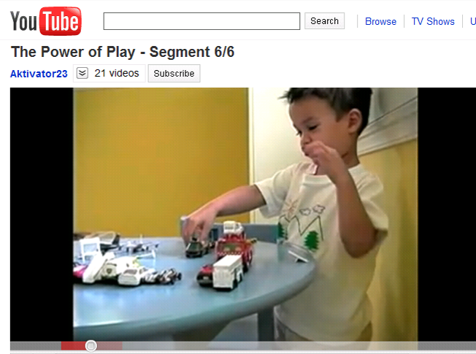
http://www.youtube.com/watch?v=Qfxz28jt80I
- Can you have play without toys?
- Why are toys important to a child’s development? What do they learn using toys?
- What advice is given to parents when buying toys?
- What are some of the best toys and where can they be found?
- What is meant by the “child projects on to the toy something else”?
- What is equally important as toys and why?
- What are parents told to remember when playing with their children?

The Power of Play videos
1 of 6: http://www.youtube.com/watch?v=XXyYQccegEk
2 of 6: http://www.youtube.com/watch?v=mhhV4S-_gbE
3 of 6: http://www.youtube.com/watch?v=MNrsyTUIg1o
4 of 6: http://www.youtube.com/watch?v=CNKXByseRtM
5 of 6: http://www.youtube.com/watch?v=rmAudvS7r8o
6 of 6: http://www.youtube.com/watch?v=Qfxz28jt80I

Activity 4: what is play
Go to www.esolchildcare.com and click Session3, Activity 4.

The Early Years Foundation Stage curriculum promotes learning through play.

In the box below list as many words or phrases that you can think of to describe play. Think about the video you watched at activity 3. Look at the pictures below to help you.

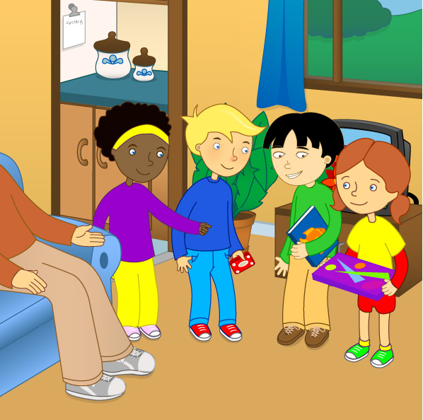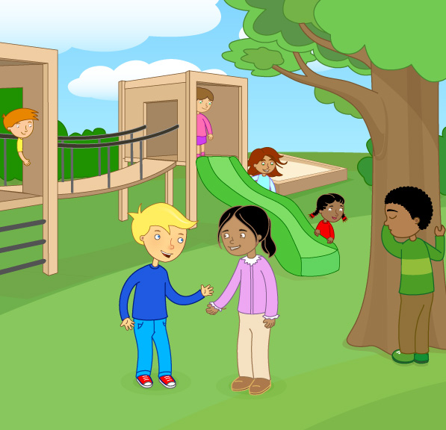

Play is:

being together having fun

Look at the tutor appendices for possible answers.
Activity 5: the value of play
Go to www.esolchildcare.com and click Session3, Activity 5 to listen to the audio.

1.) Read carefully and look up any difficult words. Then try the gapfill on the next page.

Although there are wide cultural variations in how children play, it is an essential part of growing up. All children develop and learn through play, including children with severe disabilities. Through play children learn to explore their world, they develop new skills, share experiences and learn how to deal with feelings.

Children with access to a wide range of well-selected toys and activities are more likely to be challenged and stimulated. Playful children are happier, more co-operative and more popular with their friends than those who play less.

Children also play for longer when a wide variety of toys are available. It is not necessarily the most expensive toys that provide the greatest stimulation and enjoyment. Often, it is better to have four or five different toys than one very expensive toy.

Children differ a lot in their rate of growth and development so toys should match children's changing needs and ability levels. Toys should be chosen that are fun for children to play with. To be fun they should match the child's maturity and challenge his or her skills. Children should not be forced to play or pushed into playing games that may be too difficult for them, they should be able to choose what they would like to play with.

For play to be of benefit, children should feel secure and comfortable in their surroundings. They should be able to choose what they play with. Your role will be to provide opportunities which support and extend children’s play.

2.) Write the missing words in the boxes.

explore experiences develop cultural stimulated
essential stimulation variety expensive

Although there are wide ________________________ variations in how children play, it is an ________________________ part of growing up. All children and learn through play, including children with severe disabilities. Through play children learn to ________________________ their world, they develop new skills, share ________________________ and learn how to deal with feelings.

Children with access to a wide range of well-selected toys and activities are more likely to be challenged and ________________________. Playful children are happier, more co-operative and more popular with their friends than those who play less.

Children also play for longer when a wide ________________________ of toys are available. It is not necessarily the most ________________________ toys that provide the greatest ________________________ and enjoyment. Often, it is better to have four or five different toys than one very expensive toy.

3.) Write the missing words in the boxes.

forced maturity rate challenge ability benefit
differ comfortable difficult choose opportunities

Children ________________________ a lot in their ________________________ of growth and development so toys should match children's changing needs and ________________________ levels. Toys should be chosen that are fun for children to play with. To be fun they should match the child's ________________________ and ________________________ his or her skills. Children should not be to play or pushed into playing games that may be too ________________________ for them, they should be able to choose what they would like to play with.

For play to be of ________________________, children should feel secure and ________________________ in their surroundings. They should be able to what they play with. Your role will be to provide ________________________ which support and extend children’s play.

Activity 6: the seven types of play
Go to www.esolchildcare.com and click Session3, Activity 6 to watch the video.

- Children play in different ways and these are closely linked to their development.

- Watch the video then look at the different stages shown below. Can you think of any examples of this type of play?

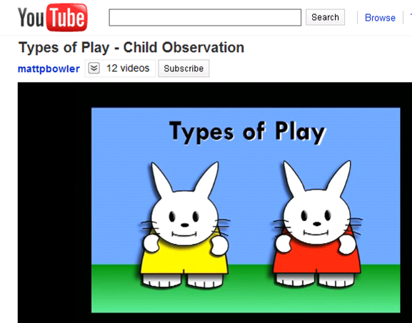
http://www.youtube.com/watch?v=CDpJwvXMX48


1. Exploratory play
Young babies will observe their surroundings. They may reach out and grasp fingers or objects.

An example of this would be.......................................................................................................
....................................................................................................................................................

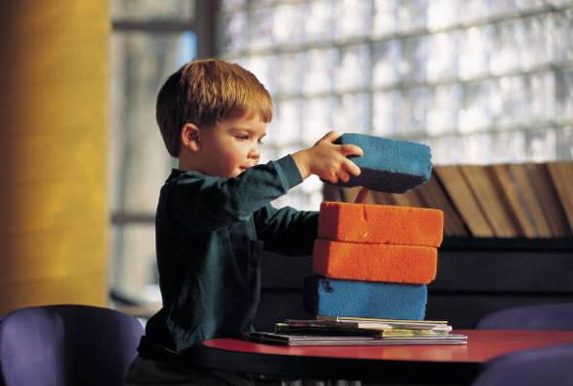
2. Solitary play (Up to 15 months)
Babies or children will play alone.

An example of this would be.......................................................................................................
.....................................................................................................................................................
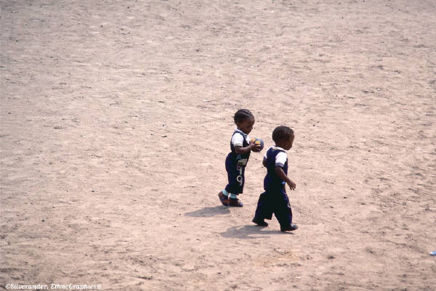
3. Parallel play (2 years)
Children play side by side or separately with little interaction.

An example of this would be................................................................................................................................................
....................................................................................................................................................
4. Association play (2 - 2½ years)
Children begin to interact and may be involved in the same activity. Play can remain solitary.



An example of this would be...............................................................................................................................................
....................................................................................................................................................

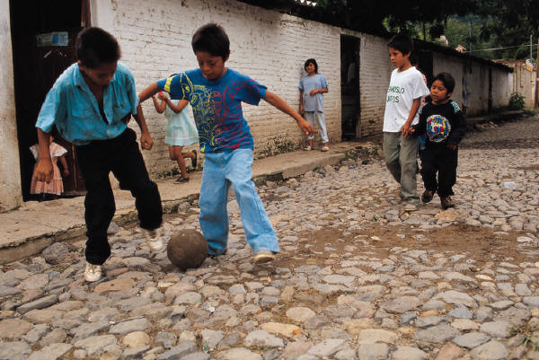
5. Turn taking /sharing (2 3/4 – 3 years)
Playing becomes more complex and simpler rules are understood
An example of this would be...............................................................................................................................................
....................................................................................................................................................

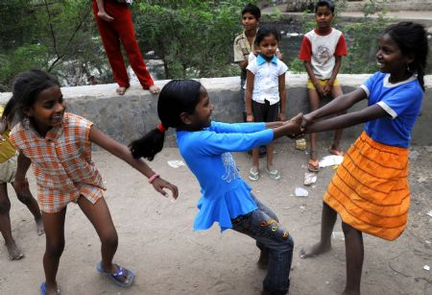
7. Onlooker play
A child will watch others play, often waiting to be asked to join in.
An example of this would be......................................................................................................
....................................................................................................................................................

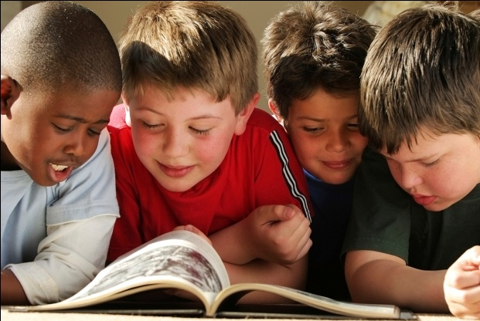
7. Co-operative play (over 3 years)
Children are able to play together. They can adopt a role within the group and consider the needs of others.
An example of this would be...............................................................................................................................................
....................................................................................................................................................
Activity 7: the right toys
Go to www.esolchildcare.com and click Session3, Activity 7.

Play is an essential part of a child’s growth and development. Toys enhance and support learning through play. Toys are the tools of play. It is important that the toys are carefully selected with the child in mind and that they are appropriate for the child’s age.

As early years workers you are reminded that toys enhance learning and are not intended to be a substitute for warm relationships with adults. Toys can bring carers and children together in play. Think about the types of toys that children are able to play with; the selection below is intended as a guide. Remember that all children are unique and some will progress much quicker than others.

Look at the toys and ages on this page then try the activity on the next page.

1 -6 months | 6-12 months | 1–2 years
- Rattles  - Small blocks  - Teething Rings  - Bright pictures  - Bath toys  - Mobiles  - Pram toys  - Baby rockers  - Squeezy toys  - Toys with holes for easy gripping | - Stacking Cubes and beakers  - Wooden spoons  - Pots and pans  - Soft dolls  - Soft cloth/vinyl books  - Musical toys  - Stuffed toys  - Baby gyms  - Interlocking plastic rings | - Cuddly toys  - Crayons  - Wooden train  - Bath toys  - Boxes, tins and cartons  - Toys to push and pull  - Posting box  - Small world, duplo  - Toys to ride on  - Balls  - Dressing up toys
2-3 years | 3-4 years | 4-5 years
- Picture books  - Dressing up clothes  - Dolls  - Water and things to pour, tip and fill  - Sand sieves, spades  - Paints  - Dough and clay  - Balls  - Simple puzzles  - Construction toys | - Different sizes and shapes of paper/scissors  - Jigsaws  - Matching games  - Farm sets, garage, train sets  - Toys that fit together  - Books  - Home/role play toys  - Space hoppers  - Computer toys | - Woodwork tools  - Garden tools  - Puppets,  - Painting and drawing  - Junk modelling materials  - More complex table top games  - Mark making  - Musical instruments  - Bats and balls

 | toy | description | name | age
 | 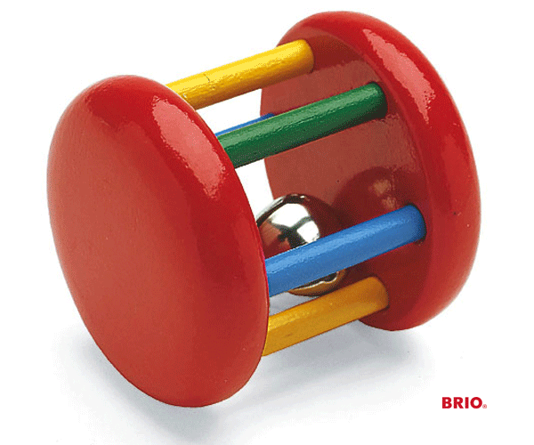 | A toy that a child can shake and it makes a noise.
 | 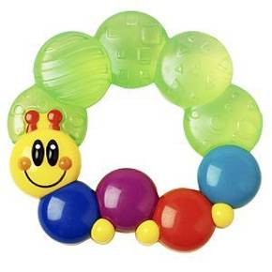 | A toy that babies can ‘bite’ on when they are teething. Often they can be cooled in the fridge.
 | 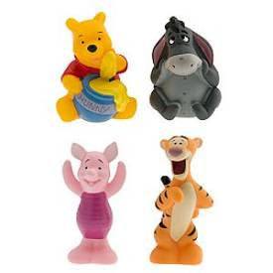 | A toy that a child can hold and squeeze.
 | 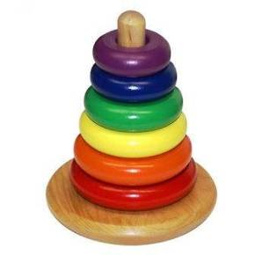 | Toys that a child can place one on top of another
 |  | Thick pencils without the wood. Good and safe for little hands.
 | 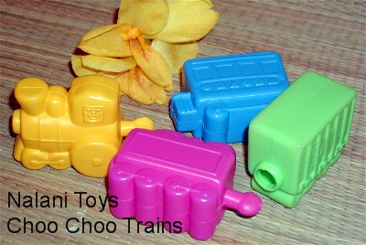 | Chunky plastic toys that can be joined together.
 | 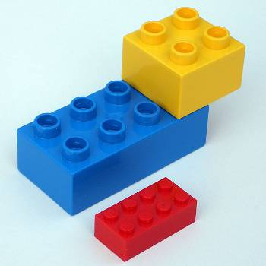 | Large plastic building blocks.
 | 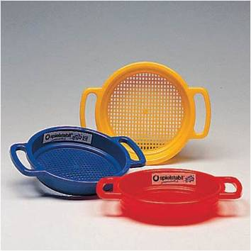 | A sieve that a child plays with in the sand.
 |  | Soft material that can be made into different shapes.
 |  | A strong plastic ball with handles that a child can bounce on.
 |  | Materials that a child can find around the house or garden to make into models.
 | 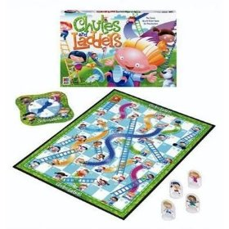 | Games for children who can follow a game with rules and turn taking etc.

Use the internet to find images of any other toys you don’t know.
Activity 8: six areas of learning & development

The EYFS identifies six areas of learning and development. Think about each area and then complete the activities on the next page.

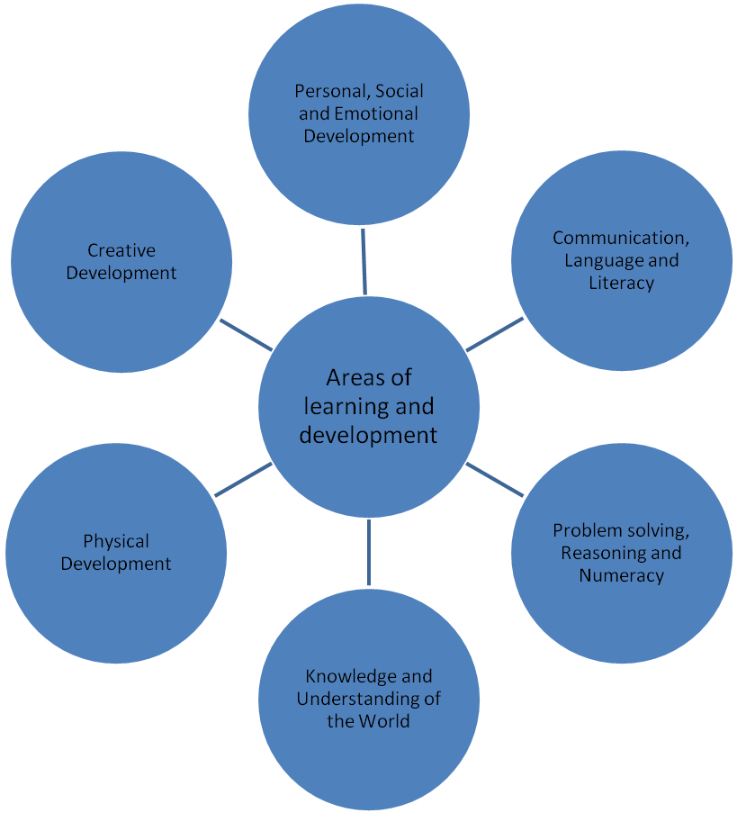
1
2
3
4
5
6

- The EYFS is all about learning through play. Look at the grid below. Can you think of fun activities and experiences for each of the areas of learning? Two have been included already.

 | Areas of Learning | Main areas for planning play | Activity/Experience
1 | PERSONAL SOCIAL AND EMOTIONAL DEVELOPMENT | - Sharing and co-operative behaviour  - Self confidence and self esteem  - Making friends and developing relationships  - Self care | 1. Taking turns to share toys  2.Helping to tidy up
2 | COMMUNICATION LANGUAGE & LITERACY | - Speaking and listening  - Reading  - Writing  - Linking sounds and letters | 1. Listening to stories  2. Singing songs
3 | PROBLEM SOLVING REASONING & NUMERACY | - Counting  - Matching  - Ordering  - Sorting  - Making & recognising patterns  - Adding & subtracting  - Shape space and measures | 1.Sharing ‘Pizza’ in the Home corner  2.Building a train track
4 | KNOWLEDGE & UNDERSTANDING OF THE WORLD | - Designing and making things  - Providing opportunities for early technology including IT  - The concept of past and present  - Exploring the world in which they live | 1. Looking for mini-beasts in the outdoor play area.  2.Planting seeds
5 | PHYSICAL DEVELOPMENT | - Opportunities to exercise and develop stamina  - Health and bodily awareness  - To move safely and develop control  - Use equipment and materials | 1.Riding tricycles  2. Threading beads
6 | CREATIVE DEVELOPMENT | - Music, movement drama and dance  - Painting & drawing  - Modelling  - Sewing , weaving and using fabrics  - Imaginative play | 1.Junk Modelling  2.Pretending to be a fire-fighter

- Children play in many different ways and for many different reasons. Complete each sentence by writing the correct ending.
Go to www.esolchildcare.com and click Session3, Activity 8 to find the answers below

1 | Physical play helps
2 | Discovery play involves
3 | Creative play helps
4 | Imaginative play allows
5 | Manipulative play helps
6 | Social play gives

a child to dream and pretend.
a child develop their artistic and musical skills.
with learning to control fingers and body movements.
a child finding out about the world they live in.
children a chance to learn to mix with others.
children learn to use their bodies. It develops muscles.

Write a sentence beginning:

Play is ____________________________________________________________________________________________

___________________________________________________________________________________________________

___________________________________________________________________________________________________

___________________________________________________________________________________________________
Planning for Play

Happy Hands Pre-school has recently opened. They have 3 rooms for children to play in.

- Room 1 - This is going to be the ‘quiet’ room. They want to set up activities that less confident children will enjoy, or simply for children who would like to be in a quiet room.
- Room 2 - This is going to be the ‘busy’ room. They want to include lots of activities to keep the children interested and happy.
- Room 3 - This is a large room that they are going to use for more energetic and noisy play.

You have been asked to suggest activities for each of the rooms. There are 20 children aged from 2 ½ to 4 ½ and there is one adult for every four children, plus lots of parent helpers to support the children. Consider your choices carefully using the six areas of learning.

Room 1 activities | Room 2 activities | Room 3 activities

Activity 9: core activities
Go to www.esolchildcare.com and click Session3, Activity 9 to complete the crossword.

Although early year’s settings are unique and individual, play is planned to include all the six areas of learning and development. This means that there are certain ‘Core Activities’ which can be found in most childcare settings. Can you find the seven activities?

Across

5. Building things and connecting objects. The noun of construct.
6. Making things from empty boxes and plastic cartons. Junk-
7. For pouring, measuring and drinking.

Down

1. Suitable for brushes, rollers and pictures.
2. A place to play, like a home, but often in a corner.
3. Something that is found at the seaside.
4. Can be made into shapes by stretching and twisting.
Activity 10: core activities
Go to www.esolchildcare.com and click Session3, Activity 10 to find words.

Can you find the toys hidden in the word search?

G | E | Z | B | D | O | L | L | S | E | L | Z | Z | U | P
I | W | B | O | B | N | M | R | W | J | Y | J | I | K | F
X | D | H | O | A | B | I | M | A | F | D | V | M | L | D
X | P | R | K | L | X | T | C | J | N | I | V | H | N | F
J | H | R | S | L | R | N | L | X | S | K | V | A | L | R
K | I | K | A | S | T | I | C | T | U | R | S | N | F | N
S | D | G | X | M | Q | A | E | R | U | G | E | I | K | S
M | Q | J | S | S | S | P | N | I | M | G | V | W | P | I
K | W | Y | B | A | P | I | P | C | F | S | M | O | O | Z
V | S | V | X | U | W | H | N | Y | K | V | O | L | O | X
V | L | F | P | K | M | S | Y | C | D | H | C | A | R | S
J | R | A | K | K | G | T | I | L | I | E | R | W | L | K
I | C | Y | T | X | M | R | L | E | X | F | F | D | Y | W
E | A | V | Y | E | B | H | A | S | M | R | O | M | Z | M
S | S | M | X | D | X | D | H | R | X | I | B | Z | D | Q

BOOKS
CARS
DOLLS
PRAMS
BRICKS
SAND
PAINT
TRICYCLES
BALLS
HOOPS
PUZZLES
JIGSAWS
Activity 11: Choose ten words from today, or use those below, and practise spelling them. Look at the glossary on the next page as well.
Go to www.esolchildcare.com and click Session3, Activity 11 for the spelling test.

Use LOOK SAY COVER WRITE CHECK

 | word | syllables | 1st try | 2nd try | 3rd try | 4th try
1 | solitary | sol i ta ry  1 2 3 4
2 | foundation
3 | curriculum
4 | development
5 | learning
6 | manipulative
7 | imaginative
8 | creative
9 | discovery
10 | physical

Glossary for Session 3
 | word | definition | example
 | balanced and consistent | Balanced- using many skills equally  Consistent - always the same | Her work was good, always balanced and consistent.
 | solitary | Alone, without others | He played on his own, away from the other children in the room, this is solitary play.
 | imaginative | To use your mind to think of new ideas. | The children had good ideas and their paintings were very imaginative.
 | pretending | To make somebody believe something that is not real. | They dresses as builders and pretended to build a house.
 | complicated | Difficult to understand because there are lots of different parts. | The model car had lots of parts and was complicated.
 | stimulated | When something or somebody makes a person think or move, this is stimulation. | The trip to the zoo had stimulated lots of ideas in class.
 | enhance | To do something that will make a thing or situation more attractive or a better quality. | The teacher enhanced the story by using models of the characters in the book.
 | substitute | A person or thing that you would put in place of another. | They had run out of orange juice so they substituted it with apple juice.
 | unique | Unlike any other. | Children are all different, they are unique.
 | milestones | A way to measure how far you have gone- or how you have developed. | The baby had just sat up. She had reached an important milestone.
 | manipulative | Handle cleverly or skilfully. | The play dough was difficult to handle so you have to be manipulative to create the shapes you need.
 | reasoning | Think carefully to work out a problem or difficult situation. | His reasoning was very good because he worked out how to use a box to stand on when he wanted some sweets from the high shelf.
 | complex | Difficult to understand because it has different parts. | The game has lots of rules and is too complex for younger children.
 | EYFS | Early Years Foundation Stage | The Early Years Foundation Stage sets out the legal requirements for the care of young children (from Birth to Five) in relation to Learning, Development and Welfare.

Session 4

Outcomes for Session 4:
✓
- Identify the five areas of child development. □
- Consider the factors that affect development in children. □
- Explain the importance of observation to assess development. □

End of Class - please tick the outcomes you think have been met for today’s session.

Evaluation: strongly agree undecided disagree strongly agree disagree
I am happy with my contribution: □ □ □ □ □
The activities were appropriate: □ □ □ □ □
The materials were too difficult: □ □ □ □ □
I have learned something new: □ □ □ □ □
The tutor was supportive: □ □ □ □ □

Reflection: If you disagreed with any of the statements above, feel free to record here why you disagreed, how you might change them and consider discussing these with the tutor.

------------------------------------------------------------------------------------------------------------------------------------------------------------------------------------------------------------------------------------------------------------------------------------------------------------------------------------------------------------------------------------------------------------------------------------------------------------------------------------------------------------------------------------------------------------------------------------------------------------------------------------------------------------------------------------------------------------------------------------------------------------------------------------------------------------------------------------------------------------------------------------------------------------------------------------------------------------------------------------------------------------------------------------------------------------------------------------------------------------------------------------------

For the online activities for this session please go to www.esolchildcare.com/session4.html
Activity 1: Child Development Video
Go to www.esolchildcare.com and click Session 4, Activity 1 to watch the video on child development.

Watch the video then answer the questions.

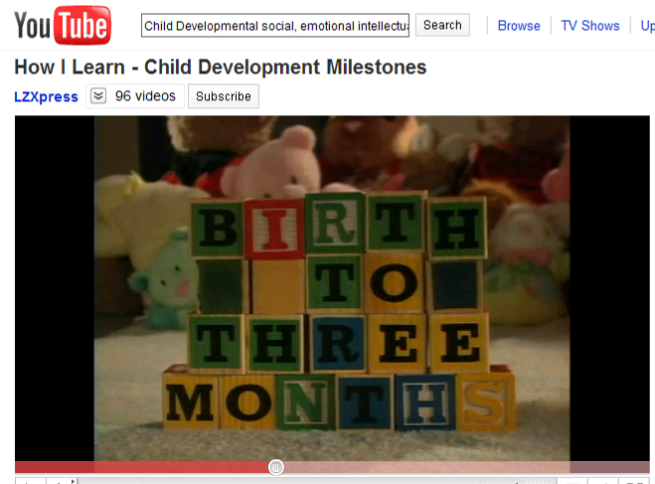

http://www.youtube.com/watch?v=7hn0O_L6lfI

Milestones are stages of development that occur throughout a child’s and adult’s life. This video looks briefly at birth to three months.

1. What do babies want when they reach the emotional milestone?

2. What happens when babies reach the physical milestone?

3. What do babies do when they reach the intellectual milestone?

4. What happens when babies reach the social milestone?

Activity 2: the 5 areas of child development
Go to www.esolchildcare.com and click Session 4, Activity 2.

Read carefully and write the missing words.

effect | physical | intellectual | activities | language
develop | emotional | social | important | five

Children develop very quickly. There are ________________________ main areas of development. Although we will look at them separately they are all closely linked together. Development in one area can ________________________ development in another area. It is very ________________________ that we give children a variety of toys, ________________________ and experiences that help them to ________________________ in all areas.

- The ________________________ process allows children to work and play with other children and adults.
- The ________________________ process allows children to talk and listen to others or use sign language.
- The ________________________ process allows children to learn how to move their bodies using both gross motor (big muscle) and fine motor (small muscle) skills.
- The ________________________ process allows children to think, use their memories and solve problems.
- The ________________________ process allows children to express and control their feelings.

Child Development

emotional | physical | intellectual | social | language

What does PILES stand for? Write the correct word.

P
I
L
E
S

Activity 3: the human life-span
Go to www.esolchildcare.com and click Session 4, Activity 3.

Although we are looking at children’s development it will be useful to look at the whole area of human development in order to familiarise yourself with some of the terms used. During an average lifetime we move through a range of ten different developmental stages.

1.) Write the missing stages

Prenatal stage | Middle childhood | Infancy | Toddler | Early childhood
Neonatal stage | Middle adulthood | Young adulthood | Adolescence | Late adulthood

Stages |  | What do you notice in the video?
1 | Prenatal stage________  from conception to birth | child develops; eyes closed; looks like a baby; learning in womb; looks asleep
2 | _____________________  from birth to 1 month
3 | _____________________ from 1 month to 2 years
4 | _____________________  from 1 to 2 years
5 | _____________________ from 1 to 5 years
6 | _____________________ from 5 to 12 years
7 | _____________________ from 12 to 20 years
8 | _____________________ from 20 to 40 years
9 | _____________________ from 40 to 65 years
10 | _____________________ from 65 years onwards

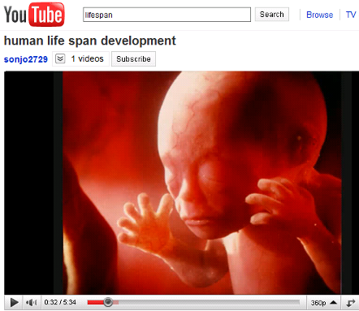
2.) Optional: watch the video and make any notes above.

http://www.youtube.com/watch?v=ud_BqE8Afdo
Activity 4: child development skills
Go to www.esolchildcare.com and click Session 4, Activity 4.

Look at the following skills that children learn as they develop. Can you work out which area of development they belong to?

P I L E S (✓) tick the correct box

Statements: |  | physical | intellectual | language | emotional | social
1 | Stand up.
2 | Hold a crayon or paintbrush.
3 | Start to put two or more words together.
4 | Fit objects together to make a tower.
5 | Choose own friends.
6 | Follow simple instructions.
7 | Communicate when happy or excited.
8 | Ask for a drink or food.
9 | Dislike being restrained and throw tantrums.
10 | Cry when main carer leaves.
11 | Need reassurance when tired.
12 | Understand sharing and turn-taking.
13 | They cooperate or help with dressing.
14 | Interested in what happens around them.
15 | Kick a ball.

Activity 5: child development grid - Can you ‘drag and drop’ the statements into the correct box?
Go to www.esolchildcare.com and click Session 4, Activity 5 to drag and drop or your teacher will give you some cards.

 | 0-1 year | 1-3 years | 3-5 years | 5-11 years | 11-16 years
Physical |  | Able to run and climb, walk up and down stairs using alternative feet. Can turn pages in a book and shows an interest in mark making. |  | Children continue to grow in height and become more skilled in quicker, confident and more accurate hand movements. | This period marks the start of physical changes for young people as their bodies prepare for adulthood.
Intellectual |  | They are starting to enjoy pretend play with small world activities and the home corner. Are keen to play repetitively. |  | There is an awareness of the consequences of their behaviour and increased thoughtfulness.  Some problem solving and co-operation. | Many have developed skills that are equal to those of adults and they are starting to think about their future.
Language/  Communication | Babbling becomes more tuneful and inventive and first words are beginning to appear |  | Children are fairly fluent in their speech and are easily understood. Though still the odd pronunciation error. |  | Stories and writing that shows imagination as well as being legible and reasonably grammatical.
Emotional | Babies are able to recognise the smell of their mother and are quickly soothed when they hear her voice. |  | Children are fairly fluent in their speech and are easily understood. Though still the odd pronunciation error. |  | Children want to explore their own identity; this may cause clashes with parents as young people try to develop their own personality and space
Social |  | Starting to play more with other children of their own age, although some of their time will be spent playing alongside others. |  | Friends are important to children of this age. Many children will start to have established friendships and preferences. | Enjoyment when with their friends, which is likely to be more important than family. Prefer to be part of a group.

Activity 6: factors that affect child development
Go to www.esolchildcare.com and click Session 4, Activity 6 to email your answers.

There are lots of factors that can affect child development. Some of them are good. Some of them are bad.

Give an example of how each factor might have a good or bad affect on child development. Can you think of any others?

Factors: |  | good affect | bad affect
1 | genetic | Some people believe that some children are born with a natural ability to learn more quickly. | Some children are born with disabilities and illnesses that make it difficult for them to grow normally and learn.
2 | environment
3 | ethnic/cultural
4 | economic  (poverty/wealth)
5 | nutrition
6 | illness
7 | smoking
8 | alcohol
9 | housing
10 | parents
11 | peers
12
13
14
15

Activity 7: observation
Go to www.esolchildcare.com and click Session 4, Activity 7 to watch the video.

It is important that early years workers are able to observe and record children’s development.

There are various techniques of observation and you will have the opportunity to try these out in your early years setting. Remember! You need to ask permission to observe the child and if you are allowed to use the information.

Observation is a record of what you have seen. Observation should be:

objective – this means fair and accurate (fact) and not
subjective – which is what you think you have seen (opinion).

However, two people can look at the same thing but see differently. Look at the picture below. What do you see? Ask other people what they see. Do you both see the same thing or something different?

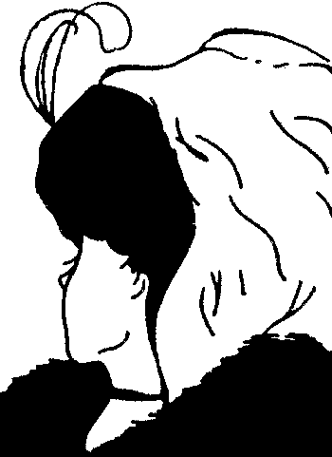
Watch the video and make notes about what you think is important in child observation.

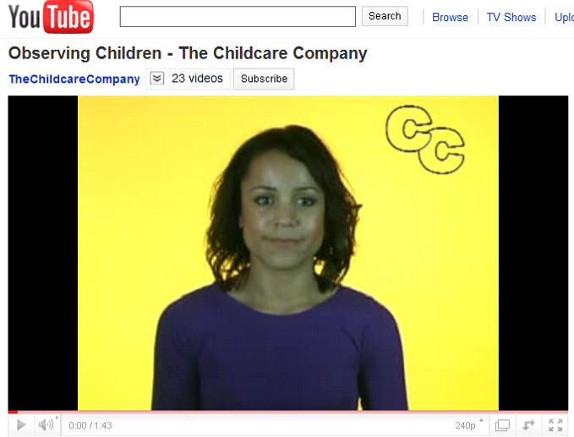
http://www.youtube.com/watch?v=6DY8rgtZ1S0
Notes:

Activity 8: objective or subjective
Go to www.esolchildcare.com and click Session 4, Activity 8.

Observation should be objective and not subjective. But what does this mean?

A.) Put these words into their correct opposites

subjective | wrong | belief | false | opinion | biased

 | Positive | Negative | 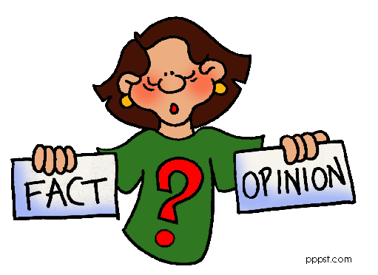
1 | fact
2 | true
3 | right
4 | objective
5 | unbiased
6 | real

How are these words similar and different? Does ‘subjective’ mean the same as ‘wrong’?

B.) Read the comments made by some childcare observers.
Decide if the observer has made a subjective or objective comment.
 | Comment | Objective / Subjective
 | Susan and Claire were playing on the carpet with a box of building blocks. Claire pointed to a circle they had made and said to Susan, “That looks like a roundabout”.
 | Takis said, “No, I am not allowed to eat meat and I shall not eat this”.
 | Cheung enjoys playing with counters and making shapes.
 | Emily did not want to come to school.
 | Susan and Maneer played well together.
 | Harry kept making noises and yawning while the other children on the table were writing in their books.
 | Takis is fussy about food today.
 | Raoul kept distracting other children from their work.
 | Avinash collected all the red counters and made them into a round shape. She then collected all the blue counters and made them into a square shape. She then collected all the yellow counters and arranged them in a wavy line.
 | Emily was upset and held her mother’s hand tightly.

Activity 9: why we observe
Go to www.esolchildcare.com and click Session 4, Activity 9 to complete the crossword.

Observing children is a skill that you will develop over time; it requires practice and will be something that you will do regularly in your early years setting. So why do we observe children? Write the missing words:
changes progress concern development adult planning activities individual better health safety links practice
Why we observe:
Across
1. To assess a child's state of __________________
4. To identify good and not so good __________________
6. To note __________________in behaviour
7. To learn about __________________children’s needs
8. To identify any __________________issues in the setting
9. To inform future __________________
11. To get to know a child __________________
12. To measure the success of __________________or equipment
Down
2. To help identify __________________between circumstances and behaviour
3. To assess a child's __________________
5. To assess a child’s overall __________________
6. To monitor a __________________that has already been raised
10. To identify when __________________intervention would be helpful
Activity 10: Choose ten words from today, or use those below, and practise spelling them. Look at the glossary on the next page as well.
Go to www.esolchildcare.com and click Session4, Activity 10 for the spelling test.

Use LOOK SAY COVER WRITE CHECK

 | word | syllables | 1st try | 2nd try | 3rd try | 4th try
1 | opinion | o pin i on  1 2 3 4
2 | milestone
3 | communicate
4 | observation
5 | progress
6 | social
7 | language
8 | affect
9 | objective
10 | subjective

Glossary for Session 4
 | word | definition | example
 | Restrain | To control the actions or behaviour of someone by force. | The boy had lost his temper and had to be restrained to stop him hurting himself.
 | Throw tantrums | A sudden period of uncontrolled anger.  When you have a tantrum it is often said that you ‘throw a tantrum’. | When the parent wouldn’t buy her sweets she ‘threw a tantrum.’
 | Crawling | To move slowly on your hands and knees. | The child crawled across the floor. He was crawling.
 | Shuffling | To walk by pulling your feet slowly along the ground rather than lifting them. Small children often move around on their bottoms over the floor. | The child couldn’t walk yet but he could get across the room by shuffling along on his bottom.
 | Tricycle | A bicycle that has three wheels, designed to be easier to balance. | The child’s first bike was a tricycle and he found he could ride it well.
 | Threading | to put something long and thin such as string or thread through a narrow hole or into a small space. | The children enjoyed treading wooden beads on to a string.
 | Preferences | When you like something or someone more than another person or thing | The children preferred (had a preference for) apple juice.
 | Mark making | Making a mark using a pen or crayon on paper – not writing yet but just making a mark. | If you gave the little boy some crayons he could hold them well enough to make some marks on the paper, this is mark making.
 | Consequence | a result of a particular action or situation, often one which is bad or not convenient | The teacher was away on a course so there was no class as a consequence.
 | Repetitive | Doing something over and over again. | The children liked to sing the same song over and over and it got very repetitive.
 | Babbling | To talk or say something in a quick, confused, excited or silly way. Before small children talk they often make noises that don’t make sense. | The baby lay in her bed and babbled to herself.
 | Two word compound | Words that are made up of two different words – they are compounded (joined) together. | The words armchair (arm + chair) and bathroom (bath + room) are two word compounds.
 | Major | More important, bigger or more serious than others. | Sugar is a major cause of tooth decay.
 | Influence | The power to have an effect on people or things. | When children fight in the play ground it has an influence on their behaviour in the classroom.
 | Fluent | When a person is fluent, they can speak a language easily, well and quickly. | The family from Germany have been in the UK for some time and they are fluent in English.
 | Pronunciation error | Making a mistake in saying a word so that it doesn’t sound correct. | He can say lots of different words but sometimes his pronunciation is not correct.
 | May cause clashes | A clash is when people have different ideas or opinions and disagree or argue about it. | The children couldn’t agree on what they wanted to do so it may cause a clash between them.
 | Generic | Belonging or relating to genes (= parts of the DNA in cells) received by each animal or plant from its parents. | The boy had red hair and so did his mother so it must have been genetic – he got his red hair from his mother.
 | Counters | An object used to mark a place or marks numbers. | The girl likes to play with toys that use numbers or counters.
 | Yawn | To open the mouth wide and take a lot of air into the lungs and slowly send it out, usually when tired or bored | He found the story very boring and he was yawning all the way through it.
 | Wavy | Having a series of curves – not in a straight line. | The girl had long wavy hair but her brother’s hair was straight.
 | Fascinating | Extremely interesting. | The story was fascinating.
 | Adult intervention | When an adult becomes involved in a difficult situation in order to improve it or stop it from getting worse. | It was only adult intervention that stopped the fight getting worse.
 | Focus | To look closely at something. | The teacher focused all her attention on the children.
 | Circumstances | A fact or event that makes a situation the way it is. | The child was not feeling well but she came to school and did well under the circumstances.

Session 5

Outcomes for Session 5:
✓
- Discuss the legal and statutory requirements which must be followed in order to keep children safe. Consider the factors that affect development in children. □
- Identify hazards in the healthcare setting. □
- Consider your role in keeping children safe. □

End of Class - please tick the outcomes you think have been met for today’s session.

Evaluation: strongly agree undecided disagree strongly agree disagree
I am happy with my contribution: □ □ □ □ □
The activities were appropriate: □ □ □ □ □
The materials were too difficult: □ □ □ □ □
I have learned something new: □ □ □ □ □
The tutor was supportive: □ □ □ □ □

Reflection: If you disagreed with any of the statements above, feel free to record here why you disagreed, how you might change them and consider discussing these with the tutor.

------------------------------------------------------------------------------------------------------------------------------------------------------------------------------------------------------------------------------------------------------------------------------------------------------------------------------------------------------------------------------------------------------------------------------------------------------------------------------------------------------------------------------------------------------------------------------------------------------------------------------------------------------------------------------------------------------------------------------------------------------------------------------------------------------------------------------------------------------------------------------------------------------------------------------------------------------------------------------------------------------------------------------------------------------------------------------------------------------------------------------------------

For the online activities for this session please go to www.esolchildcare.com/session5.html
Activity 1: vocabulary
Go to www.esolchildcare.com and click Session 5, Activity 1.

Look at these definitions and examples. Write the missing words in the boxes.

 | definition |  |  | example
 | Give authority for someone to do something. |  |  | The child had __________________ from his teacher to go to the toilet.
 | Something that could go wrong and cause harm. |  |  | The floor was wet, it was a real ________________ because the children might fall.
 | Misfortune, mishap, event causing injury. |  |  | If you don’t tidy up in the playroom you might have an __________________.
 | State of affairs, circumstances or conditions. |  |  | The carer didn’t know what the __________________ was at home.
 | Positive, certain about something, assertive. |  |  | Some children are very __________________ about their reading.
 | A document with a written set of rules that employees must follow. |  |  | If you are not sure about what to do you can read the __________________ the employer has written.
 | A way of doing things that is intended to achieve a certain result. |  |  | You must always follow __________________ when you work with the children.
 | Something that could be very dangerous and will cause harm. |  |  | If you don’t look when you are crossing the road there is a _______________ you will be hit by a car.
 | Directed, overseen, organised or controlled. |  |  | It is important that the children are __________________ when they play in the garden.
 | Laws in a legal document produced by the government. |  |  | If you have to write a policy at work you can look at the __________________ produced by the government to help you.
 | A company that employs people to work for them. |  |  | The _________________ is required to do a health and safety check and write a H&S policy.
 | Someone who works for a company. |  |  | The __________________ complained that health and safety was not good enough in the company.

supervised accident situations permission legislation employer
confident procedure risk hazard policy employee
Activity 2: keeping children safe
Go to www.esolchildcare.com and click Session 5, Activity 1 to listen to the text and answer the questions.

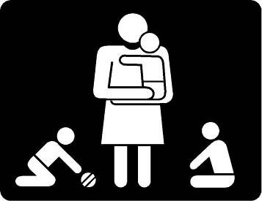
Parents should feel confident that their children are in safe hands and also that they have a role to play in ensuring the nursery is a safe place for everyone. As children grow there are many risks to their safety and they rely upon the people caring for them to protect them from harm. Parents should feel confident that their children are in safe hands. The Health and Safety at Work Act (1974) is the most important piece of legislation relating to health and safety.

Read the text below then answer the 10 questions on the next page.

Health & Safety at Work Act 1974

The Act sets out the general duties which employers have towards other employees and members of the public, and which employees have towards themselves. The main requirement on employers is to ensure, as far as reasonably practicable, the health, safety and welfare of employees and those affected by their work. (This includes anyone who has permission to enter the setting.)

Settings with five or more employees must have a written health and safety policy and need to carry out risk assessments. They are required to record the significant findings of the risk assessment and make arrangements for implementing the health and safety measures identified by the risk assessment.

The Act states that employees should follow the setting’s health and safety procedures and use the health and safety equipment provided. They should not put others at risk by their actions.

The Act states that employers have a duty of care towards their employees and must take every reasonable step to consider their health and safety and to minimise risks.

The EYFS (Early Years Foundation Stage) explains what is acceptable in terms of health and safety (H&S) in their ‘Welfare Requirements’. All settings are regularly inspected by Ofsted (Office for Standards in Education) to ensure that early year’s settings are operating correctly. They have the power to close settings if this is not the case.

All settings that provide care or education for children, from birth to nineteen years of age, have policies and procedures to deal with H&S. The policies state what the rules of the setting are. The procedures say what should be done if a situation arises that requires action by an adult to keep children safe, to protect them from harm and to deal with emergencies.

It is essential that adults working in early year’s settings are well informed and aware of H&S issues and H&S procedures. Safety of children is of paramount importance. One of your first tasks when starting work in an early year’s setting is to read and learn about H&S procedures as you have a duty to keep children safe.
Health & Safety Act questions (circle the correct answer: a, b, c or d)

- What is the main requirement of the Health & Safety act on employers?

  - To ensure the health, safety and welfare of their employees and those affected by their work. (correct answer)
  - To ensure the health and welfare of their employees.
  - To ensure the health and safety of their employees and those affected by their work.
  - To ensure the health and safety of those affected by their work.

- What does the Act set out?

  - The general health and safety duties for employers and employees. (correct answer)
  - The general health and safety duties for members of the public.

- When are risk assessments required?

  - When there are only two people working together.
  - When there are five or more people employed. (correct answer)

- What does the Act state about using Health and Safety equipment at work?

- That health and safety equipment should be available if people would like to use it.
- That health and Safety equipment must be available and used. (correct answer)

- What does the Act state about employees following Health and Safety procedures?

  - Employees have to follow Health and Safety procedures when they have time.
  - Employees have to follow Health and Safety procedures at all times. (correct answer)

- What does the Act state about causing risks at work?

  - That employees must try not to take many risks at work.
  - That employees must not put others at risk by their actions. (correct answer)

- What responsibility does the employer have to the employee in the Act?

  - The employers must try to look after the employees whenever they are at work.
  - The employers have a duty of care, take every reasonable step to care for them and minimise risks for the employees. (correct answer)

- What does Ofsted have the power to do in early year settings?

  - To rewrite the Health and Safety rules.
  - To close the setting if it does not meet the Health and Safety requirements. (correct answer)

- The policies and procedures that are in place in early year settings explain:

  - What should be done if a situation arises that requires an adult to keep children safe. ( correct answer)
  - Where you can go to find out about Health and Safety.

- If you were an adult working in an early years setting which would be the most important task to do on the first morning?

  - Read and learn the Health and Safety procedure. (correct answer)
  - To find out when the children go out on trips.

Activity 3: what is health & safety
Go to www.esolchildcare.com and click Session 5, Activity 3.
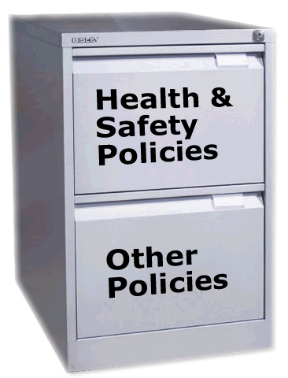
You have just started at Jolly Tots pre-school and have been asked to read all the policy documents; unfortunately they seem to be a bit mixed up!

Tick the documents which relate to Health & Safety and which are ‘Other Policies’?

Clue: 15 are health & safety and 6 are other. Two have been done.

Tick the correct policy type |  | H&S Policy | Other
 | Fire drills | ✓
 | Safeguarding children |  | ✓
 | Ensuring the correct room temperature
 | Hand washing
 | Supervision of children
 | Behaviour management
 | Disposal of waste
 | Security
 | Employing staff
 | Dealing with spillages and bodily fluids
 | Dealing with illness
 | Food preparation
 | Planning play
 | Applying sun hats and sun cream
 | First aid procedures and administration of medicine
 | Equal opportunities
 | Risk assessment
 | Checking indoor and outdoor areas
 | Checking equipment
 | Communication with parents
 | Toilet training

Did you manage to choose the correct policies? I expect you’ve realised that this is a very big file because there are lots to think about in terms of health and safety.

Check your results:

Everything belongs in the Health and Safety Policy file except for those below:

No. 2 - Safeguarding children – this relates to child protection and because it is very important it always has its own separate ‘Safeguarding’ policy document
No. 16 - Equal opportunities - this usually has its own separate policy document, but it is part of every policy document found in the setting.

No. 9 - Employing staff – this is usually found in the ‘Organisation’ policy document, however staff can only be employed if they have an up to date CRB check (look again at session 1)

No. 6 - Behaviour Management has its own policy document that sets out what to do if a child is not behaving appropriately and if there is a risk of harm

No. 13 - Planning play – this is usually found in the ‘Curriculum’ policy document.

No. 20 - Communication with parents – this usually found in the ‘Partnership with parents policy document

Activity 4: welfare requirements
Go to www.esolchildcare.com and click Session 5, Activity 4.

Overview of the Welfare Requirements
Early year’s settings are inspected by Ofsted who regularly inspect and check that the setting carries out the legal requirements and the welfare requirements. The ‘requirements’ ensure that all children are safe and receive a good standard of care.

What are the current welfare requirements?
The welfare requirements are set out in the Early Years Foundation Stage (EYFS) which came into force in September 2008. Find the missing words.

 | Welfare Requirement | Guidance
1 | _______________ and promoting children’s welfare | The provider must take the necessary steps to _______________ and promote the welfare of children.  The provider must promote the good health of the children, take necessary steps to prevent the spread of infection, and take appropriate action when they are ill.  Children’s behaviour must be managed effectively and in a manner appropriate to their _______________ of development and particular individual needs.
2 | _______________ people | Providers must ensure that ___________ looking after children, or having unsupervised access to them, are suitable to do so.  Adults looking after children must have appropriate qualifications, training skills and knowledge.  Staffing arrangements must be organised to ensure safety and to meet the needs of the children.
3 | Suitable premises, environment and equipment | Outdoor and indoor spaces, furniture, equipment and toys must be safe and _______________ for their purpose
4 | _______________ | Providers must plan and organise their systems to ensure that every child receives an _______________ experience. Learning and development must be tailored to meet each child’s individual needs.
5 | _______________ | Providers must maintain records, policies and _______________ required for the safe and efficient management of the setting and to meet the needs of the children.

stage Suitable adults Safeguarding suitable
Organisation safeguard procedures Documentation enjoyable
Activity 5: preventing hazards
Go to www.esolchildcare.com and click Session 5, Activity 5 to watch the video.
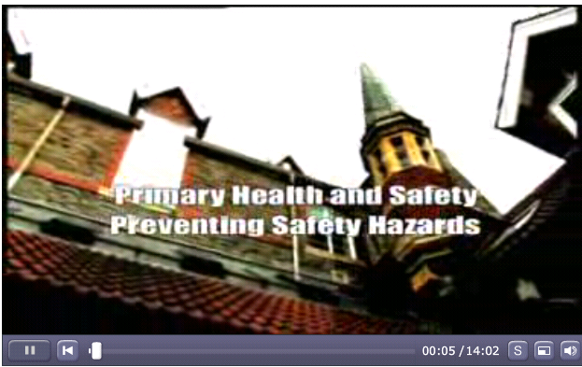
Watch the video on preventing hazards and answer the questions.

00:00-00:30
1.) In a school, who should be protected by health and safety?

00:30-00:58
2) What type of risk are coats laying on the floor?

00:58-02:20
3) Why is it important to have a fire practice at lunchtime?

06.40-07.50
4) When they look at a classroom they identify 7 different risks, how many can you name?

07.50-08.45
5) Who came to the help of the teacher who fell down the stairs?

08.45-09:55
6.) Outside the school, when it is frosty or snowy, what is done to make the playground safe?

09:55-10:28
7) There is a school rule about moving around the school, what is it?

10:28-10:40
8.) There is a pillar inside the school entrance that they feel might be a risk, what do they decide to do to minimise the risk?

12:06-13:10
9) There are three things to ensure in the playground, can you name them?

Activity 6: spot the hazards
Go to www.esolchildcare.com and click Session 5, Activity 6.

Look at the picture below and write the correct number next to the hazard. The first 10 have been done for you.
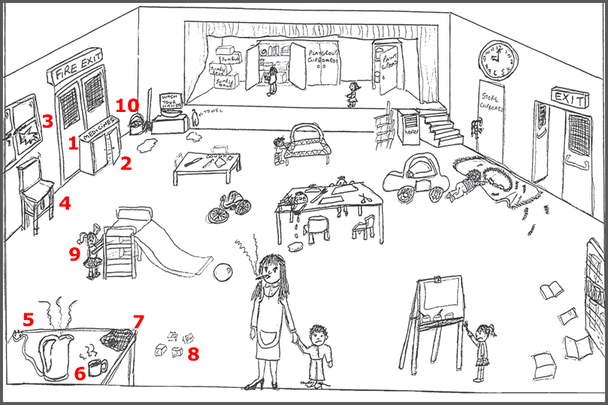

- Fire exit blocked  - Medicine cabinet open  - Window broken  - Chair standing in front of broken window  - Hot kettle with trailing plug  - Hot drink at the edge of the table  - Dirty tea towel  - Bricks left on the floor  - Young child climbing up a slide unattended  - Mop and bucket for cleaning left out next to hand wash area  - No paper towels just a hand towel hanging up  - Spills on the floor  - Boxes stacked up  - Child looking in the playgroup cupboard | - Child standing close to the edge of the stage  - Paint cupboard unlocked  - Chairs stacked up  - Heater without guard near a staircase  - Store cupboards with the keys in  - Exit left open  - Child playing on the floor in front of the door  - Rug in front of the door  - Toys left scattered on the floor  - Child climbing on the trampoline without help  - Knives left on the play dough table  - Glue dripping onto the floor | - Small child reaching for scissors on table  - Small child not able to reach the painting easel and without an apron Books left on the floor  - Football obstructing the slide  - Slide and trampoline without safety mats and badly positioned  - Adult smoking and wearing high heels  - Child with shoelaces unfastened  - Inadequate staffing, there is only one adult

This activity showed a particularly bad example of an early year’s setting. There were so many things wrong with it that it would most certainly have been closed down by Ofsted.

The safety of the child is of paramount importance. This is a phrase that you will hear over and over again. However, you need to be careful that you don’t ‘over protect’ the children as they need to be able to take risks and stretch their skills in order to develop.

Activity 7: risk and safety
Go to www.esolchildcare.com and click Session 5, Activity 7.

When children play there will always be an element of danger. It is important that children take some risks so that they can learn and develop. Write the missing words.

risks confidence safely opportunity activities
adventurous balance careful judgements acceptable
Why should children take some risks?

Across
1. Carers must monitor children’s safety but allow them to be creative and __________________
6. A child who is not allowed to try new challenges will not learn about what is dangerous and what is __________________
7. Children can develop __________________and self-belief through tackling new challenges.
8. Carers must be __________________not to over-protect children.
9. So children learn how to play __________________
10. The best way for children to learn about safety is to allow them to take __________________

Down
2. Children need the __________________to take risks which are still safe.
3. So that children can learn new skills by trying new __________________
4. Riding a two-wheel bike is dangerous but a child needs to learn how to __________________
5. A child who is not allowed to try new challenges will not learn how to make safety __________________

It is the responsibility of the early years setting to ensure that there is a qualified First Aider available for every session. It is the responsibility of the staff to know who that person is.
All accidents must be recorded in the accident book, it should say:
- the name
- when and where it happened
- description of the accident
- description of the injury
- who saw it
- what treatment was given
It should then be signed by the parent or carer.

Activity 8: safety signs and safety marks
Go to www.esolchildcare.com and click Session 5, Activity 8.
Read the two pages on safety marks and safety signs then answer the questions.

Safety Marks http://www.safekids.co.uk

As part of your role as a childcare worker, you will be required to regularly check that the toys and equipment used by the children is safe. Anything which is damaged or broken should be removed from play.

Children in the UK are protected by safety laws that require that everything sold is safe and meets a standard that has been agreed for the product. Look at the signs below. They are used to show that goods are up to the required safety standard. You might see them on packaging or in some cases on the product itself. Do you know what they mean?

The Kite Mark | The CE Mark | The Lion Mark
 |  | 
When you see a toy or product with this mark it means that the British Standards Institution has independently tested it and has confirmed that the product conforms to the relevant British Standard. The Kite mark is the symbol that gives consumers the assurance that the product they have bought really does conform to the appropriate British Standard and should therefore be safe and reliable. | This symbol, together with the name and address of the first supplier was required by law to appear on all toys placed on the market in the European Union after 1990 to show that it passes all European standards. It is not a European safety marker or quality symbol. Its purpose is to indicate that the toys bearing the mark are intended for sale in the European Community. The toys meet the European Toy Safety Directive and can be sold across the EU. | The Lion mark was developed in 1988 by the British Toy and Hobby Association as a symbol of toy safety and quality for the consumer. The mark is only used by BTHA members, although they supply around 95% of all toys sold in the UK. For a toy to display this mark, it indicates that the supplier has signed a strict code of practice which covers toy safety and the highest standards of ethics in advertising.

There may be warnings written alongside the CE mark that indicate the appropriate age and these should be heeded. A toy that is safe for a 5 year old may be dangerous for a younger child. Anything that looks like a toy but does not have a CE mark should not be given to a child.
Safety Signs
- Safety signs are one of the main means of communicating health and safety information.
- The Health and Safety at Work Act says that employers must display signs that alert people to danger.
- There are four types of safety sign in use, each of which has a particular shape and colour which makes them easy to identify with little use of words.

Colour | The meaning of the sign | Example
Red | Indicates danger. This says what you can and cannot do. | 
Yellow | A warning sign. This says that you must be careful. | 
Blue | A mandatory sign. This says that you must do something. | 
Green | This indicates safe conditions and says what the safe conditions are. | 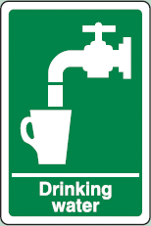

- What mark tells you that a toy can be sold in Europe?
- What colour sign tells you that something is safe?
- What sign tells you that a toy meets the standards of the British Standards Institution?
- What colour sign tells you something you must do?
- What colour sign tells you that you must be careful?
- What mark tells you that a toy’s safety has been approved by the BTHA?
- What colour sign tells you that something is dangerous?

Activity 9: health and safety poster
Go to www.esolchildcare.com and click Session 5, Activity 9 to listen.
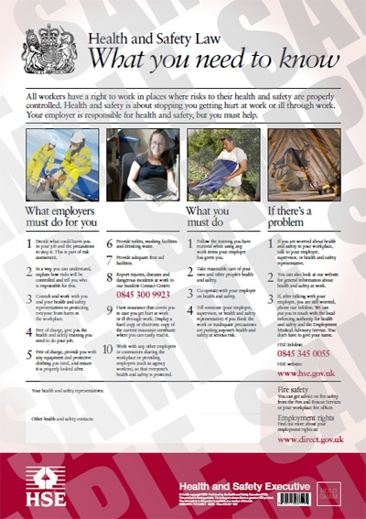
Employers have a legal duty under the Health and Safety Information for Employees Regulations to display the Health and Safety at Work Act (1974) poster in a place where it can be seen by everyone in the workplace. It sets out the responsibilities of both the employer and the employee and what you need to do if there is a problem.

Below is a text version of the poster. You can also listen online at Session 5.

All workers have a right to work in places where risks to their health and safety are properly controlled. Health and safety is about stopping you getting hurt at work or ill through work. Your employer is responsible for health and safety, but you must help.

What employers must do for you?

1 Decide what could harm you in your job and the precautions to stop it. This is part of risk assessment.

2 In a way you can understand, explain how risks will be controlled and tell you version of pocket card who is responsible for this.

3 Consult and work with you and your health and safety representatives in protecting everyone from harm in the workplace.

4 Free of charge, give you the health and safety training you need to do your job.

5 Free of charge, provide you with any equipment and protective clothing you need, and ensure it is properly looked after.

6 Provide toilets, washing facilities and drinking water.

7 Provide adequate first-aid facilities.

8 Report injuries, diseases and dangerous incidents at work to our Incident Contact Centre: 0845 300 9923

9 Have insurance that covers you in case you get hurt at work or ill through work. Display a hard copy or electronic copy of the current insurance certificate where you can easily read it.

10 Work with any other employers or contractors sharing the workplace or providing employees (such as agency workers), so that everyone’s health and safety is protected.

What you must do

1 Follow the training you have received when using any work items your employer
has given you.

2 Take reasonable care of your own and other people’s health and safety.

3 Co-operate with your employer on health and safety.

4 Tell someone (your employer, supervisor, or health and safety representative) if
you think the work or inadequate precautions are putting anyone’s health and safety
at serious risk.

If there is a problem

1 If you are worried about health and safety in your workplace, talk to your employer, supervisor, or health and safety representative.

2 You can also look at our website for general information about health and safety at work.

3 If, after talking with your employer, you are still worried, phone our Infoline. We can put you in touch with the local enforcing authority for health and safety and the Employment Medical Advisory Service. You don’t have to give your name.

HSE Infoline: 0845 345 0055
HSE website: www.hse.gov.uk

Fire safety
You can get advice on fire safety from the Fire and Rescue Services or your workplace fire officer.

Employment rights
Find out more about your employment rights at: www.direct.gov.uk

In your own words, answer these questions:

1.) What must employers do for their employees?

2.) What must the employee do in the workplace?

3.) What should you do if think there is health and safety problem?

Activity 10: preventing accidents
Go to www.esolchildcare.com and click Session 5, Activity 10.
Nearly all accidents can be prevented. Look at the comments below and decide who could prevent the accident.

a.) this is an accident which I could prevent
b.) this is an accident which my employer could prevent
c.) this is an accident which is beyond the control of me or my employer

Who could prevent this accident? |  | a.) | b.) | c.)
 | Not following instructions | ✓
 | Faulty equipment
 | Earthquake
 | Failing to give warnings to others
 | Not enough working space
 | Powercut
 | Too many distractions such as listening to music
 | Not enough supervision
 | Too much rain leading to the premises being flooded
 | Not clearing up spillages quickly
 | Poor training
 | Not using equipment properly
 | Working long hours and becoming tired
 | Having an allergy which is not treated
 | Not enough storage for materials
 | Not using personal protective clothing or equipment
 | Unclear instructions
 | Affected by drugs or alcohol
 | Allowing unsafe methods of lifting/handling
 | Messing about / not behaving properly

Activity 11: Choose ten words from today, or use those below, and practise spelling them. Look at the glossary on the next page as well.
Go to www.esolchildcare.com and click Session5, Activity 11 for the spelling test.

Use LOOK SAY COVER WRITE CHECK

 | word | syllables | 1st try | 2nd try | 3rd try | 4th try
1 |  | 1 2 3 4
2
3
4
5
6
7
8
9
10

Activity 12: what do you know

Whether you are experienced with early year’s settings as either a parent or helper, or are completely new to the whole environment, take a few minutes to test your knowledge. Put a tick in the box that best applies to you

✓ ✓
 | Health and safety in Pre-school. | I know what to do | I need to find out what to do
 | Do you know what to do if a child is hurt?
 | Do you know what should be kept in a first aid box?
 | Are you able to use all the contents of a first aid box?
 | Do you know the procedure for treating minor injuries?
 | Do you know who to contact in case of a medical emergency?
 | Do you know where to record any incident or accident?
 | Do you know who to contact if you have child protection concerns?
 | What do you do if you discover a fire?
 | Have you taken part in a fire drill?
 | Do you know how to make sure that someone knows you are in a pre-school building?
 | What do you do if you find anything damaged in a pre-school?
 | Do you know what Health and Safety policies are?
 | Do you know where to find them?
 | Do you know what to do if you meet a stranger/ adult in the pre-school that you do not know?
 | Do you know what should you do if you find a child wandering around a pre-school building without an adult?
 | If you are asked to go outside in the play area or elsewhere with the children do you know how many children you can supervise?
 | Do you know what the procedure is if a child is not collected from a pre-school?
 | Do you know what to do you do if a parent /carer turns up drunk to collect their child?

If most of your ticks are in the last box be sure to put these on your list of things to do next in session 6.
Glossary for Session 5
 | word | definition | example
 | Practicable | Able to be done. | She had to tell her mother about the trip and did as soon as she practicably could.
 | Welfare | The health, happiness, and fortunes of a person or group: | The teacher was very concerned about the children’s welfare.
 | Significant | Important, worth paying attention to. | The fact he had not brought a coat to school was significant because they thought there might be problems at home.
 | Minimise | To reduce something. | They looked at the room and made some changes to minimise any risks to the children and staff.
 | Look in more detail. | To look at something very closely so they could see every part. | They looked at all parts of the trip in detail to identify any risks.
 | Paramount | More important than anything else. | The children’s safety is paramount.
 | Mishap | An unlucky accident. | The trip passed without any mishaps.
 | State of affairs | A situation or set of circumstances. | When they did a check of the school they found a poor state of affairs, the floors and furniture were in bad condition.
 | Assertive | To be confident or forceful. | To do a leaders job you have to be assertive.
 | Intended | Planned. | She had intended to tidy the toy cupboard today.
 | Overseen | Supervised. | The carers in the nursery are supervised; some are overseen by the manager.
 | Muddled up | In the wrong order. | The files were in the wrong order on the shelf; they were all muddled up.
 | Safeguarding. | To keep something safe, free from harm. | It is all adults’ responsibility to safeguard the children.
 | Complies | To act as instructed. To comply with something. | The manager makes sure that they comply with all the safety rules.
 | In a manner | To do something in a certain way. | Children’s behaviour is managed in a manner that is appropriate to their stage of development.
 | Outdoor spaces | An area of land that is not built on. | The field next to the school makes a good outdoor space for the children to play.
 | Tailored to meet their needs… | Made especially to meet particular needs. | The games were tailored to meet the children’s particular needs.
 | Tackling | To make a determined effort to do something. To tackle something. | The game was difficult for the children but they seemed determined to tackle it.
 | Calm | Not showing or feeling nervousness, anger, or other strong emotions: | When the children were upset the teacher stayed very calm and dealt with the situation.
 | TLC | An expression when things need special attention: tender loving care. TLC | Because the child felt unwell they gave her plenty TLC.
 | Cold compress | Compress- flatten by pressure; squeeze or press. Cold compress is to compress, usually a wound, with a cold piece of cloth. | To help stop the bleeding they used a cold compress.
 | Unequal pupils | Unequal- not the same size.  Pupils - the dark circular opening in the centre of the iris of the eye | When they checked him after the accident they checked to see if his pupils were unequal.
 | ABC | An aid to remember the order to check somebody who is unconscious. Airways, Breathing and Circulation. | When they found the unconscious child they followed their first aid training and checked her airways, breathing and circulation. ABC
 | Fluffy | Fluff- soft fibres from fabrics such as wool or cotton  Fluffy, something that is soft and has fluff. | They cleaned the wound with material that was not fluffy.
 | embedded | When something is inside another thing. | When he fell in the ground he got a piece of glass in his hand; it was embedded in his hand.
 | Symbol | A mark that is used to represent something. | When you buy toys you must check they have ‘The Kite Mark’ which is the symbol to show they meet British Standards.
 | Strict code of practice. | A code of practice is an agreement to meet certain standard.  Strict - demanding that rules concerning behaviour are obeyed and observed: | The staff knows what the agreed practice is and knows the organisation follow a strict code of practice.
 | Ethics | Moral principles (attitudes) that influence a person's or organisation’s behaviour. | He followed all the rules and principles, he had good ethics.
 | Mandatory | Something that has to be done. | If you want to work with children it is mandatory that you have a CRB check.
 | Tampering | When you interfere (with something) in order to cause damage or make unauthorized alterations: | The teacher had tampered with things in the room until nothing worked correctly.
 | Messing about | Behave in a silly or playful way. | It was very noisy when they children were messing about.
 | Inadequate | Not having the quality or quantity required. | There was not enough space in the room so it was inadequate for the class.
 | Drunk | Having drank so much alcohol that you cannot behave as you usually do. | The man was so drunk he couldn’t walk in a straight line.

Session 5

Outcomes for Session 5:
✓
- Discuss the legal and statutory requirements which must be followed in order to keep children safe. Consider the factors that affect development in children. □
- Identify hazards in the healthcare setting. □
- Consider your role in keeping children safe. □

End of Class - please tick the outcomes you think have been met for today’s session.

Evaluation: strongly agree undecided disagree strongly agree disagree
I am happy with my contribution: □ □ □ □ □
The activities were appropriate: □ □ □ □ □
The materials were too difficult: □ □ □ □ □
I have learned something new: □ □ □ □ □
The tutor was supportive: □ □ □ □ □

Reflection: If you disagreed with any of the statements above, feel free to record here why you disagreed, how you might change them and consider discussing these with the tutor.

------------------------------------------------------------------------------------------------------------------------------------------------------------------------------------------------------------------------------------------------------------------------------------------------------------------------------------------------------------------------------------------------------------------------------------------------------------------------------------------------------------------------------------------------------------------------------------------------------------------------------------------------------------------------------------------------------------------------------------------------------------------------------------------------------------------------------------------------------------------------------------------------------------------------------------------------------------------------------------------------------------------------------------------------------------------------------------------------------------------------------------------

For the online activities for this session please go to www.esolchildcare.com/session5.html
Session 1 answers

Leaders activity – answer sheet to activity 3, Session 1

- Reliable, punctual and a hard worker in the setting

- Experience of working with children

- Working as part of a team in a professional and not “mumsy” manner

- Awareness of child development

- An awareness of the EYFS curriculum

- GCSE standard of English/Literacy

- GCSE standard of Mathematics/Numeracy

- Good communicator with adults and children

- Suitable dress/appearance for the job

- Ability to manage behaviour positively

- A relevant early years qualification

- Ability to use initiative

- Able to plan targets for self and others

- Well organised

- Ability to display work

Qualities activity – answer sheet to activity 8, Session 1

Tick which belongs in each category |  | Personal qualities | Communication skills | Knowledge of children | Personal skills
 | patience | ✓
 | energy and stamina | ✓
 | calm and caring attitude | ✓
 | creativity and imagination | ✓
 | sense of humour | ✓
 | empathy | ✓
 | respect for the different beliefs and values of other people | ✓
 | negotiation skills |  | ✓
 | confident about communicating with children |  | ✓
 | confident about communicating with parents |  | ✓
 | confident about communicating with other professionals |  | ✓
 | able to work as part of a team |  | ✓
 | good listening skills |  | ✓
 | good observational skills |  | ✓
 | awareness of non-verbal communication |  | ✓
 | how children develop |  |  | ✓
 | how children learn |  |  | ✓
 | what children learn at different stages |  |  | ✓
 | how to organise children’s learning |  |  | ✓
 | how to assess children’s learning |  |  | ✓
 | lifting and handling techniques |  |  |  | ✓
 | basic first aid |  |  |  | ✓
 | good writing skills to write reports |  |  |  | ✓
 | basic knowledge of technology |  |  |  | ✓

Session 3 answers

Activity 2

Age | Year | Key Stage
3-4 | Pre-school | EYFS
4-5 | Reception | EYFS
5-6 | Year 1 | KS1
6-7 | Year 2 | KS1
7-8 | Year 3 | KS2
8-9 | Year 4 | KS2
9-10 | Year 5 | KS2
10-11 | Year 6 | KS3
11-12 | Year 7 | KS3
12-13 | Year 8 | KS3
13-14 | Year 9 | KS4
14-15 | Year 10 | KS4
15-16 | Year 11 | KS4

Activity 5

• Children’s work
• Fun
• Involves others
• Solitary
• Imaginative
• Happens outside or inside
• Pretending
• Interesting
• Educational
• Exciting
• Adventurous
• Enjoyable
• Creative
• Complicated
• Challenging
• Skilful

Activity 7

toy | description |  | name |  | age
 | A toy that a child can shake and it makes a noise. | 1 | rattle | 2 | 1-6 months
 | A toy that babies can ‘bite’ on when they are teething. Often they can be cooled in the fridge. | 3 | teething ring | 4 | 1-6 months
 | A toy that a child can hold and squeeze. | 5 | squeezy toys | 6 | 1-6
 | Toys that a child can place one on top of another | 7 | stacking toys | 8 | 6-12
 | Thick pencils without the wood. Good and safe for little hands. | 9 | crayons | 10 | 1-2
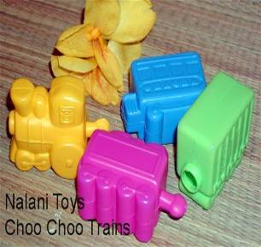 | Chunky plastic toys that can be joined together. | 11 | interlocking plastic toys | 12 | 6-12
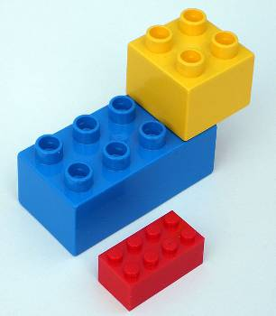 | Large plastic building blocks. | 13 | Duplo | 14 | 1-2
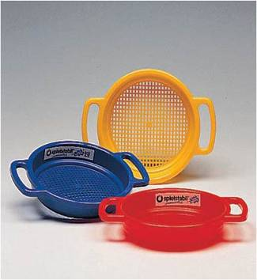 | A sieve that a child plays with in the sand. | 15 | sand sieve | 16 | 2-3
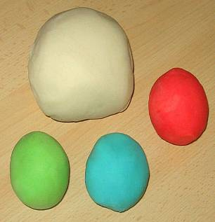 | Soft material that can be made into different shapes. | 17 | play dough or clay | 18 | 2-3
 | A strong plastic ball with handles that a child can bounce on. | 19 | space hopper | 21 | 3-4
 | Materials that a child can find around the house or garden to make into models. | 21 | junk modelling materials | 22 | 4-5
 | Games for children who can follow a game with rules and turn taking etc. | 23 | complex board games | 24 | 4-5

Activity 9 answers

Session 4

Session 4, Activity 3 answers

stage
1 | The prenatal stage:  from conception to birth
2 | The neonatal stage:  from birth to 1 month
3 | Infancy:  from 1 month to 2 years
4 | Toddler:  from 1 to 2 years
5 | Early childhood:  from 1 to 5 years
6 | Middle childhood:  from 5 to 12 years
7 | Adolescence:  from 12 to 20 years
8 | Young adulthood:  from 20 to 40 years
9 | Middle adulthood:  from 40 to 65 years
10 | Late adulthood:  from 65 years onwards

Session 4, Activity 4 answers

Statements: |  | physical | intellectual | language | emotional | social
1 | Stand up. | ✓
2 | Hold a crayon or paintbrush. | ✓
3 | Start to put two or more words together. |  |  | ✓
4 | Fit objects together to make a tower. |  | ✓
5 | Choose own friends. |  |  |  |  | ✓
6 | Follow simple instructions. |  | ✓
7 | Communicate when happy or excited. |  |  | ✓
8 | Ask for a drink or food. |  |  | ✓
9 | Dislike being restrained and throw tantrums. |  |  |  | ✓
10 | Cry when main carer leaves. |  |  |  | ✓
11 | Need reassurance when tired. |  |  |  | ✓
12 | Understand sharing and turn-taking. |  |  |  |  | ✓
13 | They co-operate or help with dressing. |  |  |  |  | ✓
14 | Interested in what happens around them. |  | ✓
15 | Kick a ball. | ✓

Session 4, Activity 5 answers (cut out and give to students to students. Ideally laminate or use website.)
 | 0-1 year | 1-3 years | 3-5 years | 5-11 years | 11-16 years
Physical | Crawling, rolling or shuffling, possibly even walking; is able to pick up small objects and can point. | Able to run and climb, walk up and down stairs using alternative feet. Can turn pages in a book and shows an interest in mark making. | Enjoys riding on tricycles, climbing and simple ball games. Skilful use of hands to do threading, pouring and using scissors. | Children continue to grow in height and become more skilled in quicker, confident and more accurate hand movements. | This period marks the start of physical changes for young people as their bodies prepare for adulthood.
Intellectual | Babies learn about their environment from their senses and will explore objects using their hands and mouth | They are starting to enjoy pretend play with small world activities and the home corner. Are keen to play repetitively. | They are keen to help and copy adults. They are starting to become independent and can organise their play if given the opportunity. | There is an awareness of the consequences of their behaviour and increased thoughtfulness.  Some problem solving and co-operation. | Many have developed skills that are equal to those of adults and they are starting to think about their future.
Language/  Communication | Babbling becomes more tuneful and inventive and first words are beginning to appear | They enjoy nursery rhymes and songs and their language continues to develop from two word compounds. | Children are fairly fluent in their speech and are easily understood. Though still the odd pronunciation error. | In these years reading and writing becomes much easier, although there will be variations in speed and competence. | Stories and writing that shows imagination as well as being legible and reasonably grammatical.
Emotional | Babies are able to recognise the smell of their mother and are quickly soothed when they hear her voice. | They like to do things for themselves and get frustrated and angry and have frequent temper tantrums. | Children feel easier at being separated from their carer. Sharing of toys becomes easier. | Life in the classroom and playground is a major influence on these children, this can affect their confidence. | Children want to explore their own identity; this may cause clashes with parents as young people try to develop their own personality and space
Social | Starting to learn that making eye contact, smiling and laughing can keep their carer’s attention. | Starting to play more with other children of their own age, although some of their time will be spent playing alongside others. | Enjoys being with other children, seeking out particular playmates. Responding well to adult praise and recognition. | Friends are important to children of this age. Many children will start to have established friendships and preferences. | Enjoyment when with their friends, which is likely to be more important than family. Prefer to be part of a group.

Session 4, Activity 8

 | Positive | Negative
1 | fact | opinion
2 | true | false
3 | right | wrong
4 | objective | subjective
5 | unbiased | biased
6 | real | belief

 | Statement | Objective / Subjective
 | Susan and Claire were playing on the carpet with a box of building blocks. Claire pointed to a circle they had made and said to Susan, “That looks like a roundabout”. | Objective
 | Takis said, “No, I am not allowed to eat meat and I shall not eat this”. | Objective
 | Cheung enjoys playing with counters and making shapes. | Subjective
 | Emily did not want to come to school. | Subjective
 | Susan and Maneer played well together. | Subjective
 | Harry kept making noises and yawning while the other children on the table were writing in their books. | Objective
 | Takis is fussy about food today. | Subjective
 | Raoul kept distracting other children from their work. | Objective
 | Avinash collected all the red counters and made them into a round shape. She then collected all the blue counters and made them into a square shape. She then collected all the yellow counters and arranged them in a wavy line. | Objective
 | Emily was upset and held her mother’s hand tightly. | Subjective

Session 4, Activity 9

To learn about individual children’s needs
To note changes in behaviour
To get to know a child better
To assess a child’s overall development
To assess a child’s progress
To assess a child’s state of health
To identify any safety issues in the setting
To identify when adult intervention would be helpful
To help identify links between circumstances and behaviour
To inform future planning
To identify good and not so good practice
To measure the success of activities or equipment
To monitor a concern that has already been raised
Session 5, Activity 2
Health & Safety Act questions (circle the correct answer: a, b, c or d)

- What is the main requirement of the Health & Safety act on employers?
  - To ensure the health, safety and welfare of their employees and those affected by their work. (correct answer)
  - To ensure the health and welfare of their employees.
  - To ensure the health and safety of their employees and those affected by their work.
  - To ensure the health and safety of those affected by their work.
- What does the Act set out?
  - The general health and safety duties for employers and employees. (correct answer)
  - The general health and safety duties for members of the public.
- When are risk assessments required?
  - When there are only two people working together.
  - When there are five or more people employed. (correct answer)
- What does the Act state about using Health and Safety equipment at work?
- That health and safety equipment should be available if people would like to use it.
- That health and Safety equipment must be available and used. (correct answer)
- What does the Act state about employees following Health and Safety procedures?
  - Employees have to follow Health and Safety procedures when they have time.
  - Employees have to follow Health and Safety procedures at all times. (correct answer)
- What does the Act state about causing risks at work?
  - That employees must try not to take many risks at work.
  - That employees must not put others at risk by their actions. (correct answer)
- What responsibility does the employer have to the employee in the Act?
  - The employers must try to look after the employees whenever they are at work.
  - The employers have a duty of care, take every reasonable step to care for them and minimise risks for the employees. (correct answer)
- What does Ofsted have the power to do in early year settings?
  - To rewrite the Health and Safety rules.
  - To close the setting if it does not meet the Health and Safety requirements. (correct answer)
- The policies and procedures that are in place in early year settings explain:
  - What should be done if a situation arises that requires an adult to keep children safe. ( correct answer)
  - Where you can go to find out about Health and Safety.
- If you were an adult working in an early years setting which would be the most important task to do on the first morning?
  - Read and learn the Health and Safety procedure. (correct answer)
  - To find out when the children go out on trips.
Session 5 Activity 4

 | Welfare Requirement | Guidance
1 | Safeguarding and promoting children’s welfare | The provider must take the necessary steps to safeguard and promote the welfare of children.  The provider must promote the good health of the children, take necessary steps to prevent the spread of infection, and take appropriate action when they are ill.  Children’s behaviour must be managed effectively and in a manner appropriate to their stage of development and particular individual needs.
2 | Suitable people | Providers must ensure that adults looking after children, or having unsupervised access to them, are suitable to do so.  Adults looking after children must have appropriate qualifications, training skills and knowledge.  Staffing arrangements must be organised to ensure safety and to meet the needs of the children.
3 | Suitable premises, environment and equipment | Outdoor and indoor spaces, furniture, equipment and toys must be safe and suitable for their purpose
4 | Organisation | Providers must plan and organise their systems to ensure that every child receives an enjoyable experience. Learning and development must be tailored to meet each child’s individual needs.
5 | Documentation | Providers must maintain records, policies and procedures required for the safe and efficient management of the setting and to meet the needs of the children.

Session 5 Activity 5

(00:00-00:30)

1.) In a school, who should be protected by health and safety?
Answer: children and staff

(00:00-0058)

2) What type of risk are coats laying on the floor?
Answer: a trip hazard.

(00:00-02:20)

3) Why is it important to have a fire practise at lunchtime?
Answer: Because there are different staff working at lunchtime.

(00:00-06.40 – 00:00-07.50)

4) When they look at a classroom they identify 7 different risks, how many can you name?

Answer:
Projector wires hanging down
Stairs
Hot drink in classroom
Drink by the computer
Drink left on the edge of the table
Water could be spilt around the sink
Generally untidy

(00:00-08.45)
5) Who came to the help of the teacher who fell down the stairs?

Answer: Another teacher who was a first aider.

(00:00-09:55)
6.) Outside the school, when it is frosty or snowy, what is done to make the playground safe?
Answer: Grit is put on the ground.

(00:00-10:28)
7) There is a school rule about moving around the school, what is it?
Answer: You must walk – no running.

(00:00-10:40)
8.) There is a pillar inside the school entrance that they feel might be a risk, what do they decide to do to minimise the risk?
Answer: Wrap the pillar with foam and hazard tape.

(00:00-12:06 - 00:00-13:10)
9) There are three things to ensure in the playground, can you name them?
Answer:
All play equipment should conform to European Standards
The playground should be supervised at all times
A risk assessment must be done.

Session 5, Activity 7

So children learn how to play safely.

So that children can learn new skills by trying new activities.
The best way for children to learn about safety is to allow them to take risks.
Riding a two-wheel bike is dangerous but a child needs to learn how to balance.
Children need the opportunity to take risks which are still safe.
Carers must be careful not to over-protect children.
Carers must monitor children’s safety but allow them to be creative and adventurous.
Children can develop confidence and self-belief through tackling new challenges.
A child who is not allowed to try new challenges will not learn how to make safety judgements.
A child who is not allowed to try new challenges will not learn about what is dangerous and what is acceptable.
Pre-Course Questionnaire

We hope that you will enjoy completing this course “So you want to work in Childcare?”

Before you begin, please answer these questions. At the end of the course you will be asked to complete a further questionnaire.

This information will help us to improve the course and check that it has helped to support your learning.

About you

First name ___________________________________

Surname ___________________________________

TICK ☑ the box
1. Age 16 -19yrs □ 20-30yrs □ 31–40 yrs □ 41-55yrs □ 56yrs + □

2. Gender Female □ Male □

3. Is English your “first” language? Yes □
No □

If “No” what is your first language?
___________________________________

4. Are you employed? No □
Yes □

5. If “Yes” are you employed Full time? □
or Part-time? □
What is your job role?
___________________________________

6. What course are you studying at college? ___________________________________

Your IT skills
1 = A lot 4 = Never
1 2 3 4
7. I use a computer at home □ □ □ □
8. I use a computer at college □ □ □ □
9. I use a computer at work □ □ □ □
10. I use the internet to search for information □ □ □ □
11. I use the internet to send emails □ □ □ □

12. How confident are you in using a computer to help you in your learning?

1 = Very confident 4 = Not confident
1 2 3 4
□ □ □ □

Working in childcare

13. I know what the duties of a childcare assistant are.

1 = Strongly agree 4 = Strongly disagree
1 2 3 4
□ □ □ □

14. I know the skills and qualities that are needed to work in childcare.

1 = Strongly agree 4 = Strongly disagree
1 2 3 4
□ □ □ □

Understanding new words

Look at the list of words below. Write the missing word. If you do not know what the word means, leave the box blank. You will be looking at these words later in the course. Please do not use a dictionary to help you with this activity.

Patience Liaise Adhere Confidential Calm
Empathy Emotional Stamina Technique Initiative

 | Word | Definition
15 |  | About your mind rather than your body.
16. |  | Secret, not to be shown or talked about to other people.
17. |  | To stick formally to something.
18. |  | To work closely with a person or group etc and give he/her/them regular information about what you are doing.
19. |  | A particular way of doing something.
20. |  | The quality of being able to stay calm and not get angry.
21. |  | The ability to do something that requires a lot of physical or mental effort for a long time.
22. |  | The ability to imagine how another person is feeling.
23. |  | Not excited, worried or angry.
24. |  | The ability to see what is necessary or needs to be done without being asked or told.

Thank you

Post-Course Questionnaire Evaluation

Well done for completing the course “So you want to work in Childcare?”!

We hope that you have found this course helpful. Please spend some time carefully completing this evaluation. This will help you to reflect on your learning and help us to improve our learning materials.

About you

First name ___________________________________

Surname ___________________________________

Your IT skills TICK ☑ the box

1. How did you complete this course? on paper □ on the computer “on line” □

2. How confident do you now feel in using a computer to help you in your learning?

1 = Very confident 4 = Not confident
1 2 3 4
□ □ □ □

Working in childcare

3. I understand what the duties of a childcare assistant are.

1 = Strongly agree 4 = Strongly disagree
1 2 3 4
□ □ □ □

4. I understand the skills and qualities that are needed to work in childcare.

1 = Strongly agree 4 = Strongly disagree
1 2 3 4
□ □ □ □

5. The activities in the course were:

very useful to me □ quite useful to me □ not useful to me □

Understanding new words

Look at the list of words below. Write the missing word. If you do not know what the word means, leave the box blank. Please do not use a dictionary to help you with this activity.

Patience Liaise Adhere Confidential Calm
Empathy Emotional Stamina Technique Initiative

 | Word | Definition
6. |  | About your mind rather than your body.
7. |  | Secret, not to be shown or talked about to other people.
8. |  | To stick formally to something.
9. |  | To work closely with a person or group etc and give he/her/them regular information about what you are doing.
10. |  | A particular way of doing something.
11. |  | The quality of being able to stay calm and not get angry.
12. |  | The ability to do something that requires a lot of physical or mental effort for a long time.
13. |  | The ability to imagine how another person is feeling.
14. |  | Not excited, worried or angry.
15. |  | The ability to see what is necessary or needs to be done without being asked or told.

The learning materials
The learning materials were:

1 = Yes, excellent 4 = No, not at all
1 2 3 4
16. Well organised □ □ □ □
17. At the right level for me □ □ □ □
18. Interesting □ □ □ □
19. Useful for me □ □ □ □
20. Easy to understand □ □ □ □

21. Did you have sufficient help to support you to complete the course?

1 = Yes, I did 4 = No, not at all
1 2 3 4
□ □ □ □

Comments
22. Write below anything further you would like to add.

Thank you

