What’s your job?
7.1

1. I work in a school. I teach children. I’m a ……………………
2. I work in an office. I type letters and answer the telephone. I’m a ……………………
3. I work in a shop. I sell things to people. I’m a …………………………
4. I work in a surgery. I treat people’s teeth. I’m a ……………………..
5. I work outside. I keep animals and grow food. I’m a ………………….
6. I work in a shop. I cut people’s hair. I’m a ……………………….
7. I work in a garage. I fix cars. I’m a ………………………..
8. I work in a restaurant. I cook the food. I’m a …………………..
9. I work in a restaurant. I serve the customers. I’m a …………………
10. I work in different places. I put out fires. I’m a ……………………



Sales assistant

Secretary

Farmer

Mechanic


Waitress

Teacher

Hairdresser

Waiter


Dentist

Chef

Firefighter

Ask other people:

- Where do you work?
- What‘s your job?
- What do you do in your job?
Write about yourself:
I’m a ………………………………………………………………………………………
I work in a ……………………………………………………………………………….
I …………………………………………………………………………………………...

Interviews
7.2

















Reading and questioning a wage slip
7.3

Write the words next to the meaning

Tax code

Tax
National insurance

Pension contribution

Net pay

Deductions

Employee
number

Gross pay

Pension

National insurance number

1. The money you get before they take anything away:
2. Your personal ‘Social Security’ number:
3. The number that shows how much tax you will pay:
4. Money when you retire (stop working):
5. The wage you actually have:
6. The money you pay for when you retire:
7. Money they take away before you get your wage:
8. Money for National Health and Social Security benefits:
9. Money for the government for roads, schools, military, and so on:
10. Your personal number in your work place:

Reading and questioning a wage slip
7.3

Sample wage slip
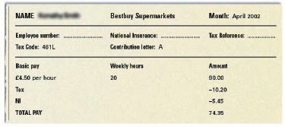

1. What is this person’s tax code?
2. What is their basic hourly pay?
3. Do they work part time or full time?
4. What is their gross pay?
5. Is the gross pay for a week or for a month?
6. How much are the deductions?
7. Is the total pay correct?

Reading and questioning a wage slip
7.3

How do you check your wage slip?

- Write in the correct word below: Subtract; Add; Multiply; Divide

1. The hourly pay is £9.20. A person works 18 hours per week.
What is the weekly pay?
……………….. £9.20 by 18.

2. The gross monthly pay is £1268. Deductions are £367.
What is the net pay?
……………….. £367 from £1268.

3. The job pays £17000 per year.
What is the monthly pay?
……………….. £17000 by 12.

4. You pay £52 tax and £28 National Insurance contribution.
What are your total deductions?
……………….. £52 to £28.

- Check these wage slips. Talk in English as you do it.
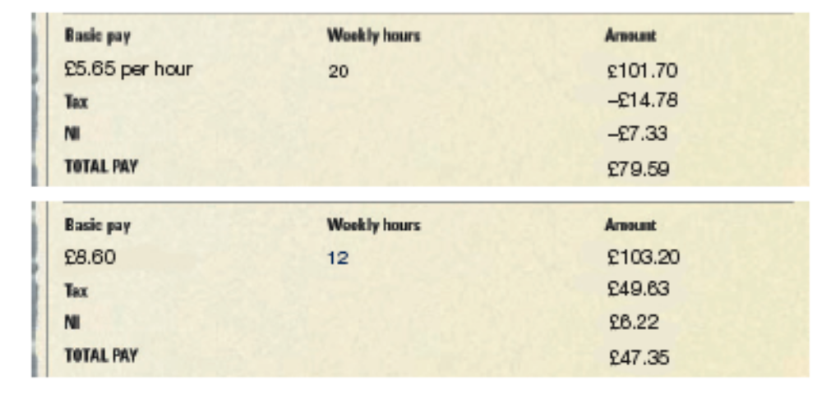

- What is wrong?
- Who can you speak to?
- What can you say?

Contract of employment
7.4

CONTRACT OF EMPLOYMENT

1. Names of the contracted parties
Between: Pizza Palace (the ‘employer’)
191 Bingham Road, Thornton Heath, Surrey, CR7 2BZ
And: Terry Smith (the ‘employee’)
12 Smalltown Road, Midshire MRT 5EW
2. Starting date of the employee
Employment start date: 10 August 2004
3. Job title and description
The employee’s job title is: Assistant – full time.
The employee’s main task is to assist the owner in maintaining a consistent quality of service to customers.
4. Address of the workplace
The employee will work from: 191 Bingham Road, Thornton Heath, Surrey, CR7 2BZ.
5. Salary
The employee’s salary is £8528 gross per annum. Payments are weekly (£164 gross)
by cheque. If you do not have a bank account you will need to open one.
6. Hours of work
The employee’s working week will consist of 45 hours, from Monday to Friday and from 9 am to 6 pm. There is a 1-hour lunch break: timing to be agreed with the employer.
From time to time, the employee may be asked to work outside the contracted hours. The normal hourly rate will be paid.
7. Holiday entitlement
The employee is entitled to 4 weeks’ (20 days’) paid holiday per annum, including Bank and Public Holidays. At the end of 5 years’ service an extra day’s holiday entitlement is given – followed by a further 1-day holiday entitlement for each of the next 4 years service: bringing maximum holiday entitlement to 5 weeks (25 days). Further details are outlined in the Pizza Palace handbook.

Contract of employment
7.4

8. Sickness entitlement
Contractual sick pay: the employee will receive their normal salary for a period of
4 weeks, in any 12-month period where a doctor’s certificate is produced after
7 consecutive days’ sickness. Payments will be less statutory sick pay and any
Social Security benefits due to the employee.
9. Grievance and discipline procedures
These are outlined in the Pizza Palace handbook and are in line with the current legislation.
10. Notice periods required from both the employee and the employer
The minimum notice periods are as follows:
Time in employment Minimum notice
Under 1 month No notice
Over 1 month 1 week
2 years’ service 1 month
3 to 12 years’ service 1 week for each year to a maximum of 12 weeks.
The employee must submit a written copy of their notice to the business’s address,
as 1 above.
The employer will send a copy of the notice to the employee’s address, as 1 above.
In the case of the employee being dismissed for gross misconduct, the employer will decide if any notice period will be applied and/or worked.

I agree to the above terms and confirm I have received a copy of this contract.
…………………………………….………
Signed by the employee
Dated……………………………….…….

…………………………………….………
Signed by or on behalf of the employer
Dated……………………………….…….

Contract of employment
7.4

Wage slip
NAME: T. Smith Pizza Palace Month: November 2004

Employee number: Nat. Ins. Number: Tax Ref. 001 B
5584321 YY362718C
Tax code: 461L Contribution Letter: A
Basic pay Monthly hours Amount
£ _______ per week _______ £_______
Overtime
£ ________ per hour _______ £_______
Gross pay £_______
Income tax £69.32
NI £34.46
Net pay £_______

- Look at the wage slip. Complete it correctly by finding and calculating the following.
1. Find Terry’s basic weekly pay in his contract of employment and write in the amount on his wage slip.
2. Find Terry’s weekly hours of work. Deduct his lunch breaks for the week.
Multiply the weekly hours by four (weeks). Write the monthly hours he has worked on his pay slip.
3. Write the monthly amount on his pay slip.
4. Terry worked two hours overtime this month. He earns £6.10 an hour. Write these figures in the correct gaps.
5. Calculate his overtime pay and write it in the amount column.
6. Calculate his gross pay and write it in the amount column.
7. Calculate his net pay and write it in the amount column.

(Note: The person and company referred to in this activity are entirely fictional. Any resemblance to an
existing person or company is purely coincidental.)

Understanding minimum wage law
7.5

1. Minimum wage
2. Compensation
3. Slave
4. Poverty
5. Employment
6. Tribunal
7. Trade union
a) The lowest wage per hour which can legally be paid for a particular type of work.
b) Someone forced to work for a master and owner.
c) Work, occupation.
d) A group of workers of the same trade who join together to bargain with employers
for fair wages and so on.
e) Something given to make up for wrong or damage.
f) A group of people appointed to give a judgement, especially on an appeal.
g) Being poor, having little money or property.

Discussion

- How much is the minimum wage?
- Who decides the minimum wage?
- Is there a minimum wage in the country you come from?
- Do you think it is a good idea to have a minimum wage?
- Do you know what you can do if your employer does not pay the minimum wage?

Understanding minimum wage law
7.5

This is a true story that was in the Daily Express newspaper in June 2004. The story has been jumbled up.

Try and put the following paragraphs in the correct order. The first paragraph is in the right place.
a. A worker was only paid 29p an hour in the supermarket where he worked.

b. After he left his job, he complained to an organisation that helps workers get better working conditions. They helped him take his case to court.

c. After a few weeks he did get more money.
His wages went up to 96p an hour.
The minimum wage at that time was £4.50 an hour.

d. He won the case and the court paid him £5000 compensation.

e. The man came to England from Africa two years ago and really needed a job so he accepted the low wages. The owner of the supermarket said that he would get paid more money if he showed that he could do the job well.

f. The worker kept the job for six months before he got really fed up because he worked for long hours and did not get enough money.

Understanding minimum wage law
7.5

- Choose the best title for the story. You must explain why you have chosen it.
a. Man on low wage wins compensation
b. Man used as slave labour in supermarket
c. What a shelf stacker was paid
d. Shop worker who was paid 29 pence an hour wins compensation

- Answer the following questions:
1. What was the hourly rate of the worker’s starting pay?
2. Why was he willing to accept such a low wage?
3. What was the increase he received after a few weeks?
4. How much did this new wage fall short of the minimum wage?
5. How did he get help to fight his case?

If something like this happened to you:
- Which organisation would you go to for help?
- What would you say?
- If you wanted to write a letter, what would you write?

Discrimination at work
7.6

Match the word with its meaning

1. Discrimination a. A way to go into a place or building.

2. Employer b. Treating a person or a group in an unfair way.

3. Employee c. Continual unpleasant remarks said to someone.

4. Access d. To get a more important job.

5. Promotion e. A person who is paid to do work.

6. Harassment f. A person or company that pays others to do work.

Mark the stress and number of syllables on each word.

Discrimination at work
7.6

Are the following examples of discrimination allowed by law?
Explain why or why not.

1. Tony, 55, wanted a job as a baker. The company didn't give him the job because they wanted someone younger, to be the same age as the rest of the staff.

2. David, who uses a wheelchair, failed to get a job as a manager at a small company of ten employees. The company said it was too expensive to change the office to have wheelchair access.

3. Gabby, a young woman, always gets whistled at when she walks across the factory floor at work. The men often shout at her about her hair, clothes, and so on.

4. Jan didn't get a promotion at work, even though she was the best person for the job. Her employers thought she would soon start a family and take lots of time off work.

5. A Spanish restaurant wants to employ Spanish waiters and waitresses because they are already familiar with the food.

Discrimination at work
7.6

Discrimination and work: The law

Discrimination is usually one of the following:

1. People who are treated differently because of their race, sex, colour, nationality or marital status. For example, a woman paid less money than a man for doing the same job is a case of discrimination.

2. An employer discriminating against a person because they have a disability. To stop discrimination against a disabled person the employer must change the workplace place so that it is accessible for a disabled person.

3. There are no laws about age discrimination: you can be refused a job if the employer thinks you are too old or young for it.

4. Harassment is also a form of discrimination: for example, making racist or sexist comments.

5. Discrimination can be against a group or an individual person.

6. Sometimes an employer says discrimination is necessary for the job. For example, a French restaurant may want French staff rather than English staff, and this is allowed.

Comparing salaries
7.7

- Put these jobs in order of salary or wage. Put the highest first and the lowest last.
Highest
Doctor
Nurse
Football player
Lawyer
Housewife
Teacher
Shop assistant
Lowest
Lorry driver
I think the person who gets the highest salary is ………………………………....

I think the person who gets the lowest amount is ………………………………....

- Compare your answers with other people. Did you all get the same?
Discussion questions
Do you think relative salaries are different in different countries?
Do you think it is right that a footballer earns more than a nurse? What are the arguments for and against?
Do you think a housewife should get a wage? Give your reasons.
If you had the power to change the present situation, what would you change?

