Name: _______________________________ Date: ______________

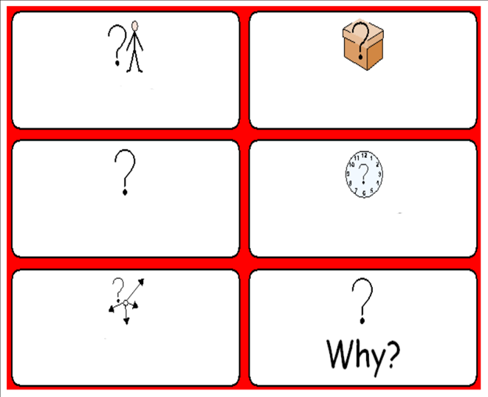
Question words

Where? = place

When? = time

What? = thing

How? = to understand

Who? = person
Words (open PowerPoint - Week 11 Words 1)

 | spellings (listen to the tutor) | correct

(Open PowerPoint - Week 11 Sentences 1)

Read the sentences with your tutor and copy the sentences neatly.

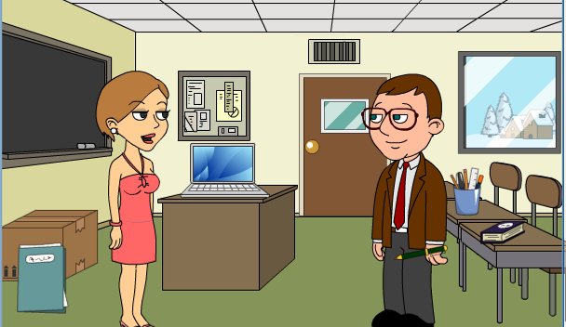

 | When do you go to class? | 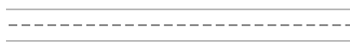

I go to class on Monday.
 | Why do you go to college?
 | Because I study English.
 | When does your class start?
 | It starts at 9.30.
 | When does your class finish?
 | It finishes at 12 o’clock.
 | Who is your teacher in January?
 | My teacher is Jennifer.

STUDENT 1 - in pairs, read the sentences to the other student and copy.

When do you go to class?
___________________________________________
Why do you go to college? ___________________________________________
When does your class start? ___________________________________________
When does your class finish? ___________________________________________
Who is your teacher? ___________________________________________

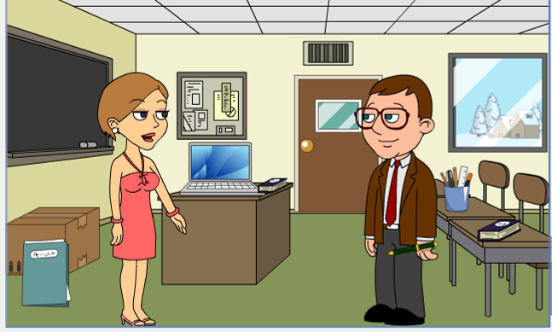
STUDENT 2 - in pairs, read the sentences to the other student and copy.

___________________________________________
I go to class on Monday. ___________________________________________
Because I study English. ___________________________________________
It starts at 9.30.
___________________________________________
It finishes at 12 o’clock.
___________________________________________
My teacher is Jennifer.

STUDENT 2 - in pairs, read the sentences to the other student and copy.

When do you go to class?
___________________________________________
Why do you go to college? ___________________________________________
When does your class start? ___________________________________________
When does your class finish? ___________________________________________
Who is your teacher? ___________________________________________

STUDENT 1 - in pairs, read the sentences to the other student and copy.

___________________________________________
I go to class on Monday. ___________________________________________
Because I study English. ___________________________________________
It starts at 9.30.
___________________________________________
It finishes at 12 o’clock.
___________________________________________
My teacher is Jennifer.

Situation 1 - classroom

Put students into groups of three. Two students should have the conversation below without looking at the script. The third person to check as below to ensure students are remembering correctly. May prompt if struggling. Then swap around.

Student 1 | When do you go to class?
Student 2 | I go to class on Monday.
Student 1 | Why do you go to college?
Student 2 | Because I study English.
Student 1 | When does your class start?
Student 2 | It starts at 9.30.
Student 1 | When does your class finish?
Student 2 | It finishes at 12 o’clock.
Student 1 | Who is your teacher in January?
Student 2 | My teacher is Jennifer.

Find and circle the words: at in on
These 3 words are called prepositions of time. We use:
- at for the TIME of day
- in for MONTHS, YEARS, CENTURIES and LONG PERIODS
- on for DAYS and DATES
Situation 2 - Work

Put students into pairs or threes. They should write a script based on a new context but reuse the language chunks and correct prepositions of time. Then read together as a dialogue.

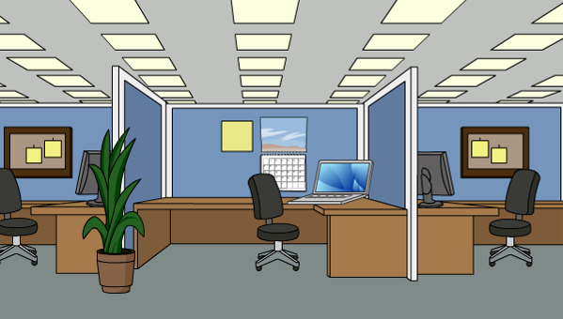

Student 1 | When do you go to
Student 2 | I go
Student 1 | Why do you go
Student 2 | Because I
Student 1 | When does your
Student 2 | It starts
Student 1 | When does your
Student 2 | It finishes
Student 1 | When did you start your job?
Student 2 | I started it

Use these words correctly:
- at for the TIME of day
- in for MONTHS and YEARS
- on for DAYS and DATES
Situation 3 – Café

Put students into pairs or threes. They should write a script based on a new context but reuse the language chunks and correct prepositions of time. Then read together as a dialogue.

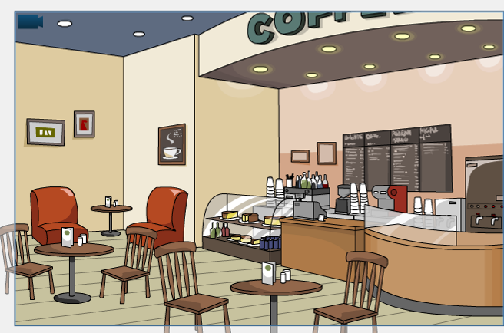

Student 1 | When do you go to the
Student 2 | I go
Student 1 | Why do you go
Student 2 | Because I
Student 1 | When does the
Student 2 | It opens
Student 1 | When does the
Student 2 | It closes

Use these words correctly:
- at for the TIME of day
- in for MONTHS and YEARS
- on for DAYS and DATES
Situation 4 – bus

Put students into pairs or threes. They should write a script based on a new context but reuse the language chunks and correct prepositions of time. Then read together as a dialogue.

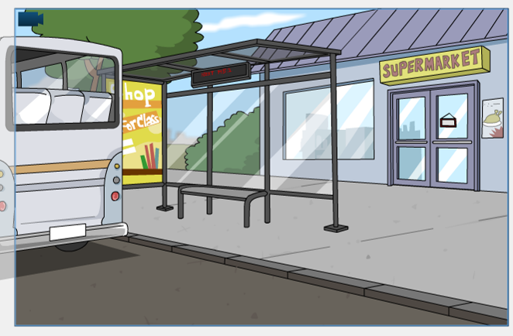

Student 1 | When do you get the
Student 2 | I get
Student 1 | Why do you get
Student 2 | Because I
Student 1 | What time does the
Student 2 | It comes

Use these words correctly:
- at for the TIME of day
- in for MONTHS and YEARS
- on for DAYS and DATES
Situation 5 – shopping

Put students into pairs or threes. They should write a script based on a new context but reuse the language chunks and correct prepositions of time. Then read together as a dialogue.



Student 1 | When do you go
Student 2 | I go
Student 1 | Why do you go
Student 2 | Because I
Student 1 | What time does the
Student 2 | It opens
Student 1 | What time does the
Student 2 | It closes

Use these words correctly:
- at for the TIME of day
- in for MONTHS and YEARS
- on for DAYS and DATES
Word shapes (lowercase letters)

1 2 3

4 5 6

7 8 9

10

college study English because start

finish class teacher January study

word search (capital letters) online click here to create more

X | U | S | T | U | D | Y | W | W | M
F | I | N | I | S | H | Y | U | S | D
C | L | A | S | S | D | F | S | G | V
T | A | S | T | U | D | Y | O | M | J
P | M | S | T | A | R | T | S | W | H
Q | Q | Y | B | E | C | A | U | S | E
M | J | A | N | U | A | R | Y | U | P
U | S | J | C | O | L | L | E | G | E
R | T | E | A | C | H | E | R | O | W
P | J | E | N | G | L | I | S | H | P

Order the sentences (this could be done orally, reading aloud and learners copy)

 | Sentences | Rewrite if incorrect
 | go to class? When do you
 | I on Monday .go to class
 | Why go to college? do you
 | I study English. Because
 | When your class start? does
 | It at 9.30.starts
 | When your class finish? does
 | It at 12 o’clock. finishes
 | your teacher in January? Who is
 | My is Jennifer.teacher

The conversation below is in the present tense. Rewrite it in the past tense.

question words / present tense verbs

When do (___did____) you go to class?
I go (_________) to class on Monday.
Why do (_________) you go to college?
Because I study (_________) English.
When does (_________) your class start?
It starts (_________) at 9.30.
When does (_________) your class finish?
It finishes (_________) at 12 o’clock.
Who is (_________) your teacher in January?
My teacher is (_________) Jennifer.

(was) (was) (finished) (did) (started)

(did) (did) (studied) (went) (did)

- at for the TIME of day
- in for MONTHS and YEARS and a period of time
- on for DAYS and DATES

PREPOSITIONS | Prepositions of time (in, on, at) 1

Fill in each blank with the correct preposition (in, on, or at):

1. ________ January.
2. ________ January 25th.
3. ________ 2004.
4. ________ Tuesday.
5. ________ 7:00 PM.
6. ________ a couple of minutes.
7. ________ the usual time.
8. ________ the middle of January.
9. ________ Saturday.
10. ________ half past 8.

- at for the TIME of day
- in for MONTHS and YEARS and a period of time
- on for DAYS and DATES

PREPOSITIONS | Prepositions of time (in, on, at) 2

Fill in each blank with the correct preposition (in, on, or at):

1. ________ the summer.
2. ________ 8:15.
3. ________ the 25th of August.
4. ________ the evening.
5. ________ night.
6. ________ August.
7. ________ the weekend.
8. ________ the morning.
9. ________ Friday night.
10. ________ six thirty.
Lesson 2
Name: _______________________________ Date: ______________

tutor note: see back page


Question words

Where? = place

When? = time

What? = thing

How? = to understand

Who? = person

Which? = to choose

Why? = to ask

Draw a line from the word to the object.

folder box board table computer poster door window pen book
Prepositions of place – write the missing words

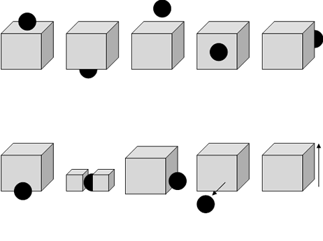

Words (open PowerPoint – Week 11 Words 2)

 | spellings (listen to the tutor) | correct

(Open PowerPoint – Week 11 Sentences 2) = answer the tutor questions

Read the sentences with your tutor and copy the sentences neatly.

What is that?
It is a pen.
Where is your pen?
It is in my hand.
What colour is your pen?
It is green.
Where is your book?
It is on the table.
Which book is yours?
The book next to the pens.

STUDENT 1 - in pairs, read the sentences to the other student and copy.

What is that?
___________________________________________
Where is your pen? ___________________________________________
What colour is your pen? ___________________________________________
Where is your book? ___________________________________________
Which book is yours? ___________________________________________

STUDENT 2 - in pairs, read the sentences to the other student and copy.

___________________________________________
It is a pen. ___________________________________________
It is in my hand. ___________________________________________
It is green. ___________________________________________
It is on the table. ___________________________________________
The book next to the pens.

STUDENT 2 - in pairs, read the sentences to the other student and copy.

What is that?
___________________________________________
Where is your pen? ___________________________________________
What colour is your pen? ___________________________________________
Where is your book? ___________________________________________
Which book is yours? ___________________________________________

STUDENT 1 - in pairs, read the sentences to the other student and copy.

___________________________________________
It is a pen. ___________________________________________
It is in my hand. ___________________________________________
It is green. ___________________________________________
It is on the table. ___________________________________________
The book next to the pens.

Situation 1 - classroom

Put students into groups of three. Place a book and a pen on the table. Two students should have the conversation below without looking at the script. The third person to check as below to ensure students are remembering correctly. May prompt if struggling. Then swap around.

Student 1 | What is that?
Student 2 | It is a pen.
Student 1 | Where is your pen?
Student 2 | It is in my hand.
Student 1 | What colour is your pen?
Student 2 | It is green.
Student 1 | Where is your book?
Student 2 | It is on the table.
Student 1 | Which book is yours?
Student 2 | The book next to the pens.

Situation 2 - classroom

Put students into pairs or threes. They should write a script based on words but reuse the language chunks and correct prepositions of place. Then read together as a dialogue.

folder box board table

Student 1 | Where is the
Student 2 | It is
Student 1 | Where is the
Student 2 | It is
Student 1 | Where is the
Student 2 | It is
Student 1 | Where is the
Student 2 | It is

Situation 3 - classroom

Put students into pairs or threes. They should write a script based on a new context but reuse the language chunks and correct prepositions of place. Then read together as a dialogue.

computer poster door window

Student 1 | Where is the
Student 2 | It is
Student 1 | Where is the
Student 2 | It is
Student 1 | Where is the
Student 2 | It is
Student 1 | Where is the
Student 2 | It is

Word shapes (lowercase letters)

1 2 3

4 5 6

7 8 9

10

folder box board table computer
poster door window pen book

Word search (capital letters) online click here to create more

Q | W | I | N | D | O | W | T | Q | Y
G | B | O | X | P | O | S | T | E | R
U | L | D | O | O | R | B | O | O | K
D | M | T | L | F | O | L | D | E | R
C | O | M | P | U | T | E | R | F | L
I | D | U | M | H | I | N | X | M | E
B | P | E | N | B | O | A | R | D | O
R | Y | R | C | P | L | T | I | B | R
O | W | T | A | B | L | E | C | S | I
W | D | O | H | L | S | B | Y | Z | K

Order the sentences
Use capital letters at the start of each sentence and full-stops.

Sentences
is that? What
It a pen. is
is your pen? Where
It is my hand. in
What is your pen? colour
is green. It
Where your book? is
It on the table. is
book is Which yours?
The the pens. book next to

PREPOSITIONS | OPPOSITES OF PREPOSITIONS 1
Write the opposite of each of the prepositions below:

1. far away ___close_________________________
2. up _______________________________
3. under _______________________________
4. in front of _______________________________
5. up _______________________________
6. in _______________________________
7. above _______________________________
8. out of _______________________________
9. on _______________________________
10. down _______________________________

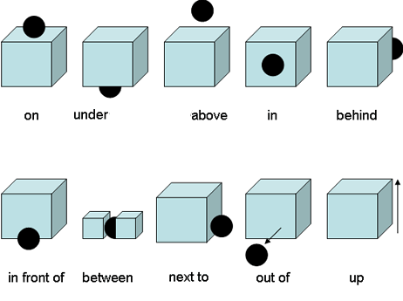

PREPOSITIONS | Prepositions of time (in, on, at) 1
ANSWERS:
1) in 2) on 3) in 4) on 5) at 6) in 7) at 8) in 9) on 10) at

PREPOSITIONS | Prepositions of time (in, on, at) 2
ANSWERS:
1) in 2) at 3) on 4) in 5) at 6) in 7) on *“at” in British English 8) in
9) on 10) at



