Name: _______________________________ Date: ______________

Adverbs of frequency

How often do you …

Always 100%
Usually 80%
Often 60%
Sometimes 25%
Never 0%

- I go to sleep. 100%
_______________________________________
- I do my homework. 80%
_______________________________________
- She does the shopping. 60%
_______________________________________
- He cleans the house. 25%
_______________________________________
- He makes the dinner. 0%
_______________________________________

Cut out the names from the back page and glue to the picture.

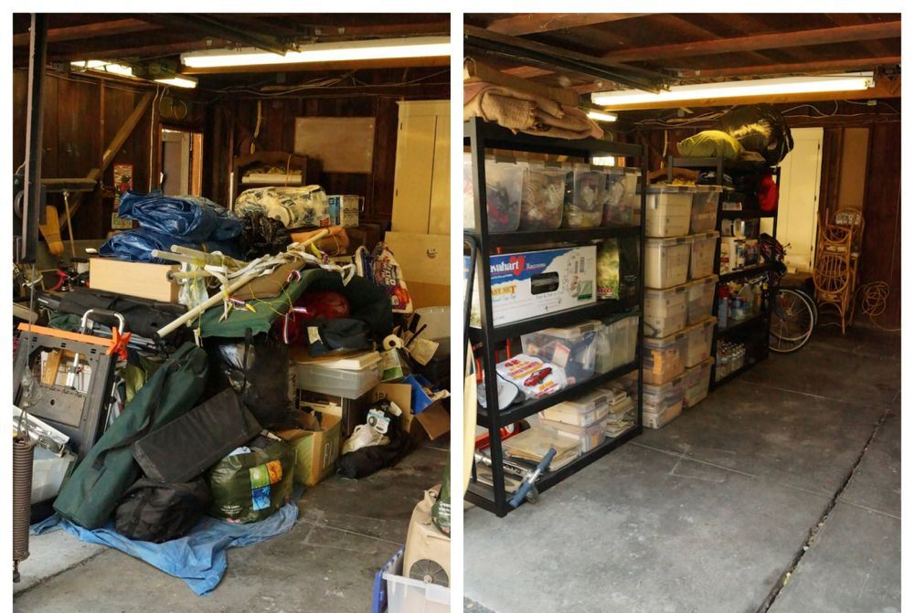 | 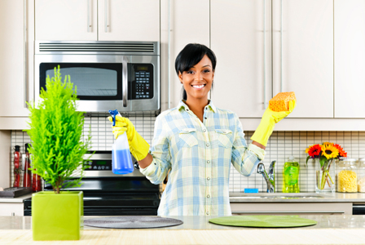
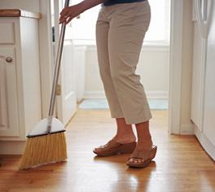 | 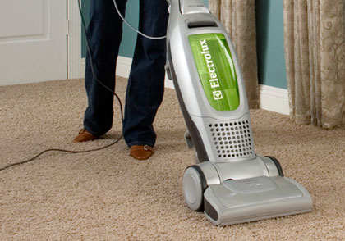
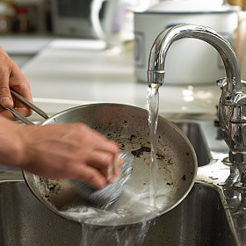 | 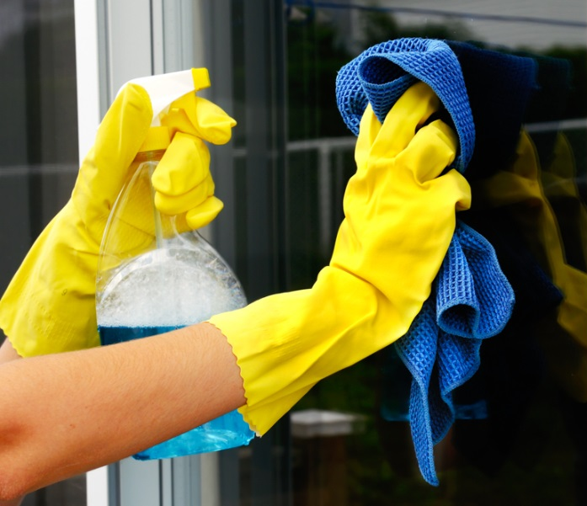
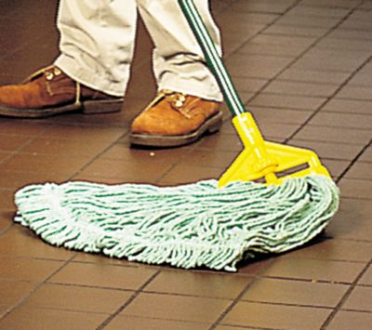 | 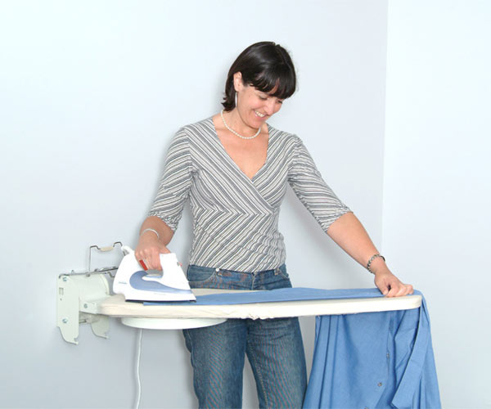
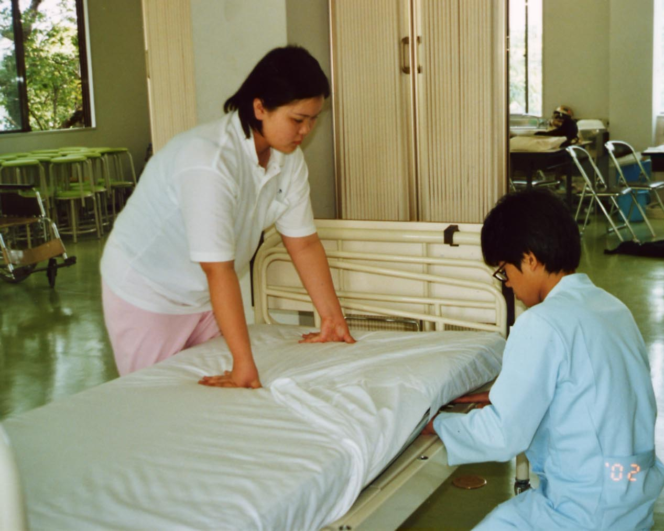 | 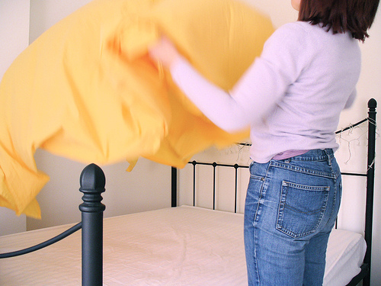

tidy up | clean the house
sweep the floor | vacuum the floor | wash the dishes
clean the windows | mop the floor | do the ironing
make the beds | change the sheets
Write the missing words.
Always 100%
Usually 80%
Often 60%
Sometimes 25%
Never 0%

- tidy up _____________
- clean the house _____________
- make the beds _____________
- change the sheets _____________
- mop the floor _____________
- sweep the floor _____________
- vacuum the floor _____________
- wash the dishes _____________
- do the ironing _____________
- clean the windows _____________
In pairs, write 10 questions and write the answer.
 | How often do you tidy up? | I usually tidy up.
 | How often do you____________ | I __________________
 | How often do you____________ | I __________________
 | How often do you____________ | I __________________
 | How often do you____________ | I __________________
 | How often do you____________ | I __________________
 | How often do you____________ | I __________________
 | How often do you____________ | I __________________
 | How often do you____________ | I __________________
 | How often do you____________ | I __________________
 | 1. tidy up  2. clean the house  3. make the beds  4. change the sheets  5. mop the floor  6. sweep the floor  7. vacuum the floor  8. wash the dishes  9. do the ironing  10. clean the windows | Always 100%  Usually 80%  Often 60%  Sometimes 25%  Never 0%

Words (open PowerPoint – Week 14 Words 1)

 | spellings (listen to the tutor) | correct

(Open PowerPoint – Week 14 Sentences 1)

Read the sentences with your tutor and copy the sentences neatly. Answer the tutor questions.

 | How often do you wash up? | 
 | I always wash up.
 | How often do you sweep the floor?
I never sweep the floor.
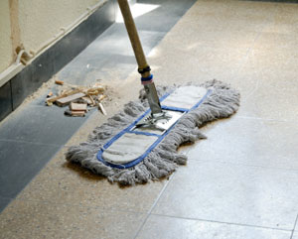
 | How often do you tidy up?
 | I sometimes tidy up.
 | How often do you iron?
 | I usually do the ironing.
 | How often do you make the beds?
 | I often make the beds.

STUDENT 1 - in pairs, read the sentences to the other student and copy.

Always 100%
Usually 80%
Often 60%
Sometimes 25%
Never 0%

How often do you tidy up?
___________________________________________
How often do you clean the house? ___________________________________________
How often do you make the beds? ___________________________________________
How often do you change the sheets? ___________________________________________
How often do you mop the floor? ___________________________________________

1. tidy up
2. clean the house
3. make the beds
4. change the sheets
5. mop the floor
6. sweep the floor
7. vacuum the floor
8. wash the dishes
9. do the ironing
10. clean the windows
STUDENT 2 - in pairs, read the sentences to the other student and copy.

Always 100%
Usually 80%
Often 60%
Sometimes 25%
Never 0%

___________________________________________
I always
___________________________________________
I usually
___________________________________________
I often
___________________________________________
I sometimes
___________________________________________
I never

1. tidy up
2. clean the house
3. make the beds
4. change the sheets
5. mop the floor
6. sweep the floor
7. vacuum the floor
8. wash the dishes
9. do the ironing
10. clean the windows

STUDENT 1 - in pairs, read the sentences to the other student and copy.

Always 100%
Usually 80%
Often 60%
Sometimes 25%
Never 0%

How often do you sweep the floor?
___________________________________________
How often do you vacuum the floor? ___________________________________________
How often do you wash the dishes?
___________________________________________
How often do you do the ironing? ___________________________________________
How often do you clean the windows? ___________________________________________

1. tidy up
2. clean the house
3. make the beds
4. change the sheets
5. mop the floor
6. sweep the floor
7. vacuum the floor
8. wash the dishes
9. do the ironing
10. clean the windows
STUDENT 2 - in pairs, read the sentences to the other student and copy.

Always 100%
Usually 80%
Often 60%
Sometimes 25%
Never 0%

___________________________________________
I always
___________________________________________
I usually
___________________________________________
I often
___________________________________________
I sometimes
___________________________________________
I never

1. tidy up
2. clean the house
3. make the beds
4. change the sheets
5. mop the floor
6. sweep the floor
7. vacuum the floor
8. wash the dishes
9. do the ironing
10. clean the windows


tidy up | clean the house
sweep the floor | vacuum the floor | wash the dishes
clean the windows | mop the floor | do the ironing
make the beds | change the sheets

- tidy up
- clean the house
- make the beds
- change the sheets
- mop the floor
- sweep the floor
- vacuum the floor
- wash the dishes
- do the ironing
- clean the windows
- pick up the clothes
- cook a meal
- set the table
- clear the table
- empty the bins
- go shopping
- take out the rubbish
- wash up
- dry the dishes
- do the washing

How often do you wash up?  I always wash up.  How often do you sweep the floor?  I never sweep the floor.  How often do you tidy up?  I sometimes tidy up.  How often do you iron?  I usually do the ironing.  How often do you make the beds?  I often make the beds. | How often do you cook a meal?  I always do the cooking.  How often do you empty the bins?  I never empty the bins.  How often do you go shopping?  I sometimes go shopping.  How often do you clean the house?  I usually clean the house.  How often do you wash up?  I often wash up.

