Restaurant: cut out the names from the back page and glue to the picture.
Name: _______________________________ Date: ______________

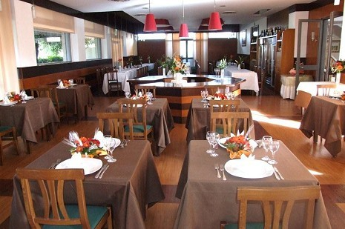
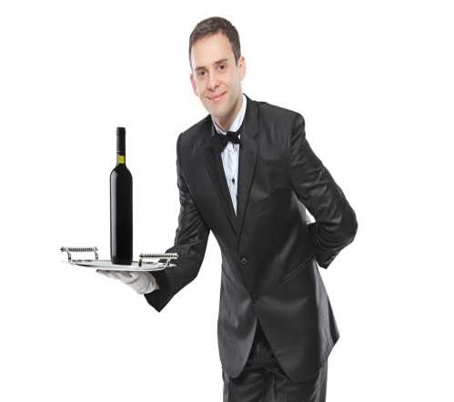 | 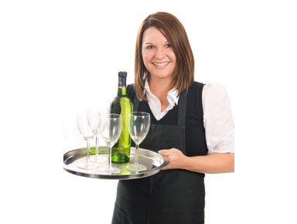
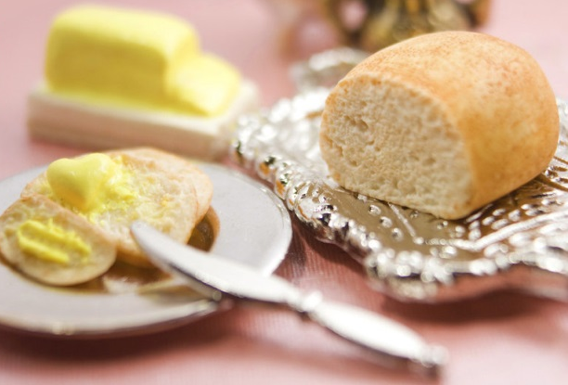 | 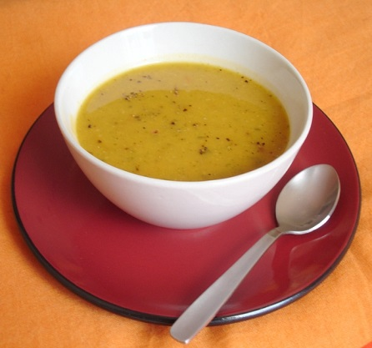
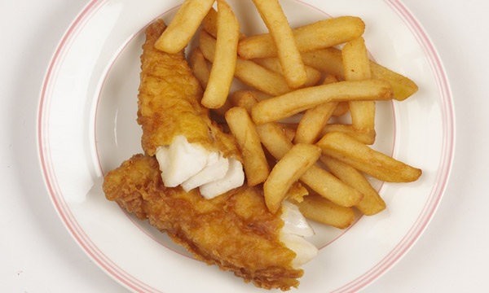 | 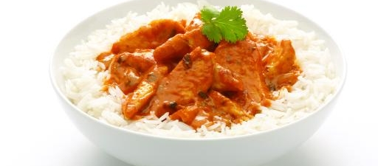
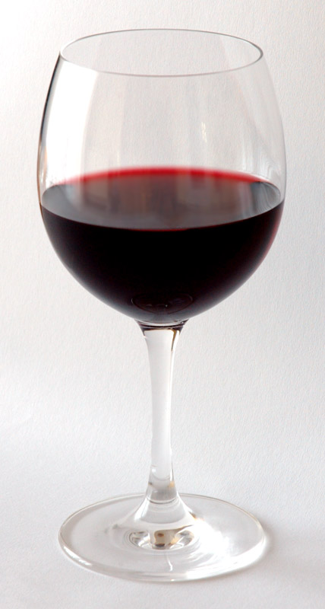
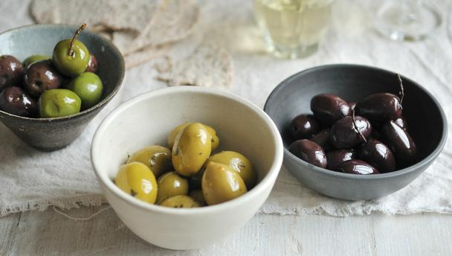 | 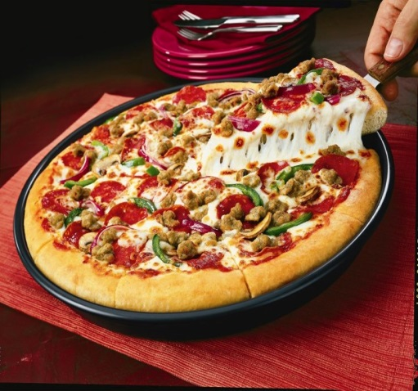
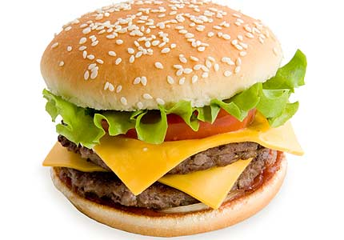 | 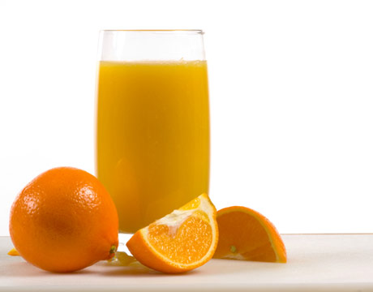
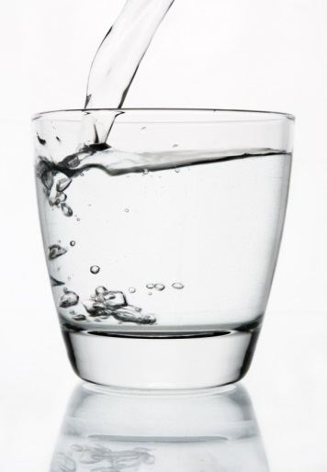 | 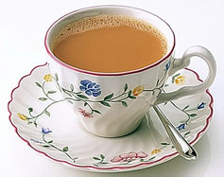
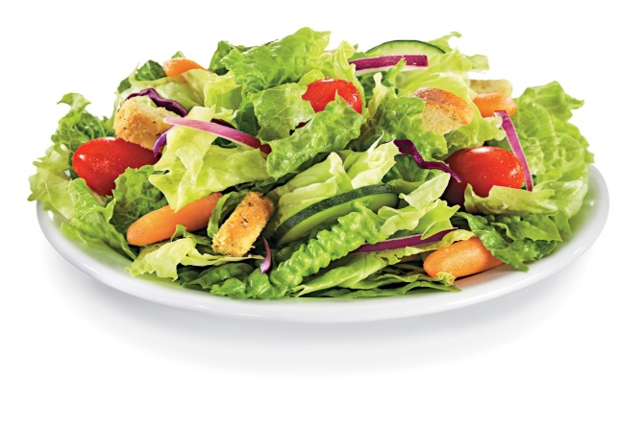

Arrange the words

Are these words people, starters, main courses or drinks?

Waiter | Glass of water
Bread and butter | Glass of orange juice
Glass of wine | Bowl of soup
Olives | Curry and rice
Pizza | Pint of beer
Hamburger | Fish and chips
Cup of tea | Waitress
Salad

People  Waiter | Starter  bread and butter | Main course  fish and chips | Drink  glass of water

RESTAURANT - Look at the picture

What can you see? Talk about the picture.

Chair table tablecloth knife fork door floor window flowers plates

Make sentences
Between next to on opposite above

The plates are ______ the table.
The table cloths are _____ the table.
The doors are _______ the windows.
The lights are ________ the tables.
The flowers are __________ the glasses.

Words (open PowerPoint – Week 16 Words 1)

 | spellings (listen to the tutor) | correct

(Open PowerPoint – Week 16 Sentences 1) Restaurant
Wine and starter drink main of chips rice bowl

What would you like for your __________?
I’ll have a _______ of soup.

I’ll have some bread ______ butter.
What would you like for your ________ course?
I’ll have fish and ________.
I’ll have curry and ________.
What would you like to _______?
I’ll have a pint ______ beer.
I’ll have a glass of _________.
Thank you for your order.

STUDENT 1 – Here is your menu.

MENU 1

STARTER
Bread and butter
Bowl of soup
Salad
MAIN COURSE

Curry and rice
Fish and chips
Pizza

DRINKS

Glass of wine
Glass of water
Cup of tea

STUDENT 2 – Here is your menu

MENU 2
STARTER

Bread and butter
Bowl of soup
Olives
MAIN COURSE

Curry and rice
Fish and chips
Hamburger

DRINKS

Glass of wine
Glass of orange juice
Cup of tea

Dining in –

Use your menus. Student 1 ask student 2 for their order. Student 2 ask student 1 for their order.

Student 1

Student 1: What would you like for your starter?
Student 2: I’ll have __________________.
Student 1: What would you like for your main course?
Student 2: I’ll have __________________.
Student 1: What would you like to drink?
Student 2: I’ll have ___________________.
Student 1: Thank you for your order.

Student 2

Student 2: What would you like for your starter?
Student 1: I’ll have __________________.
Student 2: What would you like for your main course?
Student 1: I’ll have __________________.
Student 2: What would you like to drink?
Student 1: I’ll have ___________________.
Student 2: Thank you for your order.

Extra work

We can use ‘will’ with ‘have’ to talk about what we want.
We can also use ‘would’ with ‘like’ to talk about what we want.

I will = I’ll – example: I’ll have a glass of water.
He / she will = he’ll / she’ll – example: He’ll have a hamburger.
I would = I’d – example: I’d like a cup of tea.
She / he would – She’d/he’d – example: she’d like some olives.

Wine have like pizza tea like have and like soup

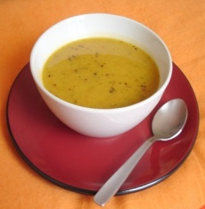 | I’d ______ a bowl of __________.
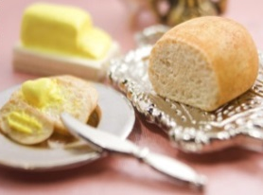 | I’ll ________ some bread _____ butter.
 | He’d ______ a cup of ________.
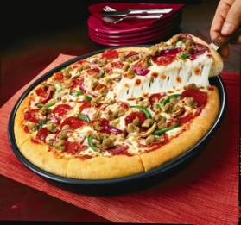 | She’d _____ some ____________.
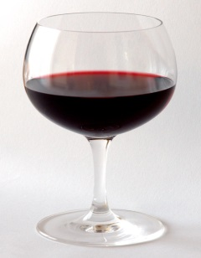 | She’ll _______ a glass of ________.

Restaurant

menu | waiter
waitress | bread and butter
bowl of soup | olives
fish and chips | curry and rice

pizza | hamburger
glass of wine | glass of water
glass of orange juice | cup of tea
coffee table | restaurant
salad

