Name: _______________________________ Date: ______________

tutor note: see back page

 | an | ap | at
1
2
3

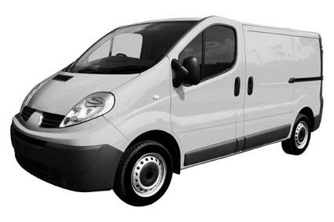 | 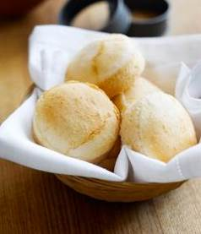 | 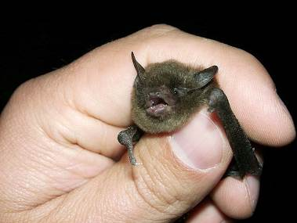 | 
 | 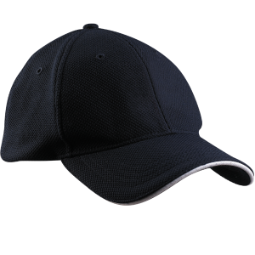 | 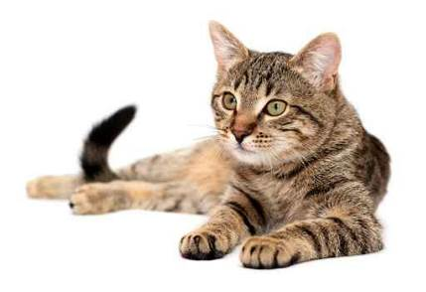 | 

Section 1 Words (open PowerPoint - Week 7 Words 1)

 | spellings (listen to the tutor) | correct

Section 2 Handwriting (choose words to practise writing)

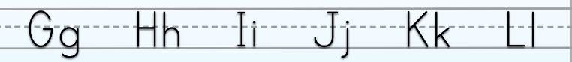

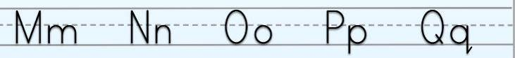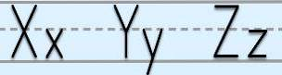
Section 3 (Introduce the key words below then open PowerPoint - Week 7 Sentences 1)

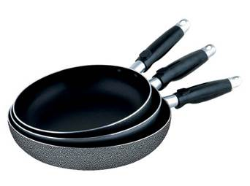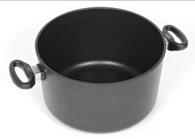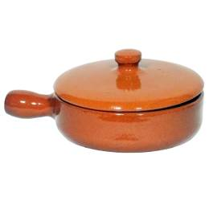
Pat / cap pans black brown

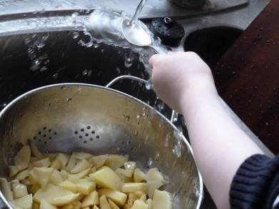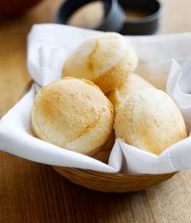
water tap baps nap

Read the sentences with your tutor.

My name is Pat.
I cook with pans.
A brown pan.
A black pan.
A tap for water.
Water to cook.
I make bread baps.
I wear a cap.
I cook in a cap.
Then I have a nap.

Section 4 allow to work alone then check in pairs

Write the missing words.

My _______ is Pat.
I cook with ________.
A ________ pan.
A ________ pan.
A ________ for water.
_________ to cook.
I make _________ baps.
I wear a __________.
I _______ in a cap.
Then I have a __________.

name cook pans brown black Water

bread cap nap have tap
Section 5 word shapes (lowercase letters)

1 2 3

4 5 6

7 8 9 10

cook pans brown black water

bread cap nap have tap
Section 6 word search (capital letters) online click here to create more

D | T | C | H | N | A | P | R | T | M
B | C | O | O | K | D | P | V | Z | T
B | R | E | A | D | W | A | T | E | R
J | H | C | H | L | V | T | A | P | C
U | Z | W | Z | B | L | A | C | K | K
H | J | H | A | V | E | W | I | R | Q
L | K | S | S | C | M | F | D | P | V
Y | O | B | R | O | W | N | A | P | O
I | W | R | Q | H | M | C | A | P | S
C | L | O | B | P | A | N | S | W | W

TAP BROWN NAP WATER HAVE NAP

PANS CAP BREAD BLACK COOK

Section 7 Order the sentences (this could be done orally, reading aloud and learners copy)

 | Sentences | Rewrite if incorrect
 | is Pat. name My
 | My name is Pat.
 | with I pans cook.
 | brown A pan.
 | black A pan.
 | tap for A water.
 | Water cook to.
 | make I baps bread.
 | cap I a. wear
 | I cap cook in a.
 | nap I have a. Then

Section 8 Look at the words below and write using IS and ARE. Make the nouns plural.
 | an |  | ap |  | at
1 | van | 4 | bap | 7 | bat
2 | can | 5 | cap | 8 | cat
3 | man | 6

IS
There is one van.

ARE
There are two vans.

Spelling activity (at home)
Write down 10 words you want to learn to spell. Practise spelling the words correctly.
Use LOOK SAY COVER WRITE CHECK

SPELLINGS

 | word | syllables | 1st try | 2nd try | 3rd try | 4th try
1
2
3
4
5
6
7
8
9
10

tutor note: see back page

 | an | ap | at
1
2
3
4

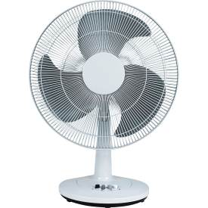 | 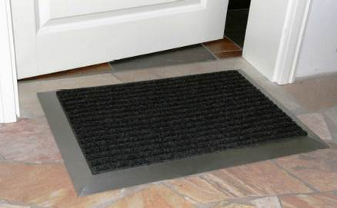 | 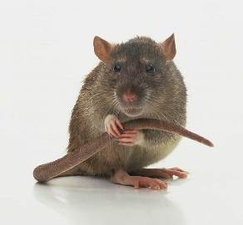 | 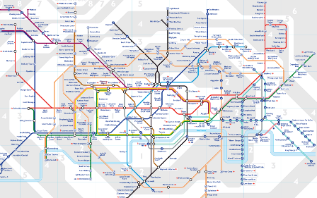
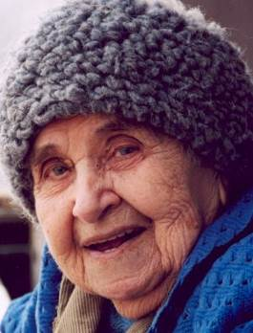 | 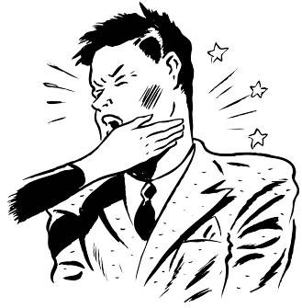
Section 10 Words (open PowerPoint - Week 7 Words 2)

 | spellings (listen to the tutor) | correct

Section 11 Handwriting (choose words to practise writing)

Section 12 (Introduce the key words below then open PowerPoint – Week 7 Sentences 2)

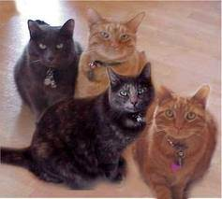
Pat two black cats two brown cats

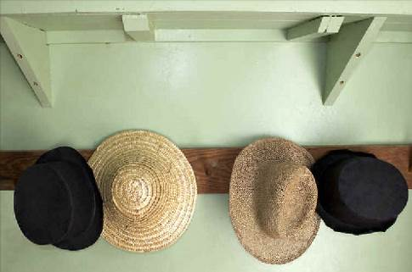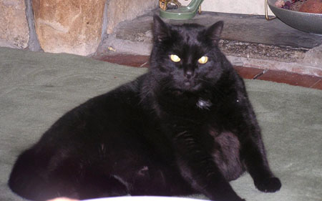
four hats fat cat

Read the sentences with your tutor.

Pat has four cats.
Two black cats.
Two brown cats.
Pat has four hats.
A cat is in her hat.
The cats are at home.
One cat is fat.
One cat ran away.
The cat came back.
One cat ate a rat.

Section 13 allow to work alone then check in pairs

Look at the text below.

Pat ________ four ________.
Two ________ cats.
Two ________ cats.
Pat has four ________.
A ______ is in her _________.
The cats _______ at _________.
One cat is ________.
One cat ran __________.
The cat came _________.
One cat ate a __________.

has cats black brown hats back
cat hat home fat away rat

Rewrite changing 2 or more to singular and plural to only 1. Use IS and ARE.

 | Pat has four cats.  Two black cats.  Two brown cats.  Pat has four hats.  A cat is in her hat.  The cats are at home.  One cat is fat.  One cat ran away.  The cat came back.  One cat ate a rat. | Pat has one cat. | 1
 |  |  | 1
 |  |  | 1
 |  |  | 1
 |  | Two cats are in her hat. | 2
 |  |  | 1
 |  |  | 2
 |  |  | 2
 |  |  | 2
 |  |  | 2
Section 14 word shapes (lowercase letters)

1 2 3

4 5 6

7 8 9 10

has black brown back cat

home fat away rat hat

Section 15 Word search (capital letters)

P | H | O | M | E | G | A | P | U | E
G | D | W | X | R | B | L | A | C | K
C | L | H | X | D | A | W | A | Y | J
H | A | T | U | C | H | Y | E | D | X
E | M | P | P | B | V | W | C | A | T
Q | C | H | A | S | W | G | X | B | N
A | X | L | S | B | A | C | K | Z | W
A | X | A | J | R | A | T | S | C | Q
Q | H | B | R | O | W | N | U | O | M
G | D | B | H | Z | F | A | T | Y | Y

has black brown back cat

home fat away rat hat

Section 16 Order the sentences (this could be done orally, reading aloud and learners copy)

 | Sentences | Rewrite if incorrect
 | Pat four cats. has
 | cats. Two black
 | Two cats. brown
 | hats. has four Pat
 | A her hat. cat is in
 | at cats home. The are
 | One is fat. cat
 | One ran away. cat
 | The came back. cat
 | One ate a rat. cat
Section 17 Look at the words below and write using IS and ARE. Make the nouns plural.
 | an |  | ap |  | at
1 | fan | 4 | map | 7 | map
2 | pan | 5 | tap | 8 | rat
3 | gran | 6

IS
There is one fan.

ARE
There are two fans.

Section 18Spelling activity (at home)
Write down 10 words you want to learn to spell. Practise spelling the words correctly.
Use LOOK SAY COVER WRITE CHECK

SPELLINGS

 | word | syllables | 1st try | 2nd try | 3rd try | 4th try
1
2
3
4
5
6
7
8
9
10

EXTENSION FOR TARGETS

Rewrite this using full-stops correctly and capital letters.

my name is Pat I cook with pans a brown pan a black pan
a tap for water water to cook I make bread baps
I wear a cap I cook in a cap then I have a nap
_______________________________________________
___________________________________________________________________________________________________________________________________________________________________________________________________________________________________________

In pairs, ask each other these questions and answer, repeating the end of each question in the answer. Write down your answers.

1.) Who cooks food?

2.) How many pans does Pat have?

3.) What does Pat make?

4.) What does Pat wear?

5.) What does Pat do after cooking?

EXTENSION FOR TARGETS
Rewrite this using full-stops correctly and capital letters.

pat has four cats two black cats two brown cats pat has four hats
a cat is in her hat the cats are at home one cat is fat
one cat ran away the cat came back one cat ate a rat
_______________________________________________
___________________________________________________________________________________________________________________________________________________________________________________________________________________________________________

In pairs, ask each other these questions and answer, repeating the end of each question in the answer. Write down your answers.

1.) What colour are the cats?

2.) How many hats does Pat have?

3.) What is in Pat’s hat?

4.) Where are the cats?

5.) What did the cat eat?

 | an | ap | at
1 | van | bap | bat
2 | can | lap | cat
3 | ran | cap | fat

 | an | ap | at
1 | fan | map | mat
2 | pan | nap | pat
3 | man | tap | rat
4 | gran | slap | sat

