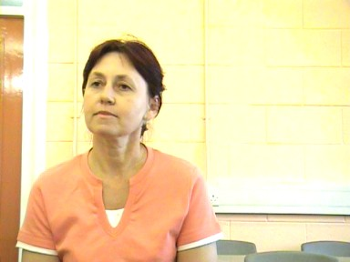
Video: My name is …

Language Skill: Give and listen to personal information
Curriculum Code: Sc/E1.4b & Lr/E1.4b
Contents:
5 minute video
Ideas for Use
Flashcards
Worksheet for video
Worksheet answers (script)

Ideas for use:

1. Distribute worksheets and watch video, asking students to listen carefully and write down the answers. Tutor many need to pause and rewind several times to enable students to listen fully and write answers.

2. Elicit incorrect grammar spoken by students on video. Ask for corrections, noting in particular that the end of a question is often repeated in the answer.

3. In threes, post-viewing, pairs ask each other personal information. Third member to spot mistakes. Tutor and third student to monitor pronunciation, grammar, stress and repetition of question in answer.

4. Create 3 flash cards with NAME, COUNTRY, LANGUAGES. Each students writes their own details on the back of each. Mix all cards together. Whole group tries to place the correct 3 cards together and identify the person.

name

country

languages

STUDENT 1
Listen carefully. And write down each answer spoken by the students.
1 | What is your name?
2 | Where do you live?
3 | What is your nationality?
4 | What course have you done this week?
5 | Are you looking for work?
6 | What type of work?
 |  | Are any of the answers spoken incorrectly?
STUDENT 2
1 | What is your name? |  | 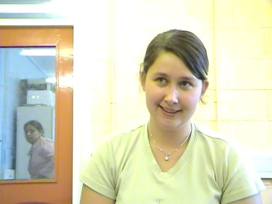
2 | Where do you live?
3 | What is your nationality?
4 | What course have you done this week?
5 | Are you looking for work?
6 | What type of work?
 |  | Are any of the answers spoken incorrectly?

STUDENT 3
1 | What is your name? |  | 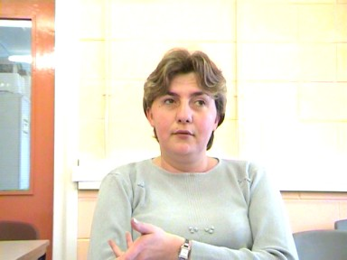
2 | Where do you live?
3 | What is your nationality?
4 | What course have you done this week?
5 | Are you looking for work?
6 | What type of work?
 |  | Are any of the answers spoken incorrectly?
STUDENT 4
1 | What is your name? |  | 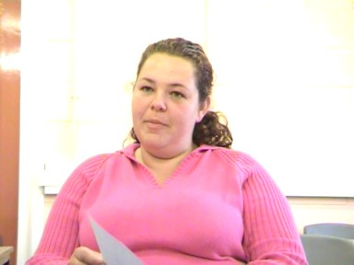
2 | Where do you live?
3 | What is your nationality?
4 | What course have you done this week?
5 | Are you looking for work?
6 | What type of work?
 |  | Are any of the answers spoken incorrectly?

STUDENT 5
1 | What is your name? |  | 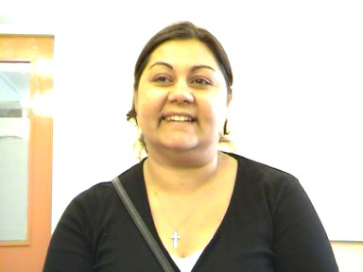
2 | Where do you live?
3 | What is your nationality?
4 | What course have you done this week?
5 | Are you looking for work?
6 | What type of work?
 |  | Are any of the answers spoken incorrectly?
STUDENT 6
1 | What is your name? |  | 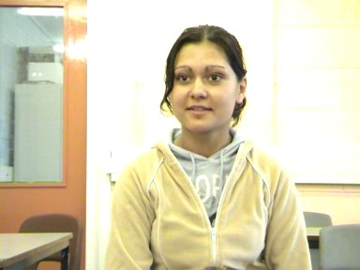
2 | Where do you live?
3 | What is your nationality?
4 | What course have you done this week?
5 | Are you looking for work?
6 | What type of work?
 |  | Are any of the answers spoken incorrectly?

ANSWERS.
STUDENT 1
1 | What is your name?
My name is Aija.
2 | Where do you live?
I live in 12 Addington Place, Hunslet, Leeds.
3 | What is your nationality?
I am Latvian.
4 | What course have you done this week?
I am ESOL course.
5 | Are you looking for work?
Yes. I looking for work. Full-time work.
6 | What type of work?
I would like cleaning and maybe picking, packing, learning in factory.
 |  | Are any of the answers spoken incorrectly?
STUDENT 2
1 | What is your name?
My name is Joanna Miller.
2 | Where do you live?
I live in Leeds.
3 | What is your nationality?
I’m Polish.
4 | What course have you done this week?
English and cleaning.
5 | Are you looking for work?
Yes.
6 | What type of work?
I looking for as a cleaner, physical worker. I can look after children. Any work.
 |  | Are any of the answers spoken incorrectly?

STUDENT 3
1 | What is your name?
My name is Alexandra.
2 | Where do you live?
Four months.
3 | What is your nationality?
My nationality Poland.
4 | What course have you done this week?
One week. One week.
5 | Are you looking for work?
I looking for job. Cleaner. Dishwasher. Kitchen porter. I don’t know. Anything.
 |  | Are any of the answers spoken incorrectly?
STUDENT 4
1 | What is your name?
My name is Barbara.
2 | Where do you live?
I live Leeds, Chapeltown.
3 | What is your nationality?
I’m Polish.
4 | What course have you done this week?
This week? ESOL and domestic work.
5 | Are you looking for work?
Yes.
6 | What type of work?
Cleaning, kitchen porter, picker, packer, dishwasher, anything.
 |  | Are any of the answers spoken incorrectly?

STUDENT 5
1 | What is your name?
Bozena.
2 | Where do you live?
Leeds. Harehills.
3 | What is your nationality?
Nationality. Czech.
4 | What course have you done this week?
Yes, college.
5 | Are you looking for work?
Yes.
6 | What type of work?
Cleaning. Wash.
 |  | Are any of the answers spoken incorrectly?
STUDENT 6
1 | What is your name?
My name is Monica.
2 | Where do you live?
I live in Harehills.
3 | What is your nationality?
My nationality is from Poland.
4 | What course have you done this week?
ESOL and cleaning.
5 | Are you looking for work?
Yes I am looking for a job.
6 | What type of work?
I want to have something to shop to help and cleaning.
 |  | Are any of the answers spoken incorrectly?

